CURRICULUM VITAE
Miss Sapna Dashrathrao Sapate 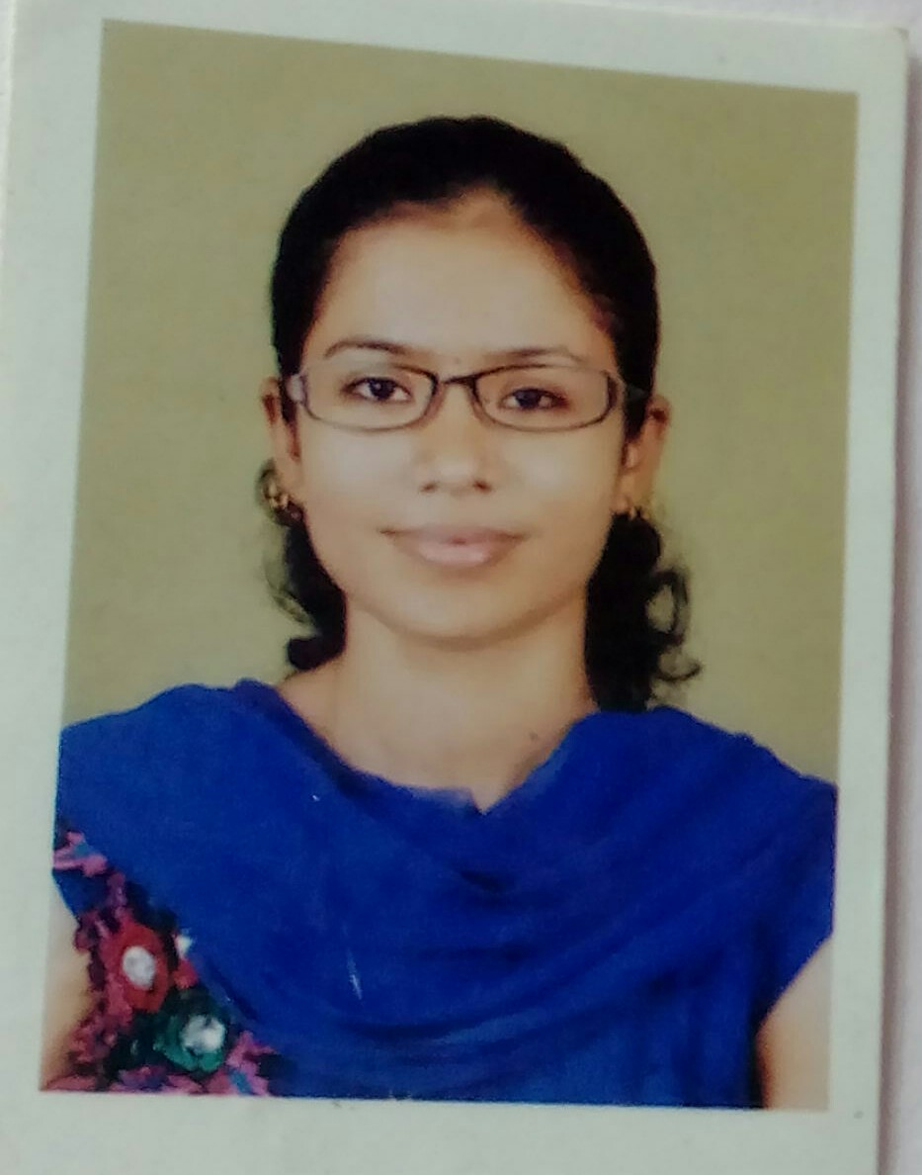
B.Sc (Microbiology, Botany, Chemistry)
Mob No. 9766085585
Email-ID: sapna.sapate11@gmail.com
CORRESPONDANCE ADDRESS:
Sapna Sapate
c/o Prajakta Chaudhari
70/71 Sultan Bilding
3rd floor, Senapati Bapat Marg,
Dadar (w) Mumbai 400028.
Maharashtra.

OBJECTIVE :
To obtain a responsible and challenging position where my education and work experience will have valuable application.
STRENGTHS :
Having Positive attitude, friendly behavior to others. Patience of mind. Hard working and sincere, good in maintaining relationship. Competitive in work.

ACADEMIC QUALIFICATION:
2003 | HSC | PUNE Board, Maharashtra. | 66.50%
2010-2013 | B.sc (Microbiology) | Sevadal Mahila Mahavidyalaya,  RTM Nagpur | 54.95%
2013 | M.Sc ^{Ist} Semester | Shivaji Science College, RTM Nagpur | 62.88 %
2014 | M.Sc. II ^{nd} Semester | Shivaji Science College, RTM Nagpur | 65.60 %
2014 | M.Sc IIIrd Semester | Shivaji Science Coolege, RTM Nagpur | 61.60 %
2015 | M.Sc IVth semester | Shivaji Science Coolege, RTM Nagpur | 65.76%

TECHNICAL SKILLS:
Molecular biology
- PAGE
- Agarose gel electrophoresis.
- Isolation and estimation of DNA, RNA & Proteins.
- Isolation of plasmid

Microbiology
- Microbial culture isolation and identification techniques.
- Different staining techniques
- Microbial tests related to quality testing of milk and water (MBRT,MTDT)

Immunology
- Blood group detection tests
- Antibiotic sensitivity test
- Different serological tests like detection of Syphilis, WIDAL test, Pregnancy test.

Plant tissue culture
- Maintaining of aseptic conditions, Preparation of stock solution of MS-medium.
- Shoot tip culture, callus culture.
- Anther culture, Embryo culture.

INSTRUMENTS HANDLED
- UV-visible spectrophotometer
- Colorimeter
- Centrifuge.
- _{P}H-Meter
- Autoclave.

AREA OF INTEREST
- Molecular biology.
- Genetic Engineering.
- Environmental Microbiology.
- Food Microbiology.
- Medical Microbiology

COMPUTER KNOWLEDGE
Good knowledge of computer fundamentals, Efficient in internet handling.
- MS. OFFICE
- MS. WORD
- MS. POWERPOINT
- MS. EXCEL
EXPERIENCE
- 9 Month Experience of teaching in Prashant Highschool, Wardhman Nagar, Nagpur. and home teaching since last 3 years.
PERSONAL DETAILS
Father’s Name : Mr. Dashrathrao Sapate
Date of Birth : 11/06/1985.
Permanent Address : 539, Nehru Nagar,
Nandanwan Main Road,
Behind Akshay Bhavan,
Nagpur – 440009.
Sex : Female.
Nationality : Indian.
Languages Known : English, Marathi, Hindi.

PERSONALITY
Innovative, cooperative , hardworking ,optimistic ,sincere & Responsible .
Date:
Place : Nagpur (Sapna Dashrathrao Sapate).

