CURRICULUM VITAE

NAYANTARA MEENA
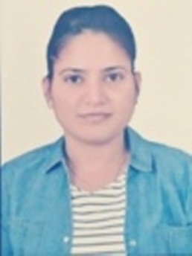

+91-8107925955
ntarameena@gmail.com
W/O Prakash Meena
House no.5, Gulab Vihar Vistar,
near TATA Power Plant and JVVNL Power House
Tonk road, Sanganer, Jaipur
302029

Objective

To associate myself with a professionally run business organization, that has potential for growth – both organizational and personal in the area of Information Science and Technology, and provides sample scope to learn, improvise and implement.

Highlights of Qualifications

- Good professional knowledge of German Language
- Deep knowledge of Web Designing
- Superior co-ordination and team skills

Work Experience

Organization: Concentrix Services Pvt Ltd., Pune (2019-2020)
Role: Advisor I, Email Support - Operations Group
Organization: Dekho network private Limited (2020-2021)
Role: Web developer (.net , Angular)

Organization: Infosys BPM Limited (Nov. 2021-Jan 2023)
Role: Process Executive ( Mortgage Group)

Education

German Language
FLP ACADEMY Marks Obtained – 79%
Concentrix, Pune (MAHA.) Year of Passing – September 2019

Master of Computer Application (MCA)
Suresh gyan vihar school of engineering and technology, Jaipur
Marks obtained: 70.88%
2009-2012
Summer Project on "Xplore Chitchat" which was of 6 months duration. Project consisted of a site and an application.
Front-end used in project: Advanced Java
Back-end used in project: Microsoft SQL Server 2005

Bachelor of Computer Application (BCA)
Board-University of Rajasthan, Jaipur Marks Obtained – 63.72%
College- Engineering college of Bikaner, Bikaner Year of Passing - March 2009

Higher Secondary (H.S.C)
Board – RBSE Marks Obtained -59.54%
School – Lady Algin, Bikaner Year of Passing - March 2006

Secondary (S.S.C)
Board -RBSE Marks Obtained - 68.17%
School - R.T.R.R.U.V. no2 Year of Passing - March 2004

PERSONAL DETAILS

Name: Nayantara Meena
Gender: Female
Date of birth: March 21, 1988
Languages Known: German, English, and Hindi.
Marital status: Married
Interests: Web- Internet Surfing, Gaming, Visiting places of attraction, Sudoku puzzles, Music listening.

