BIO-DATA

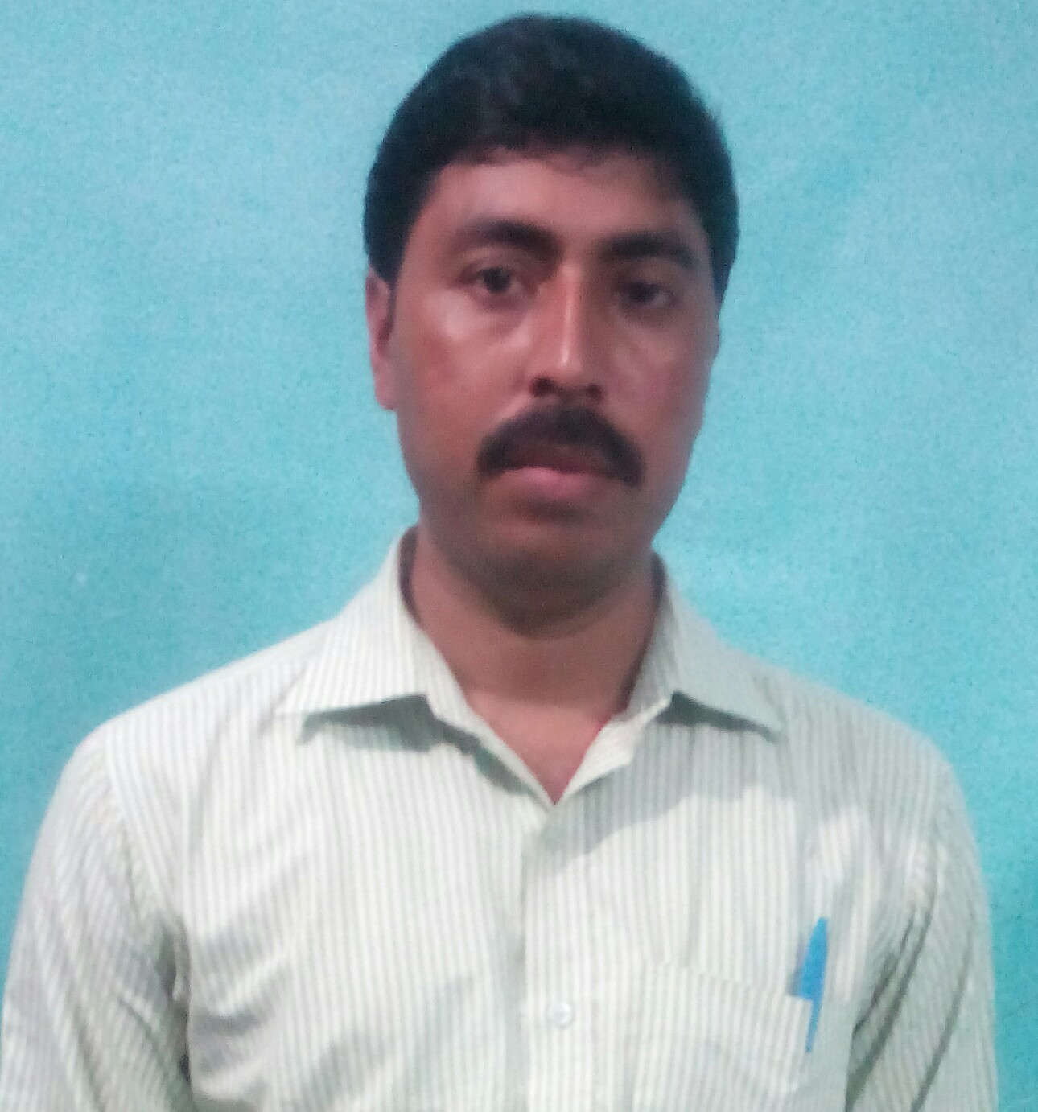
HARISH CHANDRA SINGH
Contact No – 8601222251
E-mail ID – harishsingh556@gmail.com,
harishchandra.singh2@gammonindia.com

CARRIER OBJECTIVES
Objective : A challenging position in an organization where I could enhance my skills in conjunction
with companies goals & objectives.

WORK EXPERIENCE
I have total 9.5 years experience in Construction Company.

PROJECT DETAILS
- Company : Worked at SIMPLEX INFRASTRUCTURES LIMITED , as a Sr. Asst. Store at Noida, Utter Pradesh.
Project : Town Square Shopping Mall Project.
Period : 04.09.2006 to 08.07.2007.

- Company : Worked at SIMPLEX INFRASTRUCTURES LIMITED, as a Store Officer, at P.V. Narsimha Rao Elevated Express Way Corridor Project, NH-7 connecting Banglore Highway in the state of Andhra Pradesh of Hyderabad Urban Development Authority, India’s Longest flyover 11.6 Km.
Project : P.V. Narsimha Rao Elevated Express Way.
Period : 10.07.2007 to 24.08.08.
WORKING RESPONSIBILITIES AT SIMPLEX
• Material Received Issued and Balance Records Maintain Day Wise in Foxpro Programming and reporting to Store Incharge and Commercial Manager.
- Inspection of all receipt material through indent person.
- G.R.N making in Foxpro Programming with Register.
• Ledger register maintain of major material.
- Proper stacking work of receipt material.
- Direct Material Consumption Report Maintain day wise in excel sheet and month wise in Foxpro Programming through billing department. (Example – Concrete Material, TMT Bar, Structural Steel)

- Diesel Consumption Report Day Wise
- Monthly Stock Statement of all Material.
- Maintain of Monthly Vat statement against purchase of material from
Registered Party (Under State & Out of State) and Unregistered Party.
- Maintain of Debit Note issue report for contractor and supplier.
- Material dispatch and receiving report of other site.
- Maintain of Plant and Machinery Stock Report.

- Company : Worked at Gammon India Limited as a Store Officer at Bharat Oman Refinery Limited, Bina Refinery, Dist.- Sagar, Madhya Pradesh.
Project : Cooling Water Treatment Plant. (Cooling Tower)
Period : 01.09.2008 to 30.06.09.
- Company : Worked at Gammon India Limited as a Sr. Officer Store at Gujarat Pipavav Power Company, Dist.- Amreli, Gujarat.
Project : 2 X 350 MW CCPP at Kovaya. (Cooling Tower)
Period : 01.07.09 to 31.10.2011.
- Company : Working at Gammon India Limited as a Executive Store at Anpara- D, Thermal Power Plant, Dist- Sonebhadra, U.P.
Project : 2 X 500 MW ATP (Cooling Tower)
Period : 01.11.2011 to Till Date

WORKING RESPONSIBILITIES AT GAMMON
ALL OVER WORK HANDLING OF STORE AS A STORE INCHARGE WITH MATERIAL PURCHASE:-
- Material Received Issued and Balance Records Maintain Day Wise and reporting to H.O.
- Inspection of all receipt material through indent person.
- Proper stacking work of receipt material.
- G.R.N making in Tally ERP 9 Programming with Register.
- Ledger register maintain of all material.
- Issued Material report of client material day wise.
- Client Billing Material Records Maintain.
- Monthly Stock Statement of all Material.
- Making of Purchase order for issue to party after approved of Comparative Statement from Site Incharge and H.O. for dispatch of material to site.
- Work Order Preparation of hired plant and machinery material for issue to party.

- Direct Material Consumption Report Maintain day wise in excel sheet and month wise in Tally ERP Programming through billing department. (Example – Concrete Material, TMT Bar, Structural Steel)
- Diesel Consumption Report Day Wise.
- Maintain of Debit Note issue report for contractor and supplier.
- Maintain of Reconciliation Paper.
- Maintain of Audit Report.
- Maintain of Plant and Machinery Stock Report.
- Maintain of Monthly Vat statement against purchase of material from
Registered Party (Under State & Out of State) and Unregistered Party.
- Material dispatch and receiving report of other site.

EDUCATIONAL QUALIFICATION
- Metric Passed from Bihar Board in 1996.
- Intermediate Passed from Bihar Intermediate Council in 2000.
- B.A. Passed (Honors with Political Science) from Yadunandan College Chapra Through Jai Prakash University, Bihar in 2005.
- Six Month Diploma in Material Management from National Institute of Labour Education and Management (NILEM) at Chennai in 2008.
- MBA in Supply Chain Management from Sikkim Manipal University in 2013.

OTHER QUALIFICATIONS
- One Year PG Diploma in Computer Application.
- Six Months Accounting Course with Tally.
- Typing Speed in English - 58 w.p.m.

SOFTWARE KNOWLEDGE
- M.S Office
- Foxpro
- Tally ERP 9
- SAP

PERSONAL DETAILS
Father’s Name - Sri Jagdeo Prasad Singh
Date Of Birth - 03-06-1980
Residential Address - Bari Co-operative Colony, Plot No.-125, Post – Sector-12, P.S.- Sector-12, Dist.- Bokaro Steel City, Pin – 827012, Jharkhand.
Marital Status - Married
Language Known - Hindi / English
Religion - Hindu
Nationality - Indian

I hereby declare that all the above information furnished is correct to best of my knowledge and belief.

Place: Anpara (U.P.) ( HARISH CHANDRA SINGH )

