CURRICULUM VITAE

Anisha Dhawan
PMP Certified (Cred Id: 3642309)
Professional Scrum Master1 (Cred Id: 90612)
ICP-ACC Certified
Scrum Fundamental Certified (Cred Id: 943776)
Fundamentals of Agile Project Management Certified
anishadhawan1@gmail.com
+917838223206

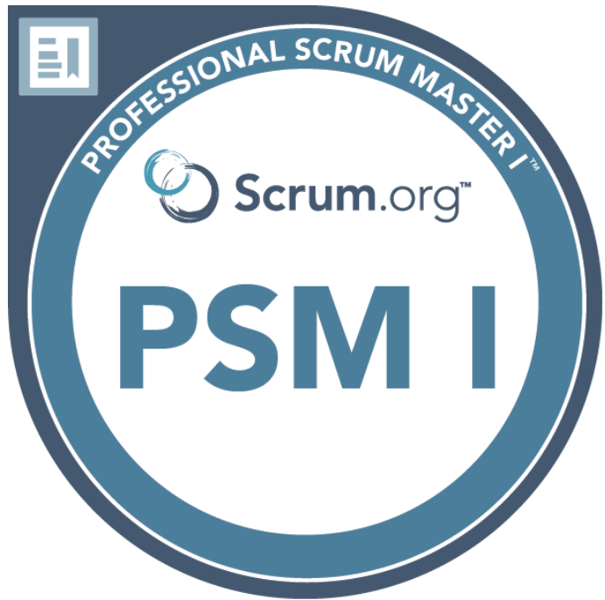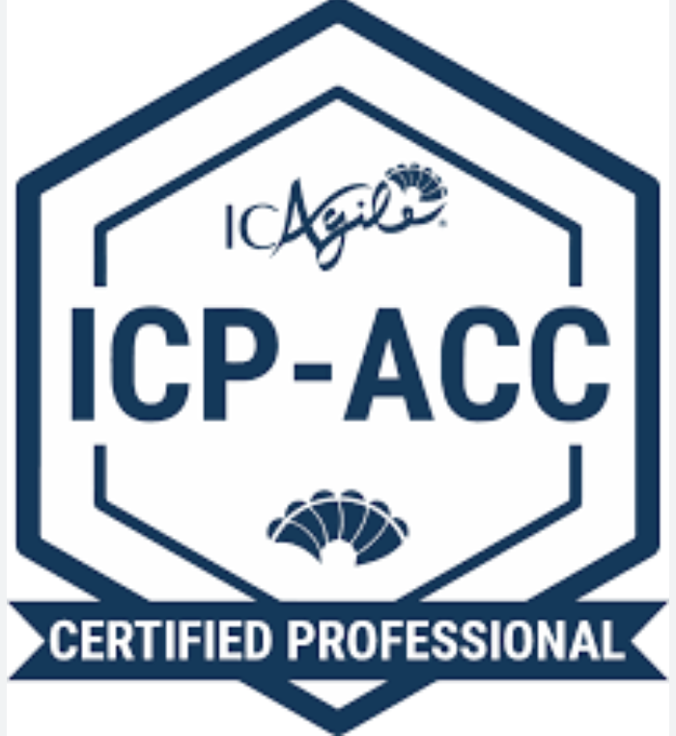

Summary: -
Total Experience: 11 years
Serving Notice Period
- Skilled in leading and managing large, complex project consisting of multiple Agile teams.
- Extensive experience in managing and coaching Agile teams, facilitating Scrum ceremonies and ensuring adherence to Agile best practices.
- Strong communication and leadership skills to collaborate effectively with stakeholders and scrum team.
- Expertise in project planning, resource allocation, risk management, release management, quality assurance.
- Proficient in JIRA, Confluence, MS office, Rally.

Work Experience: -
Current Organization-
Majid Al Futtaim – Carrefour
Served Period- 14th April 2020 to Till Date
Role- Scrum Master/Agile Project Manager

Project Undertaken: Carrefour - Marketplace
Tool & Application Used – JIRA, Confluence, MS office
Highlights –
- Supporting teams on establishing Agile Roles, Scrum Ceremonies, estimations, release management.
- Facilitating core scrum events like sprint planning, Daily scrum, Sprint Review, Sprint Retrospective etc.
- Facilitating Product Owners in Product Visioning, Backlog Prioritization in order to maximize product value.
- Mentored team to identify the impediments and supported team to resolve them and focused on empowering self-organizing and cross functional team.
- Facilitating Scrum of Scrum (SoS) in resolving blockers.
- Keep track of team velocity and Burndown charts.
- Share Sprint report to stakeholders or clients.
- Facilitate scrum teams in conducting the quarterly PI Planning, dependency discussions.

Previous Organization-
Accenture Services Pvt. Ltd.
Served Period- 28th Nov. 2017 to 11th April 2020
Role- Senior Test Engineering Analyst/Acting Scrum Master

Project Undertaken: Ecommerce Client for Middle East
Tool & Application Used – Postman, JIRA, Bitbucket, Jenkins, Confluence, TestRail, Hybris, Azure, API, SQL
Highlights -
- Facilitating scrum ceremonies like sprint planning, Daily scrum etc.
- Helping team to remove impediments.
- Involved in creating new hire training plans and providing process training to them.
- Creating Test plans for project.
- Discussing and finalizing requirement with business and other teams.
- Responsible for API test case writing and execution using POSTMAN
- Skilled in SAP Hybris, API Test & Functional API Test Automation.
- Well versed with Junit, Maven, Bit Bucket, Git, Jenkins.
- Worked for 2 months on client location i.e. Dubai

Project Undertaken: Global Hotel Chain
Tools & Applications Used- Postman, Rally, CADevTest, SOAPUI , Bitbucket, Jenkins, GIT
Highlights -
- Involved in RESTful API testing.
- Automation of webservices using CADevTest tool
- Agile methodology is used with Rally, JIRA

Project Undertaken: Energy and Oil based Client
Tools & Applications Used- Salesforce, Microsoft Navision, Team Foundation Server, WinDMS
Highlights -
- Involved in System, Integration, Regression Testing and Retesting, API Testing, REST web services.
- Responsible for covering gaps in Functional Design Specifications and requirements/business rules.
- Analyzing system and business requirement documents and developing test scenarios.
- Creating and executing detailed test cases.
- Defect logged and managed in TFS (Team Foundation Server)
- Co-ordinated with users and multiple vendor teams to analyze root cause of the issue and provide possible resolution.
- Created and maintained Requirements Traceability Matrix (RTM).

Carlson Wagonlit Travel
Served Period: 1st June 2016 to 23rd Nov’2017
Designation: Business Solution Specialist
Tools Used: HP QC, Rally, SQL Server.

Project Undertaken: Power Advantage
It is a web based application developed and used by the internal customers across the globe to measure and evaluate the performance of Teams. The project aimed at implementing Travel and HR related Tools and Products to enhance the business.
Highlights -
- Involved in Functional Testing, Retesting, Regression Testing, Smoke Testing etc.
- Writing & Executing Test scenario and Test cases as per the Acceptance criteria mentioned in the user stories.
- Logging and tracking the defects in HP QC.
- Data Testing from database by writing and executing SQL queries.
- Involved in all Scrum activities like product backlog meeting, sprint planning meeting, daily stand up and retrospective meeting.

Mercer Consulting India Pvt. Ltd.
Served Period: 12th August 2013 - 27th May 2016
Designation: Lead Implementation Analyst
Tools Used: Benefit Workstation (BW), Infomaker, CR Database

Projects Undertaken-
Clients: UHG, Kaiser, Family Dollar etc.
Domain: Health and Benefits
It delivers innovative solutions that address the health and wellness needs of clients and their employees. It relieves the client’s headache of running a benefits program: cost increases, administrative burdens, pension risks and legislative issues.
Highlights -
- Involved in smoke testing, functional testing on web applications to verify the expected & actual results.
- Extracting test data from database using SQL queries.
- Writing and Executing Test Cases and Defect logging and Retesting the bugs.
- RTM (Requirement Traceability Matrix): Mapping the requirements to the Test cases.
- Preparing Test summary report.
- Working with project team members to produce standard procedure/documentation.
- Engaged in reporting for business specific purpose by using various methodologies like MIS, Monthly or Weekly reports etc.

QL2 Software India Pvt. Ltd.
Served Period: 3rd September 2012 - 7th August 2013
Designation: Application Developer
Software & Tools used: WEBQL, MS Excel, Testing platform: - Nutmeg, Stage and Client Center

Roles & Responsibilities-
- Develops new real time research projects and handles provides ongoing support as well.

Educational Qualifications:-
- B.Tech (Information Technology) (2008-2012) from Gurgaon Institute of Technology & Management affiliated with Maharshi Dayanand University, Rohtak (Haryana) with an aggregate of 75.1%.
- 10+2 from Saint Sophia Senior Secondary School, Hisar (C.B.S.E) in 2008 with 76.3%.
- 10th from Saint Paul High School, Hisar (H.B.S.E) in 2006 with 89.5%.

Achievements & Strengths:-
- Due to my recognition of work, got opportunity to work onsite i.e. Dubai.
- Received Star of the Month Award in Mercer within 6 months of joining the organization.
- Multiple Sleep Tight awards (Client’s appreciation) from clients.
- Received Bravo Award in CWT within 5 months of joining the organization.
- Ownership and Positive Attitude.
- Ability to give the best result in pressure situations.
- Reliable and Responsible.

Personal Details:-
Anisha Dhawan DOB: Dec 19, 1991
Father’s Name: Bishamber Dayal Marital Status: Single
Permanent Address: 62-E, Jawahar Nagar, Hisar, Haryana (125001) Sex: Female

I hereby declare that all the information provided here are correct to the best of my knowledge.
Date:
Place: ANISHA DHAWAN

