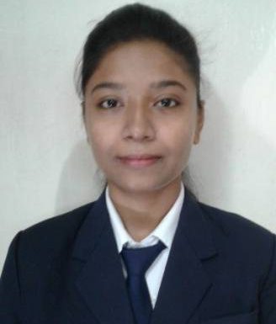
RESUME

DIPSIKHA CHOUDHURY Email:shikha.dip624@gmail.com
Phone: +919073076511

CAREER OBJECTIVE
To secure a position in a technical sector where I can use my potential to give valuable contribution from an individual level to the organization and the ability to take new challenges amidst varied opportunities with all the experience gathered in past years with and more to gain.

EDUCATIONAL QUALIFICATIONS

Course (Stream)/Examination | Institution/University | Month/ Year of Passing
B.Tech (CS) | Pailan College Of Management& Technology  Board: M.A.K.A.U.T(W.B) | 2017
12th(Higher Secondary) | Kendriya Vidyalaya Ballygunge  Board: C.B.S.E | 2013
10th (Secondary) | Kendriya Vidyalaya Sevoke Road  Board: C.B.S.E | 2011

HOBBIES AND INTEREST

Outdoor Games, Reading

PERSONAL VITAE

Date of Birth : 25th April 1995
Address : Block-A,Flat-1B, “Eden Tolly Lakeside”, M.G.Road, Kolkata- 700104
Nationality : Indian
Language Known : English, Hindi, Bengali

WORK EXPERIENCE
Organization- WIPRO
Process- British Telecom
Designation- Senior Associate
Tenurity- 2year 4months

I joined Wipro on August 29th 2017 as an Associate for the process British Telecom During my journey of 2 years and 2 months in Wipro I came across different people with different skills which helped me to enhance my skills, especially to work as a team towards a single goal and to achieve it which I learnt while working in this organization to excel in my job role and yet more to learn and explore.

Organization- Cognizant
Process- TJX
Designation- Senior Systems Engineer
Tenurity - 2 years and 8 months
With my previous experience I joined Cognizant on October 24th 2019 as a Sr.Systems Engineer for the project TJX . Through my journey of more than 2 years in this project I have always tried to put more effort in my domain of job which is incident management and extract greater scope of opportunities from the same.

Promoted as an Associate (Technical Lead) by the company.

Process- BWW (BUFFALO WILD WINGS)
Designation- Tech Lead
Now Presently, working with BWW (BUFFALO WILD WINGS) in change and release management.

OCCUPATIONAL SKILLS
Basic Networking, Troubleshooting Network related issues, Troubleshooting Devices like servers, switches, remote desktops, providing resolution to keep the business up and running. Previously involved in giving away training sessions to new folks or on new upgrades introduced in the project, handling escalated issues efficiently, priority-based issues.

Actively, engaged in actioning tasks, incidents, POS refresh as a part of deliverables.

CERTIFICATION
Completed 12month certification course Data Science and Decision Science from IIT Delhi.
Aspiring to do more such certifications and higher education in similar domain.

DECLARATION
I, hereby declare that all the information made are true and correct to the best of my knowledge and belief.

Place: Kolkata

