SHAILENDRA TRIPATHI
_____________________________________________________________________________________
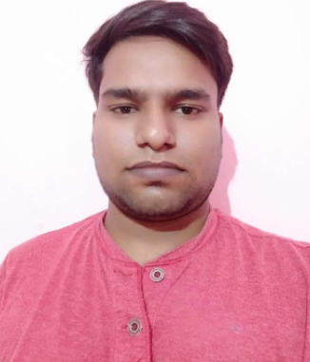
Contact No. 9936371516/9936697638
E-mail: Shailendratripathi429@gmail.com
Passport Number N603490

CAREER OBJECTIVE

To Gain Knowledge, Comprehend it, & apply it for The Profitability of The Organization
EDUCATIONAL QUALIFICATION
- Pursuing MBA from SWAMIVIVEKANAND University.
- B.COM from U.P, Board.
- 12th from U.P. Board
- 10th from U.P. Board.
TECHNICAL SKILLS
- Microsoft office products (Word, Excel), Internet Explorer, Google Chrome, Microsoft Paint.
CORE COMPETENCIES
- Operations, Sales & Business Development
- Responsible for Demand Fore casting as per Market Trends & Ensuring Optimum Inventory levels to meet the Market’s Requirement.
- Creating a Dynamic Environment through which more Sale Opportunities are being Generated and It also Motivates Staff’s & there Competency level so they give their Top Performance.
JOB RESPONSIBILITY
- Maintaining All The Reports, TOP & Bottom Line Analysis, Customer Service.
- Ensuring the Proper Replenishment, Inventory planning & Products pricing management.
- Maintaining the Departments Hygiene & Ensuring the Proper Signage’s Posters, layout planet.
- Coordinating with Category Team & Warehouse to get Stock on time
PROFFESIONAL EXPERIENCE
- A dynamic professional with 4 years of rich experience in Retail Operations, Customer Service.
- Presently Work with MODI NECHURAL PVT. LTD.
- An Effective Communicator with Excellent Relationship building & Interpersonal Skills, Having Strong analytical, problem solving abilities & Possess a Flexible Attitude.
STRENGTH
- Passionate, Adaptability Hardworking &Ready to accept challenges
- Have worked in multi-cultural Environment.

PERSONAL INFORMATION
Name : Shailendra. Tripathi
Father’s Name : Harish Ram Tripathi
Date of Birth : 5th August 1996
Marital Status : Unmarried
Blood Group : B+
Nationality : Indian
Language known : Hindi, English
Permanent Address : Vill+Post Thokwa
Dist-Basti (U.P.)
272171.
DECLARATION
I hereby declare that the above information are true to the best of my knowledge and believe.

Date:
Place:
(Shailendra Tripathi)

