Asok kumar PR
MOB- 9495320193, Mail –prasokkumar@gmail.com
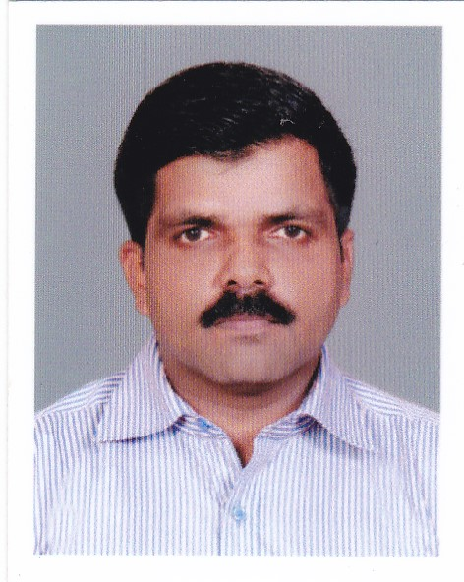
RESUME

Career Objective
I am a veteran and a luminous of the Indian Air Force. The force has inculcated in me a never say die approach… Soldiers never die, they wither away, I wish to prove it wrong…by obtaining a challenging role in the corporate world with a dynamic organization that enables me to utilize and enhance my skills and experience. Also, I am highly motivated with a flexible approach in a time-sensitive environment to respond quickly and effectively to unanticipated high workloads, events and emergencies.

Experience
(Mar 2022 to 20-01-2023 ) – Regional Manager-Administration, Muthoottu Mini Financiers Ltd, Madurai Zone, Tamilnadu
● Responsible for all the administrative activities of Zone.
i) Setting up new branches in suitable locations starting from identifying the location.
ii) Recruitment of staff.
iii) Coordinating all complaints related to the branches with Corporate Office.
iv) Handling all type of audit objections to clear in time.
v) Monitoring all documentations related to the branches.
vi) Additional charge of RM-BD of Trichy region to look after the complete business activities of the region.

(Oct 2019 to Feb 2022 ) – Senior Development Manager, Muthoot Mercantile Ltd, Trivandrum.

● Responsible for overall business development of the company.
● Dealing with all type of investments NCD, SD & FDs
● To monitor the Gold loan to avoid overdue and ensure timely closing without any financial loss to the company. Also to cross check and ensure the quality of gold received in branches.
● Responsible for opening of new branches in different regions in the country.
i) Site identification and finalization by accessing the market potential by visiting sometime personally every region.
ii) Responsible for Infrastructure and manpower recruitment of new locations.
iii) Conducting training and motivational classes for the staff in all over the region.
● Is responsible for giving induction training to staff in all regions.
● Monitoring branch activities including Administration, Business process, Marketing, Accessing the staffs, Housekeeping etc.
(Jun 2019 to Oct 2019) – Marketing& Sales manager, Bajaj Automobiles agency, Trivandrum.
(Nov 2017 to Apr 2019) – Meridian Technology, Trivandrum (Customer Relation Manager)
● An authorized service Franchise of Adonis Electronics Pvt Ltd.
● Was responsible for coordinating with company to ensure 100% customer satisfaction for the service provided.
● Key areas were,* proper man power deployment,*ensuring correct utilization of materials to rectify the customer issues,* Ensure dealer satisfaction to keep the company on top in the market.
(Nov 2014 to Sep 2017)- Mirrikh Contracting WLL, Doha, Qatar (Store Manager)
● A construction company dealing with all major projects of Qatar Government (Kaharamma, Ashgal and Q-Tel).
● Key activities are Procurement monitoring, Demand Analysis, Stores Audit, Stores Accounting, Inventory Management, Warehousing, Transportation, and Documentation for inbound / outbound Logistics. Forecasting the requirement as per the schedule to ensure timely completion of projects.
● To ensure procurement of materials from outside sources and local market.
● Liaison with suppliers for shipment of materials and its clearance with proper Supply chain management
● Ensure distribution and proper accounting of stock to avoid any loss to the company.
● Ensuring warehouse activities are managed with thorough perfection.

(Jun 2010 to Oct 2014)- Adonis Electronics Pvt Ltd (Authorized Service franchise of Onida and JVC) - (Service Manager)

● An authorized service Franchise of Adonis Electronics Pvt Ltd.
● Was responsible for coordinating with company to ensure 100% customer satisfaction for the service provided.
● Key areas were, * proper man power deployment, *ensuring correct utilization of materials to rectify the customer issues, * Ensure dealer satisfaction to keep the company on top in the market.
● Responsible for HR management, Inventory management and customer satisfaction.
(Apr 1990 to Apr 2010)- Indian Airforce as Senior NCO in charge of Logistics.

Thorough knowledge and experience in the area of Logistics function and office correspondence at Higher Formations and Station/Unit level. Other jobs performed include dealing with audit queries and objections, processing and settlement of such objections within stipulated time frame. As a supervisor, managed internal auditing, guided subordinates, and overseen effective and smooth functioning of the department, ensured discipline of staff .Looked after overall administration of the Logistics Department with utmost perfection.
Areas of interests
Logistics and Inventory Management
Accounting Management
Human resources & Administration Management
Security Management.
Mess Accounting & Administrative Management
Event management
Strength & Capability
*20 years of experience in the Indian Air Force (Logistics, HR & Admin) and 11 years in private companies.
*A good team player and Never shy from responsibilities,
*Can give long hours, Can juggle multiple projects,
*Can adapt to diverse cultures,
*Conversant with computers,
*Posses effective Communication skill, Conversant with English, Hindi and Tamil.
*Liaison and excellent public relations, Keen learner and sharing with sub-ordinates
*Can oversee the implementation of corporate policies.
*Can ensure optimum and effective utilization of resources, forecast of budgetary requirements, plan and monitor of the same
*Can plan and organize the conduct of major events in coordination with external agencies.
*Can oversee management of large group of personnel entailing recruitment, orientation, performance review, appraisal and career development.
*Supervision and management of Fire and Safety measures

Courses undergone during the Military service
● Warrant Officer Leadership Course - Year 2004
Subjects- Management, Air Force Law, Computer Science, Public speaking and Flight and maintenance safety

Personal Profile
Qualification
 | Logistics Management Course From Admin Training Institute, Indian Air Force, Belgaum | 1990 - 1991
GRADUATION | Department of Personal & Training, Govt of India | 2010
SSLC | Department of Education Govt of Keara (India) | 1988

IT Skills: Operating Systems: Windows, Excel. Was using IMMOLS (Developed by TCS&DRDO) AT IAF
○ Date of birth : 17 Mar 1973
○ Language known : Malayalam, English, Hindi & Tamil
○ Passport : Republic of India (H9873274)
○ Contact No : 0091 9495320193
○ Height : 162 cm

PERMANENT ADDRESS
PGRA- F/6,
‘HARIGOKULAM’
THOPPUVILAKAM
POWDIKONAM PO
THIRUVANANTHAPURAM Asok kumar PR

