Dipak Gupta Mobile: 91+ 9821819856 E-Mail: dipakgupta2008@gmail.com
9968204074
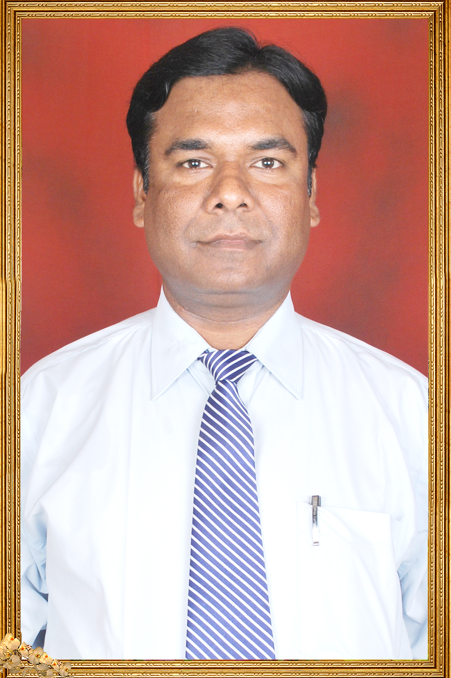

Seeking assignments in Financial Analysis/ Finance & Accounts/ Budgeting & MIS with an organisation of repute.

Summary
- Professional around 15 years of experience in Financial Analysis, Finance & Accounts and Budgeting & MIS.
- Expertise in handling Accounts & Finance activities encompassing preparation of Accounts, Reconciliation Statements leading to finalization of accounts.
- Proficient at managing & leading teams for running successful process operations & experience of developing procedures, service standards for business excellence.
- Possess excellent interpersonal, communication and organizational skills with proven abilities in team management, customer relationship management and planning.

Areas of Exposure
Accounting
- Knowledge in US Gaap (Generally Accepted Accounting Principles) & IFRS (International Financial Reporting Standards)
- Review and Monitoring of computerized books of Account maintained by team member.
- Review and controls on Reconciliation e.g. Bank, Debtors, Creditors
- Review of Maintenance of Pay Rolls by team members further provide approval for processing for salary disbursement
- Preparation and Assisting in Finalization of Balance Sheet & Profit & Loss Accounts
- All work related to PF, ESI

Finance
- Presenting & reporting accurate & timely historical financial information of the company.
- Responsible for the review & root cause analysis of the reconciliation and related journal entries including posting and verification of the entries to the general ledger.
- Maintaining Cash Book and Ledger of different parties.
- To reconcile bank statement with company books and rectify causes of differences etc.

Corporate Taxation
- Preparation & Filling of TDS Return, PF, ESI and others.
- Preparation & Filing of Goods and Service Tax Returns, Review GLS impacting GST Account.
- Preparation and estimation of Advance Tax, review and check all deposited tax impact as per computation.
Audit
- Coordination with Internal Auditor & Statutory Auditors
- All type of internal audit, External Audit, Statutory Audit, Revenue audit
- Finance Procurement, Project Report and Bank work Monitoring

MIS
- Monthly Balance Sheet and Profit & Loss Accounts
- Costing statement for each product
- Variance report (Actual costing with standard costing)
- Ageing statement â€“Debtors, Creditors, Inventory (RM, FG, WIP)
- Presentation of Financial Ratios
- Annual Budget

Project & planning work
- Project and planning work under HPCL under Central Government for SSRU, BBU, ISBL & Road and Drain work.
- Projecting & planning business work through BNI (Business Networking International).
- Projecting business & receiving business through Indiamart.com a registered businessmart.com
- Receiving business calls through business indiamart.com & reporting to party through this indiabusinessmart.com.
- Assisting in Preparation of Projected & Provisional Balance Sheet
- Dealing with all departments for all type of business function.
- Getting statutory form from GST Tax Department.
- Coordination with bank for various works.
- Maintenance of accounts in a computerized environment.

Cash Management, Fund Management
- Managing fund flow through bank loan by submitting all required documents
- Receiving cash through parties, Fund through Cheque, NEFT & RTGS
- Monitoring & controlling of all accounting activities like cash management, Bill Processing, Bills receivable, Fund Management at unit level, Foreign Exchange/Loss, Bank Reconciliation, Salary Wages, TDS, PF, Reconciliation of control accounts like Insurance, PF, Advance & Loan to employee, etc.

Auditing Experience
Achievements on executing Auditing of Hindustan Unilever Ltd.
Auditing executed of guest house at Vasant vihar, Defence colony and Lakme House Ladies Beauty parlour saloon at vasant vihar under kacchal & company (Chartered Accountant Firm) at Laxmi Nager on 15th February 2003 -30th December 2003.

Modi Flour Mill Ltd 10th March 2021 to 31st March 2022

(Senior Accounts Manager)
Skill Horizon 8th March 2018- 30th jan 2021
(Senior Accounts Manager)

ANS CONSTRUCTION PVT LTD 12th March 2009 – 30th December 2017
(Senior Accounts Manager )
ANS CONSTRUCTION PVT LTD is setup in Tuglagabad in Delhi being as its Head Office. The company is absorbed in government projects , private projects, industial cum residenrial projects, corporate office, Mall, Government Universities, collges, schools, stadium and superspeciality hospitals etc. At present the company is under work constuction HPCL as project for SSRU, ISBL, BBU, Road and drain work at Bhatinda district in Punjab state . The company is engaged in Bangalore project, Hyderabad project, Chandigarh project. Silvasa project etc.

Thirupathy Bright Industries 5th January 2005 - 25th December 2008
(Accounts Officer)
Thirupathy Bright Industries is established in 6/1 & 6/3 NULAMBUR ROAD, AYANAMBAKKAM via MADHURAVAYA.(OFF: VANAGARAM ROAD, ATHIPET) MADRAS-602102 .It is a sole-proprietor firm. Of bright section of steel bars. Its total number of staffs is under supervision.

Educational Qualification

- Master of Business Administration (Chandigarh University) Under study
- B.Com from University of Kalyani/west Bengal.
- 12th (Commerce) from west Bengal council of Higher secondary Education/west Bengal
- 10th from west Bengal Board of secondary Education/west Bengal

IT Skill
- Tally ERP9 (Software Accounting) Graduated in 2005 from SaraswatiAccountant, Janakpuri/New Delhi.
- Busy Software Accounting worked as experience.
- Marg software Accounting worked as experience.
- Ginesys Business Accounting software worked as experience.
- Certified Diploma in Computer Application from palam colony/New Delhi.2005
- Corporate Tax Law from Saraswati Accountant.Janakpuri/New Delhi.2005

Vocational skill
- Typing speed 40 words per minute from Modern commercial Institute /west Bengal.

Personal Dossier

- Date of Birth : 13th January, 1966.

- Father’s Name : Late Shree Ram Narayan Gupta .

- Correspondence Address : Pole No-177, Dada Dev Mandir Road, Raj Nager Part-II

Palam, New Delhi-110077

- Permanent Address : 35 /A M.C.Mitra Road,PO: Hazinager
Distt :( North) 24 Parganas,Pin -743135.
West Bengal
- Nationality : Indian
- Religion : Hinduism
- Marital Status : Married
- Languages Known : English, Hindi, Bangala
- Favourite Hobbies : watching news on TV.
- Personality Development : Smart, devoted to work, diligent, disciplined, punctual.
- Reference : On demand
- Relocation Facility : If company fulfils all facilities, no objection in relocation.
- Passport Facility : yes. :
- Notice period : Maximum one week only.
- Salary Drawn : Rs 8,00,000 /- Per Annum CTC.
- Salary Expected : As per company norms.

Date 22nd june,2023 (Dipak Gupta)
Place :- Palam colony , New D

