CURRICULAM VITAE

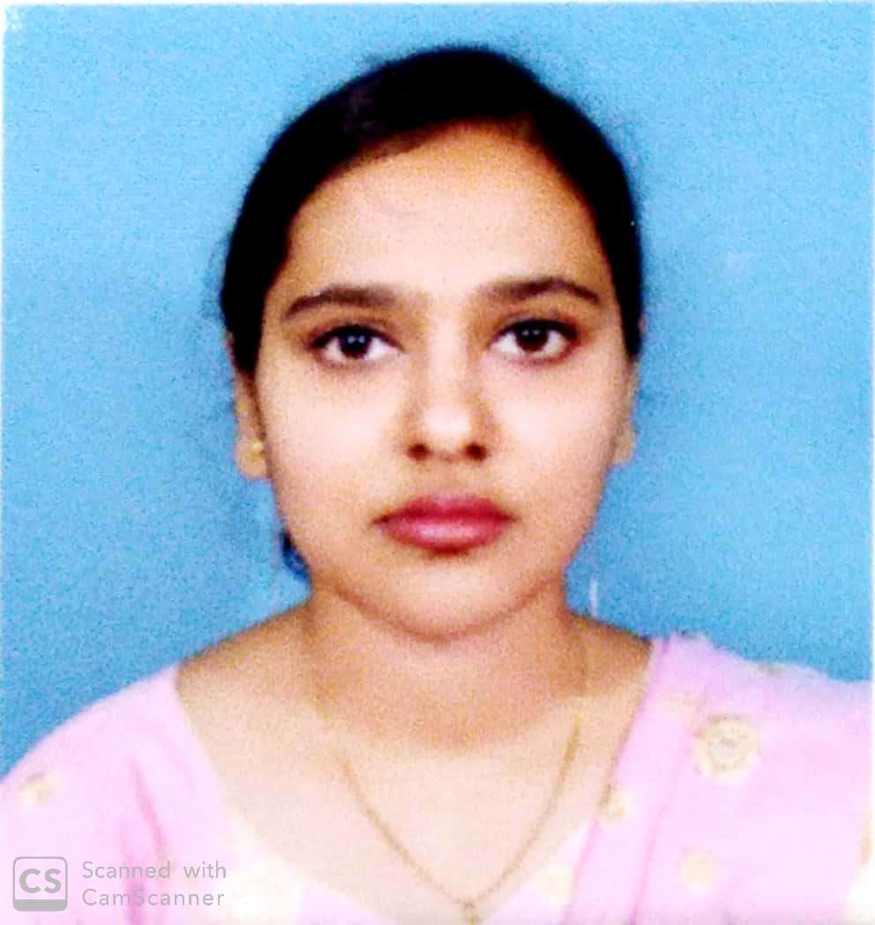
PERSONAL VITAE

Name : ANUSHREE GHOSH HOULY
Date of Birth : 21.10.1993
Address : Flat no. – 401, Shristi Abasan, Kalipark, Bablatala,
P.O-Rajarhat, Gopalpur, Newtown, Kolkata-700136
Father’s Name : ASIT KUMAR GHOSH
Mother’s Name : MANASI GHOSH
Husband’s Name : Bikram Houly
Gender : FEMALE
Language Known : ENGLISH, HINDI AND BENGALI
E-mail : anushreeghosh1993@gmail.com
Phone : 9073216235

CAREER OBJECTIVE: Enthusiastically work for an organization for its development and enhance my own skills and knowledge.
EDUCATIONAL QUALIFICATIONS:

Course (Stream)/Examination | Institution/University | Month/ Year of Passing | Performance
10th(CBSE) | K.V.C.I.S.F THAKKOLAM, ARRAKONAM, TAMIL NADU | MAY,2009 | 74%
12th(CBSE) | K.V.C.I.S.F THAKKOLAM, ARRAKONAM, TAMIL NADU | MAY 2011 | 74%
B.Sc(Life sciences) | BHARATIYA VIDYA BHAVAN’S, VIVEKANANDA COLLEGE, SAINIKPURI,SECUNDERABAD | JULY 2014 | 77%
B.Ed(Biological sciences) | NAVABHARATHI COLLEGE OF EDUCATION,BOLLARUM,SECUNDERABAD | OCTOBER,2015 | 82%
M.Sc(Biotechnology) | JIS UNIVERSITY,81,NILGUNJ ROAD,AGARPARA,KOLKATA-700109 | JULY,2018 | 84%

AWARDS & ACHIEVEMENTS: ALL INDIA TOPER IN HINDI IN AISSCE EXAMINATION 2011 SECURED 98% MARKS IN HINDI.

AWARDED WITH CBSE MERIT CERTIFICATE FOR BEING AMONG THE TOP 0.1 PERCENT OF SUCCESSFUL CANDIDATES.

AWARDED WITH SILVER MEDAL BY JIS UNIVERSITY FOR SCORING OUTSTANDING MARKS IN M.SC (BIOTECHNOLOGY).

CERTIFIED INTERNATIONAL TRADE EXPERT.

COMPUTER PROFICIENCY: 1. TRAINED IN C++ LANGUAGE.
2. GOOD SKILLS IN M.S EXCEL AND OFFICE

KEY SKILLS: Powerpoint, Project Management, Management, Marketing, Microsoft Excel, Excel, Microsoft Word, Word.

SCIENTIFIC TECHNIQUES KNOWN:

MICROBIAL TECHNIQUES: Media preparation, PLATING, STAINING of organism, STREAKING.
Immunological TECHNIQUES: ELISA, RIA.
BIOCHEMICAL TECHNIQUES: PROTIEN ESTIMATION, BUFFER PREPARATION.
Molecular TECHNIQUES: Electrophoresis, Isolation of DNA, PCR.
CHROMOTOGRAPHY TECHNIQUE: TLC.

PROJECT:

PRODUCTION OF AMINO ACIDS FROM RECALCITRANT SOLID WASTES.

TEACHING EXPERIENCE:

: 1. FOUR MONTHS OF TEACHING EXPERIENCE AS A GUEST LECTURER IN JIS UNIVERSITY.

2. WORKED AS AN ASSISTANT TEACHER FROM 2019 – 2021 IN TECHNO INDIA GROUP PUBLIC SCHOOL, KRISHNANAGAR.SERVED AS A Teacher -in - Charge.

INTERESTS & ACTIVITIES: SINGING, LISTENING TO MUSIC, READING BOOKS, READING ARTICLES

I hereby declare that all the particulars given above are true to the best of my Knowledge.
