CURRICULAM VITAE
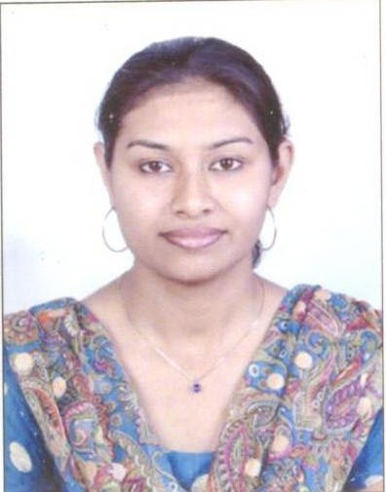

Shweta Khan
SS Survey no-122/1,Gurudatt colony no-4,
Near Datt Mandir,Walhekarwadi,
Chinchwadgaon,Pune-33
shwetas_1986@rediffmail.com
Mob- +91 9130247557/9820785761.
CAREER OBJECTIVE:
Looking Forward for a Challenging and Significant Career, to Work in Professional
Environment Where I can enrich my Skills and Work towards the Organizational goals.
STRENGTHS:
Effective communication skills and good analytical and decision making ability. Dedicated to Professional and highly motivated towards target achievements. Having the ability to complete the given task. Positive attitude, Friendliness and Flexibility and achieve in success in job.

EDUCATIONAL & TECHNICAL QUALIFICATIN:
❖ COMPLETED BACHELOR OF ARTS (SOCIOLOGY) DEGREE FROM PUNE
UNIVERSITY

   COMPLETED MASTER OF ARTS DEGREE IN (SOCIOLOGY) FROM
PUNE UNIVERSITY
❖ COMPLETED B.ED SPECIAL IN HINDI AND GEOGRAPHY FROM PUNE UNIVERSITY
❖ CERTIFICATE COURSE IN OFFICE AUTOMATION

SPORTS AWARDS AND CERTIFICATES:

- Year-1997 to 2000:- Regional Sports Certificates of Merit.
Athletics: - 100mts, 200mts, 400mts and Long Jump. (15 Certificates Awarded)

- Year-2000 to 2008:- Regional Sports Certificates of Merit.
Athletics: - 100mts, 200mts, and Long Jump. (06 Certificates Awarded)

- National Athletics Certificates:-
(04 Certificates Awarded in the year 2003 to 2004)

- Awards:-

  - N.S.S Certificate Year 2005.
  - National Seminar on Theatre: - Text and Performance Year 2007
  - Workshop on “Developing NGO Skills” Year 2006.
  - Lonavala Kondhavadi Caves Trek Year 2004.
  - Government of Maharashtra Civil Defense Corps.
  - Pune Certificate of Basic Training in the Year 2006.

- IIIrd Common Wealth Youth Games 2008 as a Volunteer Held in Pune.

- Worked with Saraswati Vishwa Vidyalya as a Hindi teacher and Hindi Head of the Department in the year 2014-15 (TGT-Hindi and S.S.T)

- Worked With Podar International School Chinchwad as a Primary Teacher in the year 2015-16.(PRT)

- Worked with Pratibha International School, Chichwad, Pune, As a TGT- Hindi for 1year.(Std-VIII,IX,X) For Academic Year-2017-18.

PERSONAL DETAILS:
- DATE OF BIRTH: 24TH Sep 1986

- MARTIAL STATUS: MARRIED

- GENDER – FEMALE

HOBBIES:
- TEACHING

- READING

- SPORTS

- DRAWING

DECLARATION:

I am very Much Confident of my Skills to work in a Team.

I Hereby Declare, that all the above given Information are True to the Best of my knowledge.

DATE: ____________ SIGNATURE
PLACE: ____________

