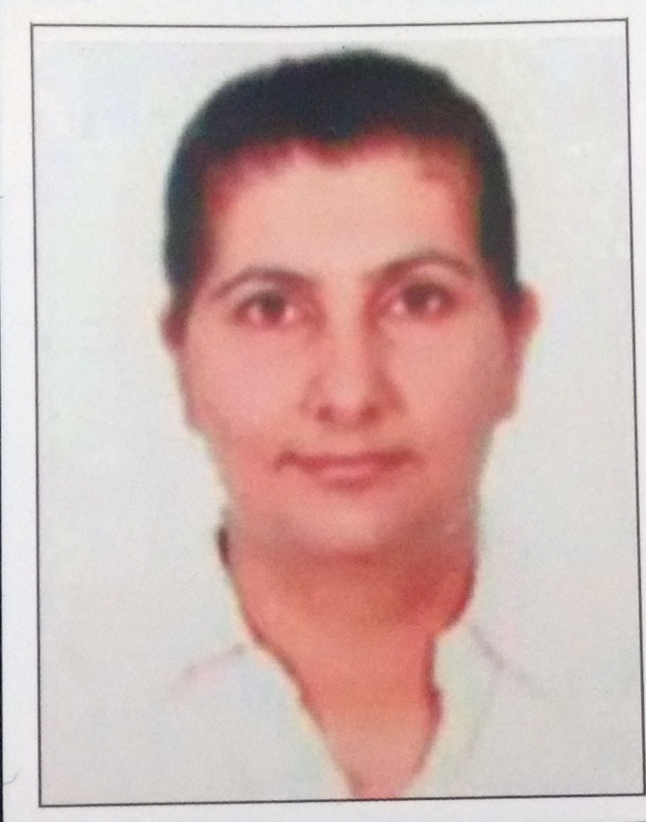
Major Meenakshi
(Veteran Armed Forces)

Mobile: +91-9540734173 /E-Mail: miniint007@yahoo.in / Current Job Location- New Delhi, India
Aiming to be associated with a dynamic, growth-oriented professional organization in corporate; in General Administration, Security Operations, Logistics, Intelligence acquisition & Human Resource Management.

Current Engagement - Freelancer trainer and counselor.

ACADEMIA

Ph.D. in Human Right ( Climatic changes ).
P.G in Human Rights - IIHR - 2010.
Master of Mass Communication) – KU - 2002.
P.G in Journalism and Mass Communication - GJU - 2001.
GNIIT - NIIT - 1999.
B.Com. - 1997.

CERTIFICATION & TRAINING

Trained in women safety and self defense techniques
Workshop for women self defense empowerment (Sensei Prem Menon – Protection Mania)
(SAIICO) Satellite Imagery Interpretation course for officers– 2009.
Interrogation course for officers - 2006.
(IOC) Intelligence Orientation Course– May 2004.
OTA - Commissioned on 08 March 2003 (Served for 10 years).

LEADERSHIP SUMMARY
Administration Management (Operational, security, Logistics & Human resource)

PR /Media events Training, procurement & welfare

- Accomplished go getter leader; proficient to take up leadership roles in the field of General Administration , Logistics & Security operations, Training ,Media PR events.
- Possess significant experience in handling activities pertaining to operational excellence; skilled in handling the overall administrative control & Security management initiatives. Arranged for necessary infrastructure involving purchase of capital equipment; managed large scale movement of stores & ensuring optimum inventory control.
- Liaising with various departments (administrative Security) authorities for obtaining necessary sanctions and ensured statutory compliances.
- Proven ability to improve operations, impact business growth & maximize profits through achievements in cost reductions, internal control & productivity improvements.
- Interpersonal skills, capable of resolving multiple & complex issues & motivating staff to peak performance. Blend of motivation, leadership and analytical abilities to enhance bottom-line results.

EMPLOYMENT DETAILS

Freelance Trainer / counselor (Feb 2016– Present)

Contributions

- Working as a freelance trainer and consultant with VINSYS for ICICI Bank.
- Working as a motivational trainer, on the panel of suicidal helpline as deterrence counselor.
- Working for publishing house as a proof reader and editor.

Security liaison officer World Cup T 20 /IPL Broadcasting 2016

Contributions
- Worked as Security Liaison Officer for Team England during T20 world cup responsible for handling Security Logistics, Broadcast & administrative profiles.

Staff Officer Commandant DIPAC (Feb 2010 – Jun 2013)

Significant Contributions

- As part of the only space based military Image Analysis Centre in the country, was responsible for Image Intelligence (IMINT) related integrated analytical inputs on Defense matters.
- Carrying out optimum exploitation and payload planning of remote sensing satellites, acquisition/processing of images, and thereafter providing in-depth analysis and value addition to those images for use by the Strategic Community.
- As Imagery Analysts worked on strategic projects for Tri Services and strategic force command.

General Staff Officer (systems) (Apr 2008 – Jan 2010)

Contribution

- Handled procurement of MI equipment (security and surveillance) and office consumables. Instrumental in conducting paperless war game and enhancement of centralized LAN network.
- Welfare of troops, and their families, placed under command.
- Identifying training needs across levels and analysis of the existing level of competencies. Developing training & development initiatives for improved productivity / capability and quality enhancement.

General Staff Officer (Imagery Interpretation Team (Feb 2007 -Apr 2008)

Significant Contributions

- Imagery Interpretation Reports and fly through on google earth of enemy terrain.
- Mobilize Mobile IITs for field exercise and handling and running of Rolta equipment.
- Conducting and security of VVIP Visits of Foreign dignitaries.

Interrogation Officer (9 Corps Counter Intelligence Security Unit (Jul 2006 – Jan 2007)

Significant Contributions

- Officer in charge of Interrogation Cell, Liaison with Civil Intelligence agencies, security cover and debugging of Corps headquarters.
- Officer in charge of special task cell for Investigation, Interrogation, subversion, sabotage and surveillance for the area of responsibility.

Interrogation Officer / Information Warfare (Counter Intelligence Unit (Jul 2003 – Jan 2007)

Significant Contributions

- Officer in charge of Interrogation Cell, Liaison with Civil Intelligence agencies, Carrying out field visit security drills and Intelligence Operations.
- As Public Relations Officer in the Information warfare department of the Army, involved in Organising Media events of the Army, writing and distributing press releases and interaction with representatives of Print & Visual Media
- Assimilation, Collation and analysis of information from open sources including International Media and assessing their strategic implications on the National Security and International Relations. Writing Defense related articles in newspapers etc

EARLY EMPLOYMENTS
- Worked as guest speaker for the Dept. of Journalism and Mass Communication, Imparted training in Personality Development, Interview and GD skills.
- Indian Express and Times of India as Jr Crime reporter. ( 2000-2003)
- Spice Telecom and Synergy International ( 1997 – 2000)

HONOUR & RECOGNITION
Spot commendation for conducting various sports events in 2010.
Commended by Army commander in 2006 for successful conduct of integration of IITs.
Certificate of Appreciation by the Chief of Integrated Defense Staff in Sep 2010.
Gold medal for best speaker in youth parliament
Cross country merit card and swimming blue (Officers Training Academy)
Certified Sea Diver (PADI)

PERSONAL DETAILS
Date of Birth 23th September 1977
Spouse Lt Col Rajeshwar Singh
Present Address Delhi Cantt - 110010

References are available upon request.

