Curriculum Vitaé

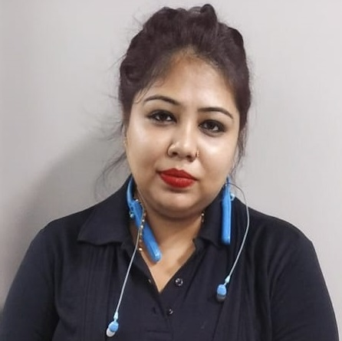

Name : Moubani Bhowmik (Sales Coordinator in MargERP Ltd)

Mobile No : 9674053402

E-mail : moubanibhowmik@gmail.com

Address : 21, Dewangazi Road, Bali, Howrah-711201

Objective : To secure a position with a stable and profitable organization, where I can be a member of a team and utilize my experience to the fullest.

Employment Details:

1.MARG ERP LTD-Recently working in MARG ERP LIMITED as a zonal Sales Coordinator),in house job since 9/2/2020 to till date.(3YRS)

A Competent professional with over 7yrs of experience in sales & marketing in Accounting software and pharma SEGMENT BOTH. and closes business deals and maintain knowledge of current market condition. Build good term relationships with new and existing responsible for serving as a primary liaison between sales department, senior manager, sales team, business partner.

# Currently taking care of channel sales distribution in ASSAM, MANIPUR, TRIPURA, ORISSA, WESTBENGAL, Coordinating the sales team by managing schedules, filling important documents and communicating relevant information. Handles queries, issues from clients and give after sale support.

# Assist sales team by setting monthly goals, takes the team lead to meet sales goals as provided by upper Management. Acts as a liaison between various branches of company and customers.

#Provides ground level feedback to management to make sure customer satisfaction , team working report.

2.Before that I have total 4 yrs of experience in pharmaceutical sales & marketing.

- Emcure pharmaceutical -Since May 2017 to Dec 2018 as a Therapy Manager at Kolkata, Durgapur .

- Cipla India Pvt Ltd. since January, 2015 to april 2017 in Cardio Critical Care Division (Vitalis), Kolkata as a Territory Manager. Mainly worked in Corporate Hospitals Like Apollo, Amri, Columbia, Ils hospital. And small nursing home Like Sanjiboni ,sterling etc

Current Job Responsibility:

- Responsible for serving as the primary liaison between sales department marketing staff, senior managers and channel partners.
- Processing sales Related proposals, contracts to channel distributors in a timely manner.
- Tracking sales order to ensure that they are scheduled and sent out on time.
- Preparing month end sales report for senior managers and also presenting them.
- Participate in tasks like presentation and meeting schedule, client communication, other administrative tasks.
- Answer the queries, settle complaint, maintain a consistent and productive relationship.
- Attend different promotional activity, increased sale of different product, convinced for Sale with knowledge and communication. And follow up the payments from distributors.
- Reporting in excel, coordinating dispatch, follow sales lead, maintaining data.

Responsible for all Admin related work in Marg Kolkata office.

Day to day follow up with existing partners for different activities and support them in resolving their queries. actively working on leads calling, responsible for account development, identifying solutions, strengthens the relationship with existing key accounts.

Achievements:

1)Secure good marks in 10 days training & enhanced scientific skills in Cipla.
2)In 2020 received appreciation for good work in pandemic situation.

3) In 2021 last quarter achieved best zonal coordinator appreciation in PAN India.

4)Recieved Star performer Award in Sep21.

Job Target :
My goal is to become associated with a company where I can utilize my skills and gain further experience while enhancing the company's productivity and reputation.

Academic qualifications :-

Degree / Certificate | Qualification | Institute | Board /  University | Year | Aggregate % / CGPA
Graduation | B.Pharm | Guru Nanak Institute Of Pharmaceutical Science & Technology | West Bengal University of Technology | 2010-2014 | 6.84
12th | Higher Secondary | Ananda Ashrama Sarada Vidyapith For Girls | West Bengal Council For Higher Secondary Education | 2010 | 52.4%
10th | Madhyamik Parikhsha(Secondary Examination) | Ramakrishna Sarada Mission Sister Nivedita Girls School | West Bengal Board Of Secondary Education | 2007 | 72.38%

Trainings:

Name of Institute / Organization | Project Title | Duration
Caplet India Private Limited | Industrial Training(Production and Testing) | 03/06/2013-15/06/2013

- Fluently speak and write in English, Hindi, and Bengali.
- Have basic knowledge in MS words, MS excel, Powerpoint and internet.

Personal Details:

Date of Birth : - 30/05/1990.
Fathers Name : - Ajit Bhowmik.
Mothers Name : - Late Bichitra Bhowmik
Sex : - Female.
Marital Status : - Unmarried.

Declaration :-
I do hereby solely declare that all above information is authentic and true to the best of my knowledge.

Date:-
Place:- kolkata
(MOUBANI BHOWMIK)

