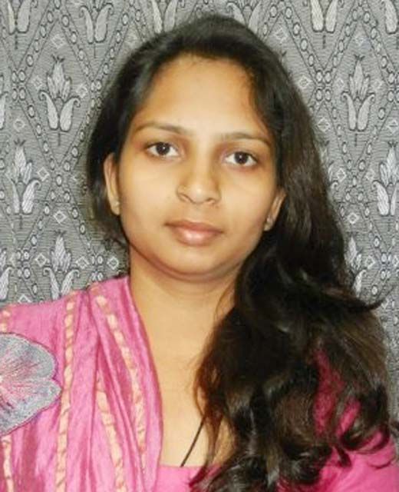
CURRICULAM VITAE

GATI SHARMA
Shahabad Road
Shantipuram Colony
Shanti Nivas Sthal, Bilari
Distt. Moradabad (UP)-244411
Mob. No.:-+918383066833
E-mail :gatisharma48@gmail.com
****************************************************************

Objective:
- To work in Challenging and dynamic environment and contribute to the best of my knowledge & abilities.

Professional Qualification:
- M.B.A. (Human Resource Management & Marketing in minor)

Educational Qualification:
- High School from U.P. Board Allahabad in 2006.
- Intermediate from U.P. Board Allahabad in 2008.
- B.M.S. (Bachelor in Management Sciences) Completed from Lucknow University in 2011.
- M.B.A. (Human Resource Management & Marketing in minor)
- Perusing HRM Generalist course from Protouch.

Extra Qualification:
- Basic Knowledge of Computer.
- Good Command on Marg Software .

Strength:
- Ability to work with team.
- Sincere and honest.
- Enjoy working with people.

Experience:
- Three years Six months experience in H.V.B. Enterprises Allahabad as a H.R. Coordinator.
- Two months experience in Marketing.
- Administrator Two years Eight months experience as Office Administrator in Jaipuria School.
- One year experience as wise Principal in Raja Ranjeet Singh Inter College Bahraich.
- One year six months experience as HR Coordinator in A & A Associates.
- Two years Experience as Head HR in Inventland Research Laboratories BADDI (HIMACHAL PRADESH).
- Currently working in Healthcare as HR HEAD & PPIC Controller. Phrmaroots HEALTHCARE BADDI (HIMACHAL PRADESH).

Personal Details
Name : Gati Sharma
Date of Birth : 02-07-1991
Husbands Name : Mr. Prashant Sharma
Marital Status : Married
Gender : Female
Language Known : Hindi, English
Nationality : Indian
Religion : Hindu
Hobbies : Novel Reading, Driving, Online Games

Declaration:

I here by declare that all above given information is true and correct to my belief and the best of my knowledge.

Date:
Place: BADDI (Gati Sharma)

