Curriculam-Vitae 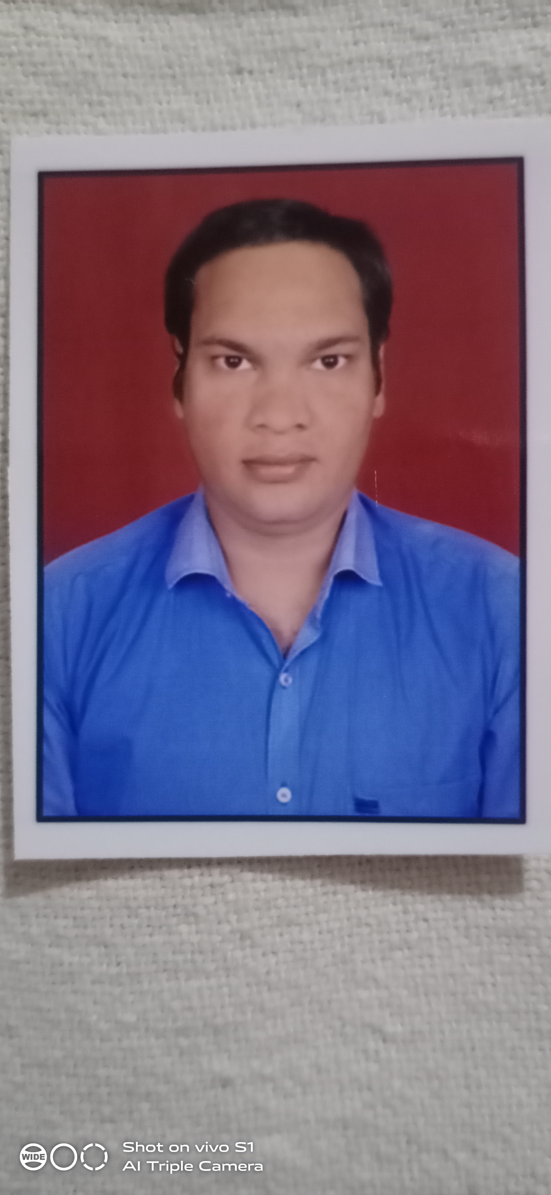

Chandra Prakash Morya
Mangyawas, Mansarovar
Jaipur-302020 (Raj.)

Contact No. +91-9664311765, +91-7688824275
Email ID: chandraprakashmorya3@gmail.com

CAREER OBJECTIVE
To work with progressive and growing organization, so as to enhance my knowledge and sharpen my skills that will help me to reach to better position through my contribution that add a value to the organization.

EDUCATIONAL QUALIFICATION
- Secondary with 45.00% from Rajasthan Board of Secondary Education, Ajmer in 2011.
- Sr. Secondary (Commerce) with 65.80% from Rajasthan Board of Secondary Educaiton, Ajmer in 2013.
- B.A. completed with 42% from University of Rajasthan, Jaipur in 2021.
- M.A. previous with University of rajasthan, Jaipur in 2022.

PROFESSIONAL QUALIFICATION
- Diploma in Electrical Engineering with 67.04% from Board of Technical Education Rajasthan, Jodhpur in 2018.

COMPUTER SKILLS
- Basic knowledge of Computer Application.
- Internet, MS Office.
- RSCIT completed from Vardhman Mahaveer Open University, Kota in 2020.

EXPERIENCE

Training Certificate from VAS Prime Vision Automation Solution Pvt. Ltd., Jaipur.
Field: PLC, SCADA, Motor & Drive, Solar PV System
- Worked as an Apprentice at RGMC, Gail (India) Ltd. Jaipur for JLPL LPG pipeline monitoring & Maintenance from 11-01-2019 to 10-01-2020.
- Worked as an JIO fiber installation engineer in vaishali JC, Jaipur.

STRENGTH:
- Hardworking
- Honesty and Loyalty.

PERSONAL INFORMATION
Date of Birth : 14th October, 1996
Father’s Name : Mr. Buddii Prakash Morya
Sex : Male
Marital Status : Unmarried
Nationality : Indian
Language known : Hindi & English

DECLARATION
I hereby declare that all the information provided by me in this application is factual and correct to the best of my knowledge and belief.

Date:
Place: (Chandra Prakash Morya)

