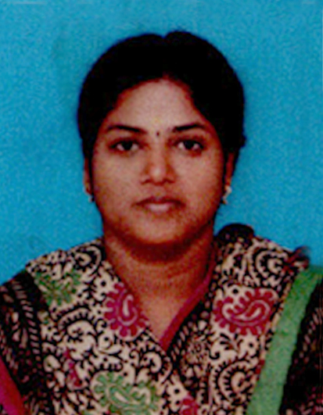
YOGESWARI. N. S

Door No. 71/8,
Meenakshi Nagar,
Theradi, Thiruvotriyur, ,
Chennai – 600 019.
Mobile: +91 95518 89327
E-Mail ID: n.s.yogeswari@gmail.com

Objective:
I would like to work in creative and challenging environment where I can learn to use my excellent organizational skills and educational background to improve my technical and analytical abilities and successfully deliver solutions to the problems.

Academic Qualifications:

Qualification | Name of the Institution | Board/ University | Percentage | Year of Study
B.Sc  Chemistry | Sir Theagaraya College | Madras University | 58 | 2004-2007
B. A.  English | Madras University | Madras University | 70 | 2013-2015
XII | Muruga Dhanushkodi Higher Secondary School | State board | 64 | 2004
X | Muruga Dhanushkodi Higher Secondary School. | State board | 75 | 2002

Work Experience:

- Two years experience in Jarulss Technology Solutions as a Resource Implementer (Back End) in Customer Support from June – 2013 to Sep 2015.

- Six months work as an Administrative Officer in Taipei Economic & Cultural Centre in Chennai from Sep 2015 to Mar 2016.

- Two Years working as Receptionist / Telephone Operator / Admin / Personal Secretary in Chitale & Son, Chennai from March 2016 to March 2018 .

- Six months working as an Associate Admin / Front Office in Boltz Engineering Private Limited at Chennai from April 2018 till Oct 2018.

- One Year working as an Associate Admin / Front Office/ CRM in Dugar Housing Limited, Chennai from Dec 2018 till March 2020.

RESPONSIBILITIES OF RECEPTIONIST / FRONT DESK EXECUTIVE:

- Welcomes visitors by greeting them, in person or on the telephone; answering or referring inquiries.

- Greet Visitors warmly and make sure they are comfortable.

- Give visitors card and direct them to where they can sign in.

- Answer phones and transfer calls to the concerned persons.

- Answer inquiries about the company, deals with the Clients, Contractors, Suppliers, & Consultants.

- Schedule meetings and conference rooms.

- Ensure Reception area is tidy.

- Handle phone calls from staffs for Leave, Permission etc.

- Hand out employee applications.

- Arrange Appointments.

- Send E-mails.

- Collect & send parcels.

- Take and relay messages.

- Update appointment calendars.

- Schedule follow – up appointments.

- Maintaining the Attendance Register of the staffs.

- Keep in track of Courier Register / Attendance Register.

- Order the Stationery items which are required for the Company and the Staffs and negotiate with the vendor.

RESPONSIBILITIES OF ADMIN:

- Co-ordinate mail flow in and out of office and forward the mails to the concern departments.

- Providing support to our managers and employees, assisting in daily office needs and managing our company's general administrative activities.

- Develop and maintain a filing system.

- Book travel arrangements.

- Ensure operation of equipment by completing preventive maintenance requirements; calling for repairs; maintaining equipment inventories; evaluating new equipment and techniques.

- Maintain computer and manual filing systems.

- Handle sensitive information in a confidential manner.

- Take accurate minutes of meetings.

- Coordinate office procedures.

- Resolve administrative problems.

- Coordinate repairs to office equipment.

Computer skill:

DMO certification in Global computer centre.

Extra-Curricular Activities:

NCC

Hobbies:

Listening Music, Cooking

Strengths:

- Leadership Traits.
- Good Communication Skills.
- Committed to deadlines and schedules.
- Adaptability.
- Quick Learner
- Dedication of work
- Soft spoken

Personal Details:

Name : Yogeswari. N. S
Spouse Name : Mr. C.B. Sarath Kumar
Status : Married
Date of Birth : 16-05-1987
Sex : Female
Nationality : Indian
Languages Known : Telugu, English and Tamil.

Declaration:

I hereby declare that all the above statements are true and correct to the best of my knowledge
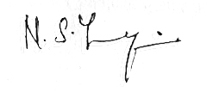
Place : Chennai
Date : 27-02-2020.

(Yogeswari. N. S)

