RAKHI simmi.rajput7@gmail.com 9871399374
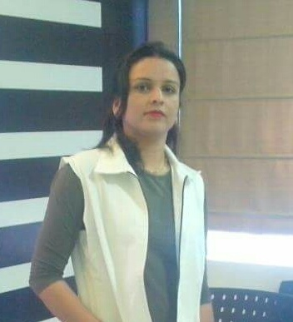

___________________CAREER OBJECTIVE_____________________

Seeking challenging assignments in field of Beauty Products and to search different ideas to prove my
efficiencies.and capabilities for mutual benefits.

__________________PROFESSIONAL QUALIFICATION________________

- Complete one year diploma course in Beauty Cosmetology from VLCC Institute, New Delhi.
- Six month certificate course in Computer Fundamental From F-tech,
Darya Ganj, New Delhi.

___________CAREEGRAPH______
Histomer
Sr. Trainer June17-Till Date
Histomer is from Italy that products based on Plants stem cell, that is skin care products

REPECHAGE
Repechage is from USA repechage is skin care products that based on sea weed. Jan.2015 to May2017

Sr. Technician.

CASMARA (Facial) Mar2010  Nov. 2014
Casmara is from Spain, they have skin care products, that nature products
Based on Algee.

Key Responsibilities:

Provide product knowledge to client.

Provide Technical Training to client.

Seminars to promote brand.

Providing strong levels of Technical support to the salon staff.

Organizing workshop in corporate.

______________________TRAINING EXPERIENCE _______________________

- Training given to Looks salons.
- Training given to Lakme salons.
- Training given to Natural salon in Chennai, Bangalore.
- Training given to Lime Lite salon in Chennai, Bangalore.
- Training given to Affinity salon.

______________________ACADEMIC QUALIFICATION ______________________

Graduation : Punjab University
Intermediate : Punjab Board
High School : Punjab Board

______________________PERSONAL INFORMATION_______________________

Husband Name. Harish Kumar
Date of birth 15th August 1978
Sex Female
Nationality Indian
Marital status Married
Language English, Hindi, Punjabi
Address Flat No. 150, Dhanya Niektan,
UP Resident Society, Sector  42, Noida (U.P.)

______________________ DECLARATION ____________________________
I hereby declare that all the information provided by me in this application is factual and correct to the best of my knowledge and belief.
References Available on Request
RAKHI

