**­­­­CURRRICULAM VITAE**

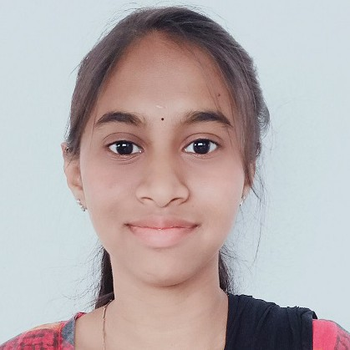

**Janani Marimuthu**

**Jananimarimuthu123@gmail.com**

**+91 9597427582**

**22/67 Oor Gounder Street, Thimmaiya Nagar, Veerakeralam**

**OBJECTIVE**

Seeking an entry-level software, I strive to associate myself with an organization where I can utilize my skills in the best possible manner, which further gives me an opportunity to grow in my career journey while contributing to the development of the organization. Excited to learn and grow within a dynamic QA team and contribute to the success of software projects.

**EXPERIENCE**

**15/05/2023 – Present**

Quality Analyst - Infynd

**Roles and Responsibilities:**

* Identify and remedy defects within the production team.
* Maintain quality and provide guidance where production is lack.
* To deliver regular feedback session for team.
* Analyze and resolve any project issues immediately.

**08/09/2021 –07/02/2023**

Senior Process Associate (Director Bio Research) - Mobius 365 Data Services

**Roles and Responsibilities:**

* Complete task accurately, maintaining quality standards. I worked as internal quality analyst.
* Training new member. Maintain daily client delivery.
* Cross work projects like Finance and Velocity.
* Develop strong working relationships with team members.
* Knowledge in Excel.
* Easy understanding and interest to learn new projects.

**EDUCATION DETAILS:**

|  |  |  |  |  |
| --- | --- | --- | --- | --- |
| **COURSE** | **BOARD/ UNIVERSITY** | **INSTITUTION** | **PASS OUT YEAR** | **PERCENTAGE/CGPA** |
| BSC | Bharathiyar University | Kongunadu Arts and Science College | 2021 | 91% |
| HSC | State Board | SRV Matric Higher Secondary School | 2018 | 87% |
| SSLC | State Board | SRV Matric Higher Secondary School | 2016 | 95% |

**SKILLS:**

* Having knowledge in Automation Programming language using **Java**.
* Having knowledge in **Selenium** **WebDriver**.
* Hands on knowledge in creating **XPATH**.
* Knowledge in web application automation testing with **Page Object Model** using **Maven**.
* Knowledge in **Data Driven** testing Framework.
* Knowledge in **BDD Cucumber** Framework.
* Good knowledge in using Singleton Design Pattern.
* Possess knowledge in **TestNG** Framework and expert in handling different methods like Simple, Ignore, Grouping etc.
* Dependency Methods, Parameter and Data provider.
* Knowledge in creating **POM** for all the pages.
* Knowledge in functional testing, Integration Testing, Regression Testing, Black Box Testing.
* Knowledge in designing and executing test scripts.
* Capable of working with team as well as individual.
* Ability to learn Domain Knowledge, related to the application within a short period of time.

**SOFTWARE KNOWS:**

|  |  |
| --- | --- |
| **SKILS** | **TOOLS** |
| Operating System | Windows |
| Language Known | Java |
| Automation | Selenium |
| Framework | TestNG, Data Driven, Cucumber |

**PERSONAL DETAILS:**

* **Name :** Janani Marimuthu
* **Date of Birth :** 20.03.2001
* **Gender :** Male
* **Father’s Name :** T. S. Marimuthu
* **Mother’s Name :** M. Meena
* **Nationality :** Indian
* **Mother Tongue :** Tamil
* **Languages Known :** Tamil and English
* **Marital Status :** Single

**DECLARATION:**

I hereby declare that the information furnished above is true to best of my knowledge.

Date : Yours Faithfully

Place : (**Janani Marimuthu)**