**RESUME**

HAVILDAR LAXMAN CHAUBEY 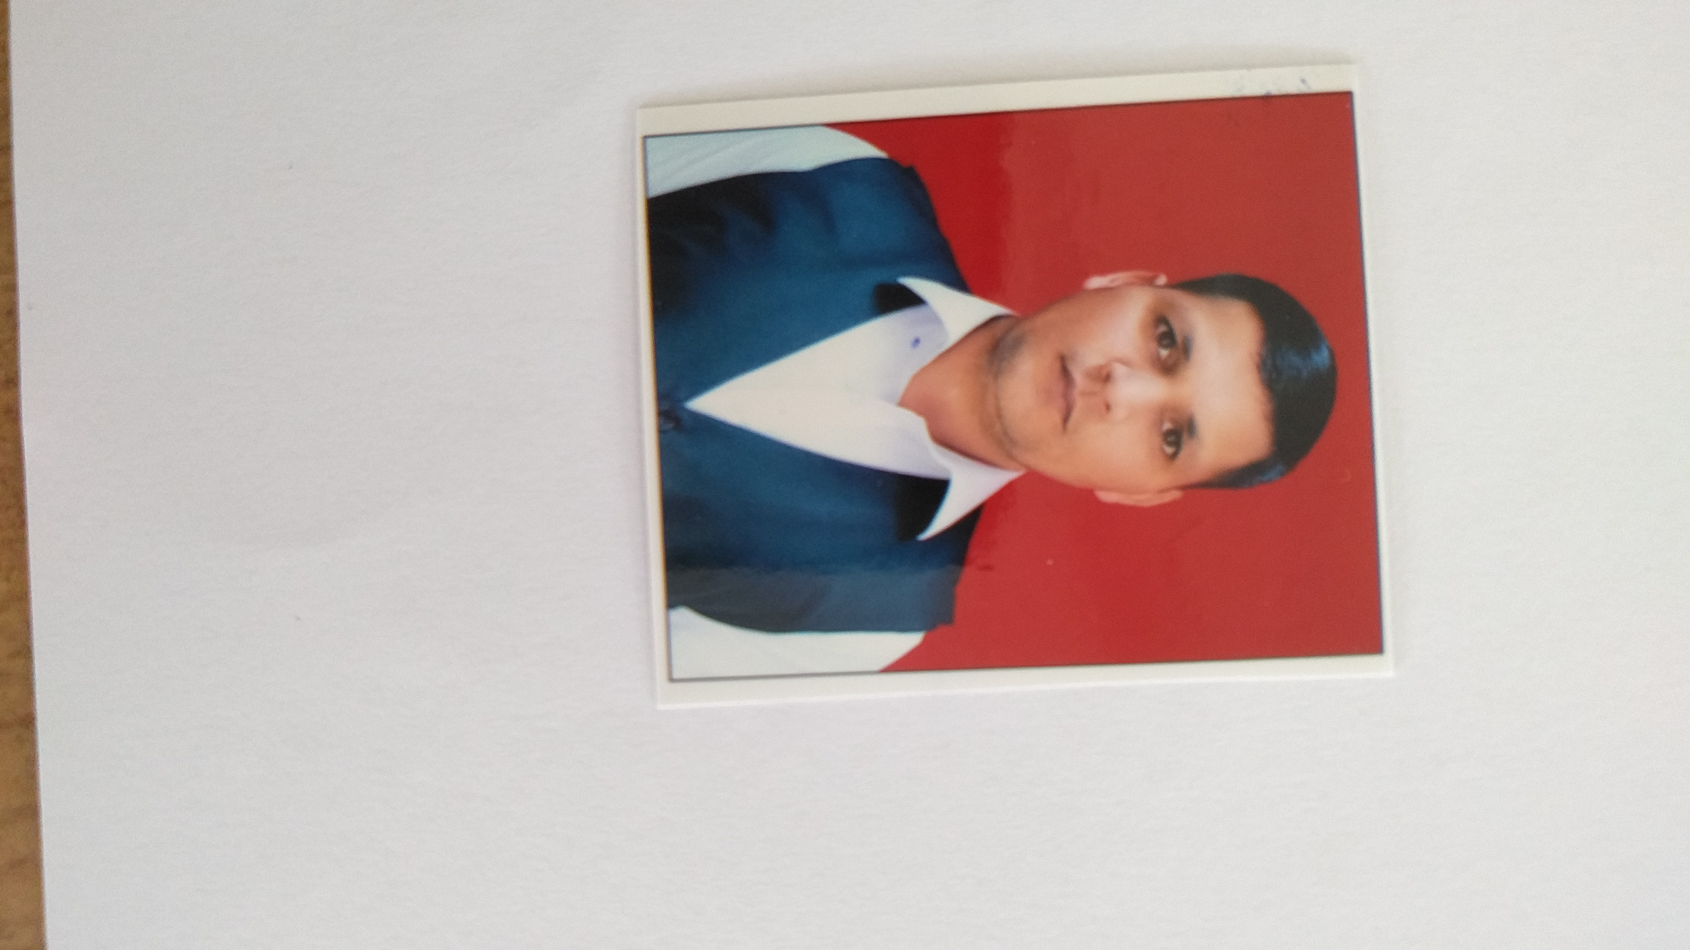

DEHRI,CHAUSA,BUXAR

BIHAR

PIN- 802114

MOB- 6294346109

laxmanchaubey59@gmail.com

**EXPERIENCE SUMMARY**

Decorated Indian Army Special Forces and NSG Veteran with over 16 year exp in defense, security and special operation with gun license. Experience as a Sky Marshaling.

**SKILLS**

Commando, Anti-terror Operation, Firefighting, Physical Security, Asset protection, General Administration, Executive Protection (PSO), Sky Marshaling (Air Security).

**DETAILED JOB DESCRIPTION**

* 16 years service in Indian Army (PARA Special Forces)
  + 03 years service in NSG
  + Lead and motivate a team in military operation
  + Respond to emergency services as part or Quick Reaction Team (QRT)
  + Sky Marshal Officer (Counter terrorism officer)
  + Telephone operator & management in battalion unit

**COURSES & GRADINGS**

* **Para Basic (Qualified Grading)**
* Advanced Demoletion (instructor Grading)
* Security trening in sudan duretion 2011 to 2012.

**AWARDS & HONOURS**

Nill

**MAJOR OPERATIONS**

* OPS RAKSHAK(J&K) w.e.f May 2006 to Jun 2007
* OPS RAKSHAK(J&K) w.e.f May 2007 to Jun 2008
* OPS RAKSHAK(J&K) w.e.f May 2014 to Jun 2018

**ACADEMIC QUALIFICATION**

* BA from Sampurnanand university Varansi 2008.
* Intermediate from UP Board 2005.
* High School from UP Board 2003

PERSONAL DETAILS

Name : Laxman chaubey

Date of Birth : 05 Jul 1985

Rank : Havildar

Unit Name : 12 PARA (Special Force)

Date of Discharge : 31 Dec 2019

Marital Status : Married

Language Known : Hindi ( Reading,Speaking & Writing), English(Reading & Writing)