**CURRICULUM VITAE**

**Shivani Chargotra**

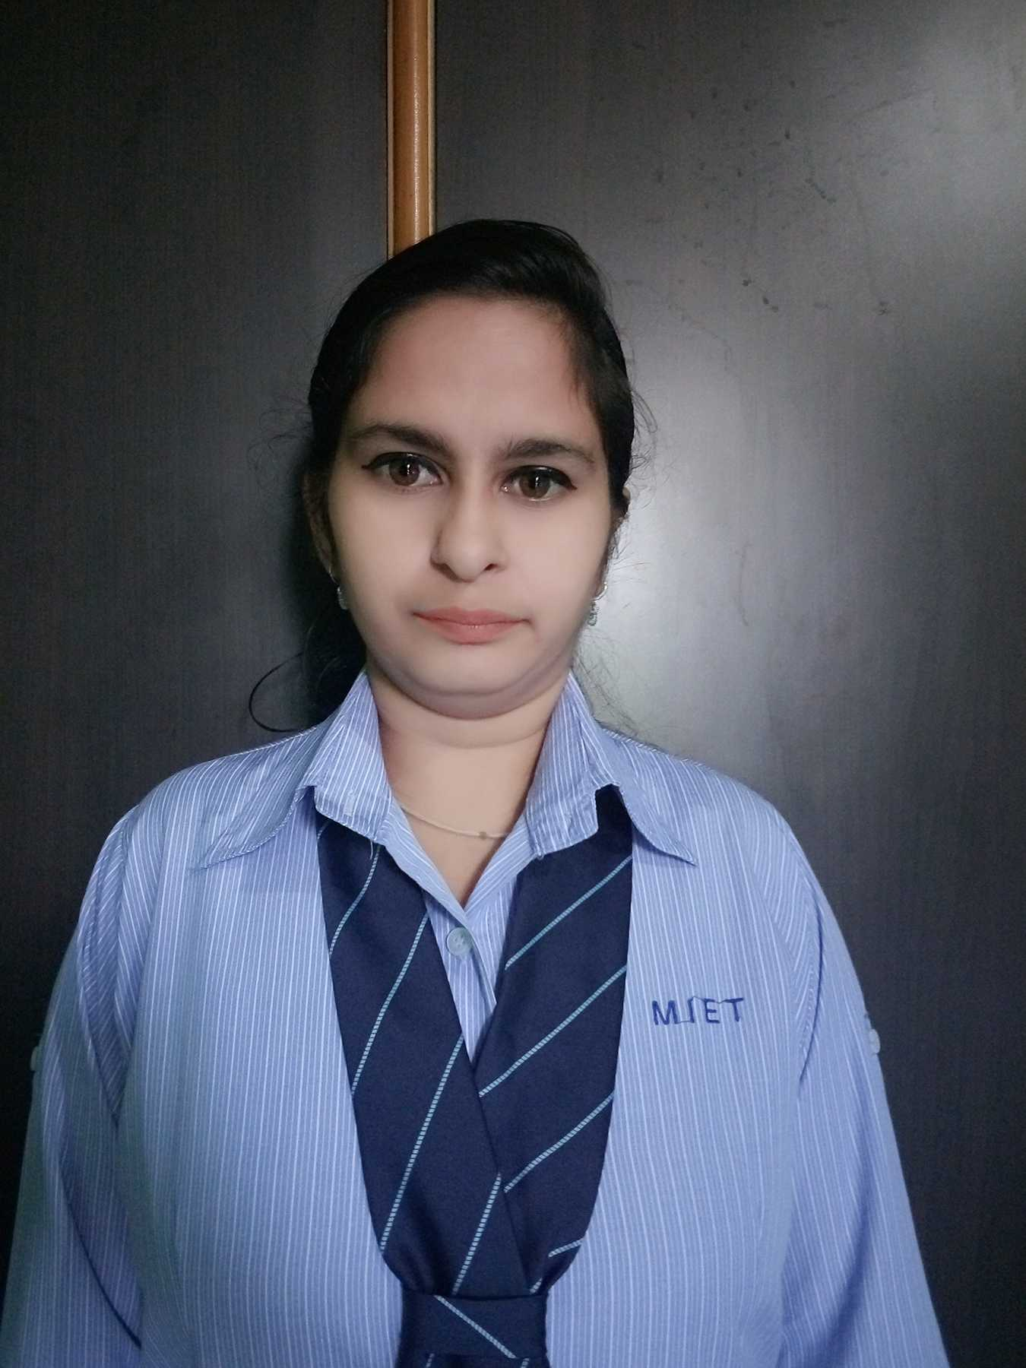

**Contact & Address: Cell No**: 7780995593 **E-mail** : shivani191295@gmail.com

**Permanent Address**: Behind Spring Dale Mission School, Rajinder Nagar Bantalab

(JAMMU AND KASHMIR), 181221

**At Present -** 1235 GBP Rosewood Estate, Barwala Road Derabassi (Punjab)**,** 140507

**CAREER OBJECTIVE**

To work for an organization that provides me the opportunity to improve my skills and knowledge along with the achievement of organizational objectives.

**TECHNICAL SKILLS**

|  |  |
| --- | --- |
| **DBMS** | Database SQL |
| **LANGUAGE** | C, C++, Python, Java |
| **PLATFORM** | Windows |
| **TOOLS** | MS Word, MS PowerPoint, Microsoft Office, Notepad, Notepad++, Anaconda, Android Studio. |

**PROJECT**

**Fruit (Apple) Categorization Detection Using Deep Learning**

Tools used: - Anaconda (Spyder), Android Studio

Algorithm used: - Convolution Neural Network Algorithm

Duration: - September-December

Learning: - In this project, I learned about various concepts of deep learning and also learned how to use Android studio and Anaconda (Spyder). In this project, the detection of the apple fruit is done by using click the image of the apple fruit.

**TRAINING ATTENDED**

1. Fundamentals of deep learning for computer vision
2. Webpreneurship

**ACADEMICS QUALIFICATIONS**

|  |  |  |  |  |
| --- | --- | --- | --- | --- |
| Qualification | University/Board | College/School | Year of passing | Percentage marks |
| BE | Jammu University | Model Institute of Engineering and Technology | 2020 | 75% |
| 12th | J&K Board of School Education | Govt.Hr.Sec.School | 2014 | 77% |
| 1Oth | J&K Board of School Education | Anuradha Mission School | 2012 | 69% |

**CERTIFICATIONS**

1. Certificate for completion of C training- Spoken Tutorial Project, IIT Bombay
2. Certificate for completion of C++ training- Spoken Tutorial Project, IIT Bombay
3. Certificate of participation in the workshop of Fundamentals of Deep Learning For Computer Vision-MIET Jammu.
4. Certificate for demonstrating competence in the completion of Fundamentals of Deep Learning For Computer Vision-MIET Jammu.

**INTERNSHIP**

Company: NIELIT, Ropar Chandigarh

Details: The six-week training about Python for Data Science and Machine Learning. This training was done by the National Institute of Electronics And Information Technology In Collaboration with the Indian Institute Of Technology.

**MEMBERSHIP**

1. Computer Society of India (CSI).
2. Indian Society for Technical Education.