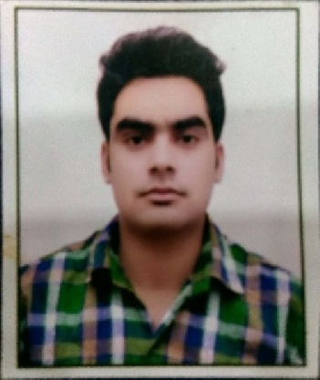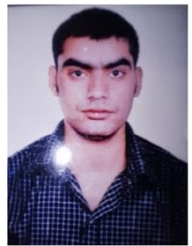**CURRICULUM VITAE**

**UMESH SHARMA**

Postal Add.:Surya Vihar Colony,

Pinto Park, Morar Gwalior (M.P.)

Near sharma atta chakki

Pin Code: 474006

Mob No.:8817562356,9424608208

Aadhar No:- 804898805937

Email.Sharmaumesh991@gmail.com

**Career Objective**

* To Work For Professional Organization, where my skills, Qualification And positive attitude will be optimally utilized and further developed.

**Educational Qualification**

* B.com jiwaji university 2013
* 12th Passed 2010 MP Board
* 10th Passed 2008 MP Board

**Experience**

* **Two year 3months Army hospital Gwalior IT support**
* **Three months HDFC BANK CITY CENTER GWALIOR**
* **One** year Experience as **BACK OFFICE SUPPORT at INDUSIND BANK CFD (CV) Gwalior**
* Two Year Experience as Trainer of **Field Technician - Computing and Peripherals at Prateek Institute of Information Technology Gwalior**
* **Two year Experience as SR BUSINESS DEVELOPMENT EXECUTIVE at RELIANCE COMPANY**

**Pvt LTD Gwalior**

**Other Qualification**

* ADCA COURSE LOTUS COMPUTER EDUCATION CENTER GWALIOR
* Certified Trainer under PMKVY2.0 in Field Technician - Computing and Peripherals (ELE/Q4601)

**Personal Profile**

**Name**  : Umesh Sharma

**Father’s Name** : Shri M.P Sharma

**Date of Birth**  : 08-05-1991

**Gender** : Male

**Marital Status**  : Married

**Language Known** : Hindi & English

**Category**  : Gen

**Religion** : Hindu

**Nationality** : Indian

**Declaration**

I have declared that all the information about me in this resume is given by me. And if you feel any problem about my information then please contact to me.

Date : -------------------

Place : ------------------- **Umesh Sharma**