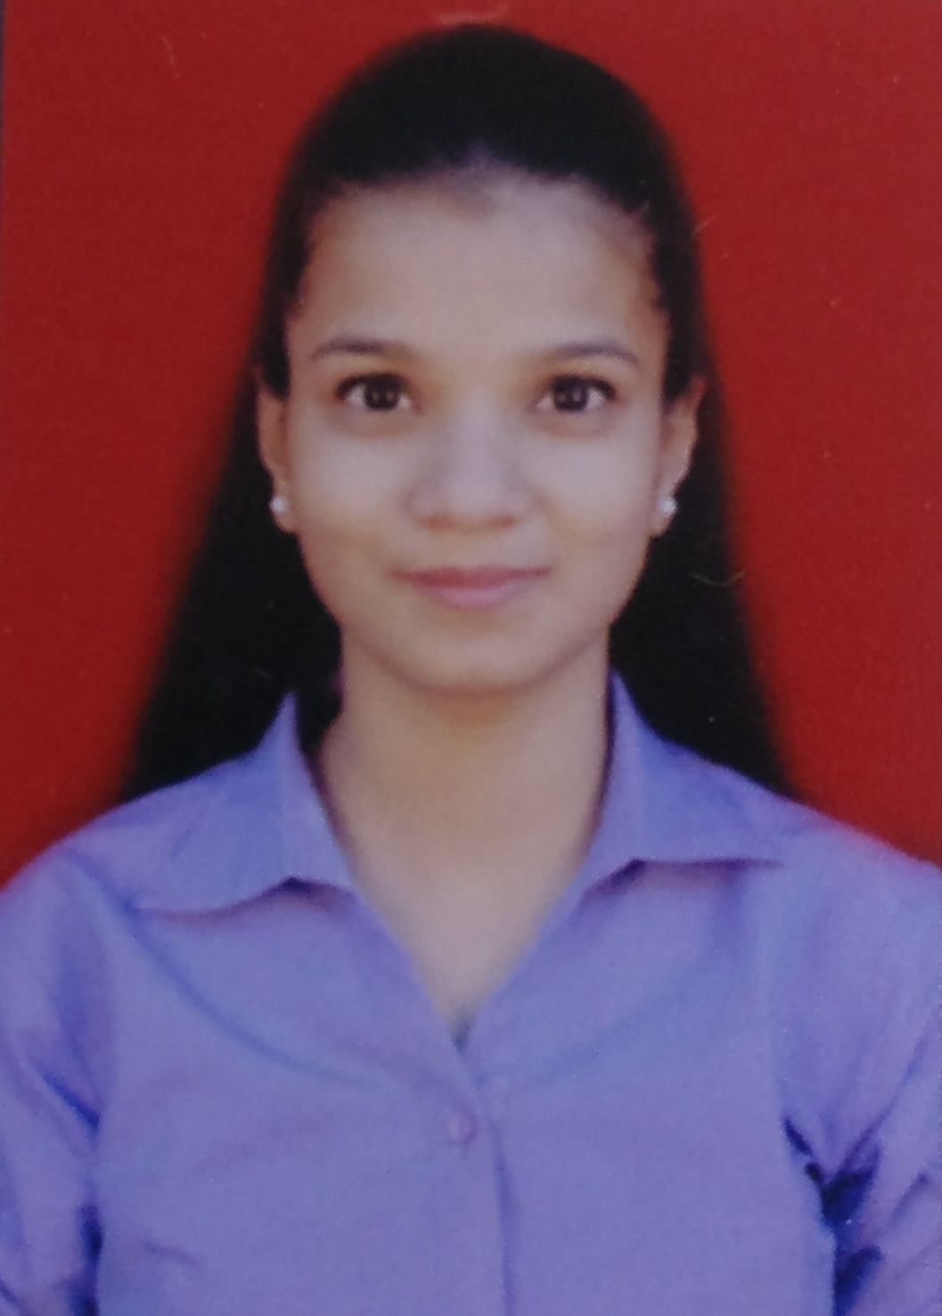

Anisha Kamlakar Tandel.

Mitali Heights,B-704,Poona

Link Road,Kalyan(East).

9820872480

8369210361

[anishatandel1998@gmail.com](mailto:anishatandel1998@gmail.com)

**Career Objective :**

To work in an organization where I can acquire new knowledge, sharpen my skills and put my efforts on achieving organization as well as personal goals.

**Academic Details :**

|  |  |  |  |  |
| --- | --- | --- | --- | --- |
| **Qualification** | **University** | **Institute /**  **Organization** | **CGPI%** | **Year** |
| B.E. | Mumbai  University | VESIT ,  Chembur | 7.8 cgpa | 2016-2020 |
| H.S.C. | Maharashtra state board | Birla College ,  Kalyan | 80.00 | Mar 2016 |
| S.S.C | Maharashtra state board | Nutan Dnyan  Mandir ,  Kalyan | 92.60 | Mar 2014 |

**Technical Skills :**

* Programming Languages : Python , C , Java
* Operating Systems : Linux , Windows
* Web Technologies : HTML5 ,CSS3 ,Javascript
* Database : Microsoft Sql Server

**Extracurricular Activities :**

* Won **1st prize** in **Non traditional rangoli competition** in junior college.
* Secured **2nd** place in **“DAM DAMA DAM”** (**dance reality show of doordarshan)** TV show.
* Completed **“PRARAMBHIK”** and **“PRAVESHIKA PRATHAM” (1st and 2nd kathak exam)** from **Gandharva University** .
* Secured **1st** place in **district level dance** competition.
* Successfully managed dance and personality event in “**UTSAV 18”** organised by VESIT 2018 **.**
* Actively participated in **“ILLUSION”** for dance and drama events.
* secured **2nd** place in the **college level dance** competition.
* Secured **2nd** place in **“AAO COOK KARE” (cooking competition)** organised by VESIT 2018.

**Projects and Work Experience :**

**Academic Projects**

1. **Online Jewellery Shopping :**

Developed a website for online jewellery shopping using python having features like user login , search items , place orders , online payment, dashboard of orders.

**2) Smart Driving Information System :**

Developed an IOT based project to notify the distance between two vehicles and accordingly will alert the driver to slow down it’s speed when the car will be too close to the next car.Will help to reduce traffic accidents.

**3) Online Resume Builder :**

Developed a website for building resume online using web technology having features like building resume

and selecting a template.

**Roles and Responsibilities :**

* I was a **cultural incharge** and also **Co-ordinator in IEEE council** for 2017-2018 year.
* I was a **Deputy Sports Secretary** for 2018-2019.
* Worked as a dance choreographer in **HERE solutions** company in the year 2019.

**Strengths :**

* Self-motivated
* Ability to handle pressure
* Hard-working
* Punctual

**Personal Details :**

* **Languages :** English, Hindi , Marathi
* **Nationality :** Indian
* **Hobbies :** Solving puzzle , Dancing

**References :**

|  |  |
| --- | --- |
| Mrs. Pooja M. Shetty,  Assistant Professor, Dept of I.T, VESIT.  +91-9920429866  [pooja.shetty@ves.ac.in](mailto:pooja.shetty@ves.ac.in) | Mrs. Vidya Pujari,,  Assistant Professor, Dept of I.T, VESIT.  +91-9821964977  [vidya.pujari@ves.ac.in](mailto:vidya.pujari@ves.ac.in) |

**Declaration :**

I hereby declare that the information furnished above is true to the best of my knowledge.

Date :

Place : Mumbai Anisha Kamlakar Tandel