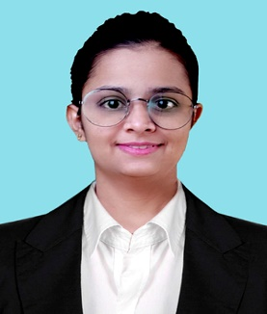**Ankita Gend**

Sr. Software Engineer

www.linkedin.com/in/ankita-gend-605b401b4

✉ ankitagend@gmail.com

 +91-9370504346

Having **2 years of experience**in Cloud Infrastructure Services Domain. My expertise lies in effectively managing user accounts, groups, and permissions in Active Directory. Additionally, I have a strong background in O365 administration, including user management, license allocation, and mailbox management. Enthusiastic about cloud technologies like Azure and Intune. Proficient in supporting SaaS applications such as Printer Logic and foundational knowledge in Intune, SCCM, and SCOM.

**KEY SKILLS:**    
**Primary:** Active Directory Administration, O365/Exchange Online Administration, Printer Logics, PowerShell Scripting  
**Secondary/Optional**: Intune, SCCM

**Experience**

2021-09 – present **Sr Analyst/ Infrastructure Support**

*Capgemini India PVT LTD, Pune*

Managing Services and infrastructure Support for technologies like Windows Server Administration and Exchange Online Administration.

Our responsibility and priority are to fulfil the customer's needs in time.

* Designed and implemented user account management strategies, including group policies and security permissions, ensuring streamlined access and enhanced security.
* Resolved authentication and authorization issues promptly, troubleshooting and optimizing Active Directory performance for a user base of almost 15K users across two domains.
* Managed Exchange Online environments, overseeing mailbox administration, email routing, and security settings for users.
* Implemented Azure Active Directory to enable single sign-on (SSO) and secure access to cloud-based applications for [number] users.
* Managed and maintained Azure AD Connect to ensure seamless synchronization of on-premises Active Directory with Azure Active Directory, maintaining accurate user identities and access control.  
  **Operating System:** Windows  
  **Special Tools:**ADUC, ADAC, GPMC, Active Directory Sites and Services, EAC, EOP, Exchange PowerShell, Microsoft 365 Security & Compliance Centre, Azure Portal, Azure CLI, Attribute Mapping Configuration, Azure AD connect health, AAD, EPM

**Higher Education**

2017 - 2021 **Computer Science, Bachelor of Engineering**

*Shivaji University, Kolhapur*

**Languages**

English (Fluent), Hindi (conversational), Marathi (Native)

**Training and Certifications**

* Trained and certified in MS–900, SC-900, and AZ–900 from Microsoft
* Received an internal certificate from Ocean Academy: “CIS - Wintel - System Engineer - Wintel Grade A - Level 1”.
* Got trained and certified in ITIL V4 Foundation Certification.

|  |  |
| --- | --- |
|  |  |
|  |  |
|  |  |