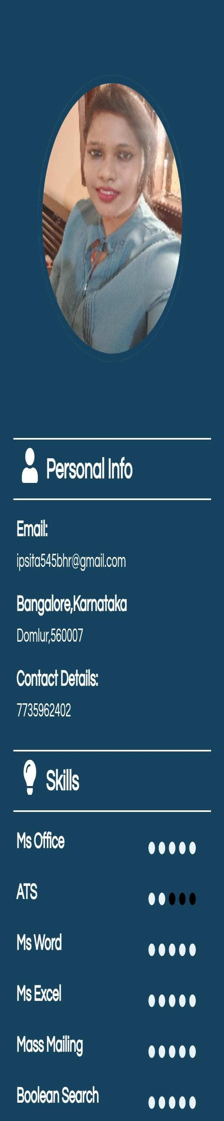

IPSITA BEHERA Mobile9692644001

WORKING AS A ASSOCIATE IN IT SECTOR IN ,BANGALORE LOCATION.HERE I USED TO DO SOURCE AND SCREEN RESUMES FROM NAUKRI PORTAL .I HIRE CANDIDATES FROM PAN INDIA FOR TOP MNC'S COMPANIES LIKE INFOSEYS,HITACHI,BIRLASOFT,TRUMINDS AND CGI.

**Work Experience**

# ORCAPOD CONSULTING SERVICES (BANGALORE) SEPTEMBER 2020-JUNE2022

* **Cold Calling to Pan India Candidates.**
* **Inbound And Outbound Calls.**
* **International Calls Such As Belgium And Australia Cilents.**
* **Source Portals From Naukri.**
* **Indian Cilents Such As –Cognizant And CGI.**
* **Chat,Messages,Email Also Done.**
* **Worked Voice And Non-Voice Process.**

APRIL 2019-OCTOBER-2020

RELUX GLOBAL (BHUBANESWAR)

* SCREENING RESUMES AND THEN SOURCE CANDIDATES FROM TIMES SHINE, LINKEDIN,FACEBOOK AND LNSTAGRAM.
* WELL KNOWN WITH ALL THE FINANCIAL TECHNIQUES TO HANDLE ANY FINANCIAL DECISIONS.
* WELL KNOWN OF MARKET SCENARIO ALSO.
* SOURCING CANDIDATES FROM JOBS PORTALS THEN COLD CALLING TO THEM FOR THE POSITIONS OF BUSINESS ASSOCIATES,SALES EXECUTIVE ,MAKETING EXECUTIVE AND BUSINESS DEVELOPMENT ETC.
* TAKE INTERVIEWS THROUGH PHONE,FACE TO FACE,ZOOM ,VIDEO CALL ETC.
* WORKED IN SBI ,HDFC, BANKS LIKE MARRIAGE LOANS,HOME LOANS ETC.

# ACCOUNTANT CUM HR EXECUTIVE (CUTTACK)

***K DUBEY AND ASSOCIATES***

APRIL 2016-MARCH- 2019

* WORKED AS ACCOUNTANT ,DONE INCOME TAX FILLINGS OF FINANCIAL YEARS.
* COLD CALLINGS TO CILENTS FOR TDS FILLING ,GST ETC.
* DONE AUDIT WORK IN SBI.
* UPDATES AADHAR CARD,PAN CARD ETC.
* COLD CALLING TO PAN INDIA CANDIDATES.
* REGISTER MAINTAINED.

MBA

# INSTITUTE OF MANAGEMENT AND INFORMATION TECHNOLOGY

***BIJU PATANAIK UNIVERSITY OF TECHNOLOGY,ODISHA***

Specializations of HR and FINANCE of 7.3 CGPA.

**MBA**

MAY-2018