COMMANDER PANKAJ SRIVASTAVA (RETD)

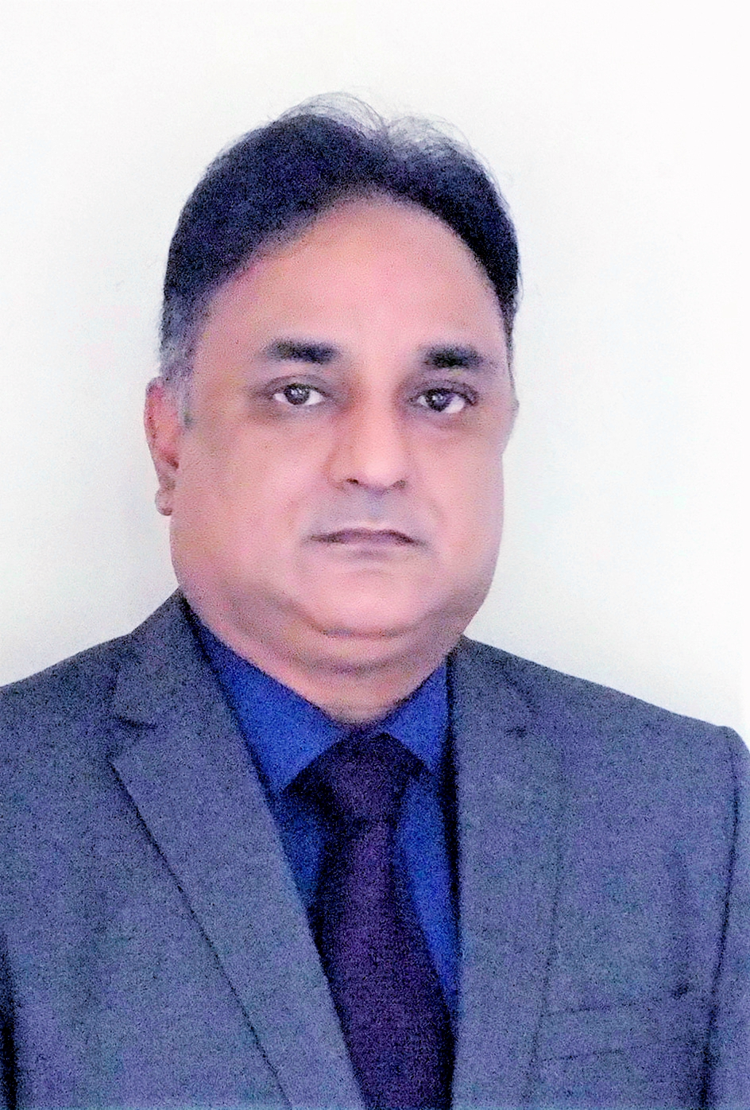

Date of Birth : 07 May 1973

Phone : +91-9969933744/8424027225

Email : pankaj95met@gmail.com

LinkedIn : <https://www.linkedin.com/in/pankaj-srivastava-81565497/>

Professional Summary

______________________________________________________________________________________________________________________________________________________________________________

Indian Navy veteran with more than 23 years of experience in the field of Capital and Revenue Procurement, Bid Management, Inventory Management, Supply Chain Management, Project Management, Inter-Agency co-ordination, Technical Leadership and Operations Management.

Work Experience

**Independent Consultant**  **May 21 - To date**

* Envisioning, setting up and operationalisation of 24 x 7 Command Centre for providing Covid Support to Corporate staff.
* Corporate War Game on ‘Future Dynamics Influencing P-75(I) Submarine Acquisition’.

**Joint Director, Ministry of Defence Acquisition Wing, New Delhi Jan 16 – Mar 21**

* Technical advisor to the decision makers in Capital procurement of Defence Equipment and Systems of Indian Navy and Coast Guard.
* Handled more than 50 procurement cases in excess of Rs 60,000 Crores (8 Billion USD) from pre-approval to Contract stage.
* Managed tenders (RFP) including analysis of requirements, tender preparation and issue, interactions with internal and external key stakeholders, pre-bid meeting and clarifications to the vendors and bid management.
* Evaluation of bids in respect of General and Technical compliances, Field Evaluation Trials (India as well as Abroad) and Commercial negotiations with the Indian and Foreign vendors.
* Analysis of conflicting views of stakeholders and representations received during all stages of procurement.
* Apex level policy formulation and analysis of procurement related policies and procedures to increase ease of business and overall effectiveness.
* Associated with the formulation of Defence Acquisition Procedures (DAP 2020), BPR of DPP 2016 and Capacity Assessment Guidelines.
* Issued 09 RFPs for major shipbuilding cases within one year which is unprecedented.
* Completion of pre-contract evaluation and negotiations in major warship cases within two years of issue of RFP providing boost to the domestic shipbuilding sector.

**Joint Controller Material Planning - Material Organisation, Mumbai Dec 11 - Jan 16**

* Led a cross-functional Supply Chain Management team of 120 personnel, undertook in-depth analysis to identify supply-demand gaps for approx 3.5 lakh types of engineering inventory/SKU’s, followed priority management and ensured timely and uninterrupted supply of spares against approx 70,000 annual demands from more than 200 Customers.
* Review of inventory, demands and consumption pattern, forecasting of requirement, short listing of vendors, tendering and contract, post contract monitoring, receipt, warehousing and issue.
* Achieved demand compliance in excess of 90% despite legacy inventory related issues through innovative planning and resource management.
* Identified shortfalls in in-house Integrated Logistics Management System and undertook measures for software upgrades resulting in rationalisation of inventory and savings of more than Rs 100 Crore (13 Million USD).
* Creation of vendor managed Single Window Water Front Support system at customer premise for demand, survey, issue and warehousing of fast moving inventory.
* Preparation of Performance and Operational Effectiveness Report for presentation to the Headquarters during Annual Reviews.

**Project Management - Aircraft Carrier Acquisition Project at Russia Aug 09 - Nov 11**

* Oversee installation of major machinery and systems of main propulsion plant and shafting.
* Resolved long pending issue of work completion against 02 major milestone payments.
* Ensured meeting of program milestones as per contractual timelines through continual interaction with all stakeholders viz. shipyard, OEMs and Professional Directorates.
* Assigned higher responsibility of Principal Coordinator for STW and trials of entire ship.

**Senior Engineer Officer - 02 Warships May 08 to Aug 09 & Dec 02 to Jul 04**

* Management of workforce of more than 75 technical combatants for operation, inventory management, preventive and breakdown maintenance of ships’ machinery.
* Installed Efficiency Enhancement measures for engineering systems.
* Awarded ‘Best Engine Room’ of the Fleet in 2009.

**Instructor - Training School (INS Shivaji) Aug 04 to Apr 08**

* Training of more than 5000 Indian and Foreign trainees annually in more than 100 courses pertaining to NBCD, Fire Fighting, Damage Control, propulsion system and shafting.
* Awarded as Best Instructor by INS Shivaji in 2006.

**Assistant Manager - Naval Dockyard, Mumbai Nov 1998 to Dec 2002**

* Management of technical workforce of more than 500 civilian personnel to undertake maintenance activities pertaining to shafting alignment, main steam propulsion systems and steam auxiliaries.
* Scheduling of work, prompt onsite decision making, monitoring, conflict management and handling of trade union issues to ensure completion of refit activities as per planned schedule.
* Reduced repair timelines by more than 20 percent through innovative measures.

Awards

* Commendation by Vice Chief of Naval Staff (2020) and by Flag Officer Commanding in Chief, Western Naval Command (2002, 2009 & 2013) for Professional Excellence.

Education

**BIT Sindri**

BE (Metallurgy). Adjudged ‘Fresher of the Year'. 1991- 95

**Jamnalal Bajaj Institute of Management Studies**

MBA- Masters of Information Management 2001- 04

Post Graduate Diploma in Management 2012

**Naval War College, Goa**

Technical Manager Course 2012

**College of Military Engineering, Pune**

Joint Services Course in Nuclear Biological Chemical Warfare 2006

**INS Shivaji**

Marine Engineering Specialisation Course 1998

NBCD Specialisation Course 2004

Certifications & Courses

* Course in Supply Chain Sourcing - Rutgers University (May 2021)
* Course in Supply Chain Planning - Rutgers University (Apr 2021)
* Course in Supply Chain Operations - Rutgers University (Dec 2020)
* Course in Supply Chain Logistics - Rutgers University (Oct 2020)
* Certificate Program in Contract Management - World Bank (Sep 2017)
* Specialisation in Repair of Main Turbines from Ministry of Defence, Russia (2005- 06)