RESUME

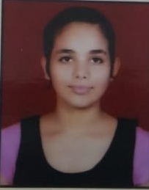

**NIDHI** H.NO.-699,Gali NO. -6,

Sehatpur,Old Faridabad

Ph NO.-8744964114

Email id-nidhi47894@gmail.com

## **OBJECTIVE:**

My Short term goal is to get a job in a reputed company where I am utilize my skill and improve my carrier path. My long term goal is to be in respectable position in that organization.

## **EDUCATION QUALIFICATION:**

### Pursuing B.TECH (Electronics & Communication Engg.) from Aravali college of Engineering and management (2018-2021)

* Diploma from B.S.F Polytechnic S.T.S New Delhi in 2018 with 72.3%

### 10th from Haryana Board in 2015 with 61%

## **EXPERIENCE:**

Fresher.

EXPERIMENTAL LEARNING:

COMPUTER KNOWLEDGE:

Microsofr office, ms excel

Basic knowledge of c programming

ACADEMIC PROJECTS:

Water Level Indicator

Automatic hand sanitizer

ACHIEVEMENT:

* Attending career development classes from last 2 months.
* Actively participated in various cultural events.
* Actively participated in various sports activities in inter school.

INTER PERSONAL SKILLS:

Analytical

Energetic.

Adaptability.

Ability to cope up with different situation.

HOBBIES:

Playing ludo

Singing

PERSONAL DETAILS:

Father’s Name : Sh. Virender kumar

Date of Birth : 20 March 1999.

Marital Status : Unmarried.

Language Known : English & Hindi

Nationality : Indian

**DATE:-…….**

**PLACE………..**

**(NIDHI)**