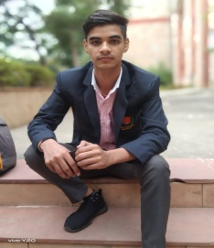

Vipin

Biomedical Engineer

Profile

An enthusiastic student looking forward to learning more about medical instruments and the workflow at hospitals as a biomedical engineer.

Details

**Address**

Jawahar nagar

Jaipur

Work Experience

**Intern at CK Birla Hospital (RBH), Sikar Road, Jaipur, 2023**

I went for internship at CK Birla Hospital after pre-final year. It was a 45-days internship that taught me maintenance and repair of medical instruments and a lot more.

**Intern at EHCC Hospital, Jagatpura Road, Jaipur, 2022**

**Phone**

+91 9588932535

**Email**

Jangamvipin98@gmail.com

**Date of birth**

24-12-2002

Skills

Education

**B.Tech. from Jaipur National University**

Pursuing B.Tech. in Biomedical Engineering from Jaipur National University (2020-2024).

Aggregate (2020-2023): 70%

Microsoft Office

Biomedical Equipments

Computer Programming

Hard working

Fast learner

Extra-curricular activities

**Paper presentations**

Active at presenting papers and presentations about my domain of work. I have presented on topics like:

1. Medical machines like Defibrillator ,ECG and Vantilator .

2. Nanoscience

3. Cryptocurrency and Blockchain Technology