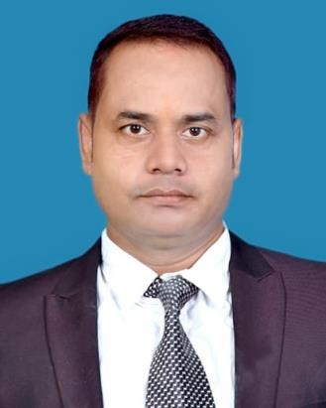**RESUME**

**ALOK KUMAR GHADEI**

# Manager (HR & IR )

E-Mail**:** [alokghadai123@gmail.com](mailto:alokghadai123@gmail.com)

Location: IOCL, Paradip, Odisha ContactNo**:**9078713707 / 8763054327

Qualifination:MBA (Human Resource Management)

**PROFESSIONAL SUMMARY**

## Above 16.5 Years of Experience in HR & IR Jobs with (Iron & Steel) Manufacturing Industries:-HR

Generalist, Recruitment, Plant HR, Industrial Relations, HR Compliances, General Administration.

**KEY SKILLS**

# 

# Excellent verbal and written communication Skills .Excellent Inter-Personal Skills, Negotiation

and Conflict resolution Skills, Excellent Organizational Skills , Analytical and problem solving Skills, Leadership Skills. Managerial Skills, Entrepreneurial Skills. Critical Thinking Skills.

**DUTIES & RESPONSIBILITIES**

* Implementation of HR policies (Recruitment, Selection ,Performance Appraisal ,Compensation

Management , Leave Policy etc.) for bringing out the best from employees.

* Employee Life Cycle Management.
* Recruitment & Induction of new entrants.
* Performance Management & Review.
* Compensation Planning &Administration.
* Attendance , Leaves & Payroll Management.
* Employee Welfare/Sports/Engagement.
* HR Records Administration.
* Ensure compliances under various Applicable Labour Laws.
* Ensure100%compliance for off role employees.
* Liaisoning with authorities under Contract Labour , Factory Inspector ,PF authorities for compliance of statutory obligation under various Labour laws.
* Employee Relations and Administration:.
* Grievance redresser Long-term settlements/wage settlements , Labour unrest/unions,
* Responsible for maintaining harmonious & cordial industrial Relations in the Organization.
* Ensure Administer Company’s Policies relating to Compensation, Benefits, Employee Relations , Health & Safety Programs.
* Responsible for managing dispute resolutions involving Unions, Management & Employees or Government agencies.
* Responsible for HR Statutory Compliances, EPF, ESIC. Labour Laws.
* Responsible for Compliances related to the Employment of Contract Labour

As per Central ACT.

* Responsible for Contract Labour Management.
* Responsible for Employee Welfare Management.

**WORK EXPERIENCES**

## Current Organization :-M/S EAST END TECHNOLOGIES PRIVATE LIMITED , @ INDIAN OIL CORPORATION LTD (I.O.C.L) . PARADIP, ODISHA.

* Job Titl**e:- Manager( HR & IR)**
* Role:-HR Operations ,Plant HR, HR Compliance, General Administration & Industrial Relations
* Reporting to: MD & Director. Period:16th JAN to Present

## Previous Organization -M/S U-Nick Interior & Associates @ Jindal Stainless Limited.

Kalinga Nagar Industrial Complex , Jajpur, Odisha. Job Title:-**Manager (HR & IR)**

* Role:-HR Operations ,Plant HR, HR Compliance, General Administration & Industrial Relations

Reporting to: General Manager..

Period:1st June 2015 to 15th Jan 2023.

## Previous Organization:-M/S OTTO Projects Private Limited @ Jindal Stainless Limited,

Kalinga Nagar Industrial Complex Jajpur , Odisha.

Job Title:-**ADMINISTRATIVE OFFICER**

Role:-HR operations, Industrial Relations, Public Relations & General Administration.

Period:-12th Feb 2012 to 31st May 2015.

## Previous Organization:-M/S Thermotech Synergy Pvt. Ltd @ UGML Wardha ,Maharashtra & BHUSHAN STEEL LTD . Angul Odisha .

Job Title:-**Executive (HR , IR & Admin)**

Period:-09th April 2007 to 15th Feb 2012.

**PROFESSIONAL QUALIFICATIONS**

**MBA :-Master of Business Administration** (**HRM)** from **JK ITM** 2005- 2007(Mumbai) Maharashtra.

**Bachelor of Arts** :- from M.G. College of Education & Technology in 2004 (Utkal University)Odisha.

**Intermediate in Science:-** from V.N. College in 1996. (CHSE) Odisha.

**TECHNICAL SKILLS**

* + Operating Systems: MS Windows 2010 / XP.
  + Office Tools MS Office(Word , Excel & PPT),Internet & E-Mail.

**Personal Details:-**

D.O.B:-22May1977

Permanent Address:-**EB-745, Badagada Brit Colony, Bhubaneswar-751018.**

Marital Status:-Married

Languages Known:-English, Hindi, Odia . Bengali

I hereby declare that the above written particulars are best of my knowledge and belief.

Thanks for your patience and time to go through my resume.

**Date** :-

**Place:-INIDIAN OIL CORPORATION LTD. PARADIP,ODISHA:-754141.**

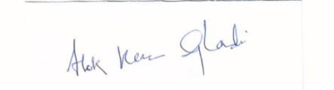

# ALOK KUMAR GHADEI