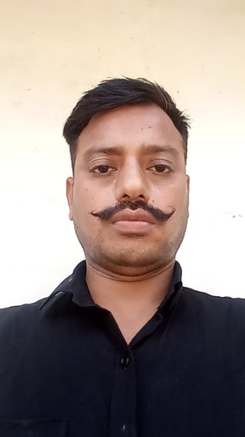 **RESUME**

Name : Brijendra Singh

S/o : Lete Babu Singh

D.O.B : 01/04/1984

Mob : 9002713632

**ADDRESS**

House No. Village Vipausi post kamalpurDIST Kanpur Nagar upPin . 209402

**PHYSICAL MEASUREMENT**

* Height - 178cm
* Weight - 84kg
* MED Cat - SHEPE-1

**EDUCATION QULAIFICATION**

* 10th form up board in 2002.
* 12th form up board in 2009.

√ PSO course NSG manesar

**WEAPON**

* All india License Riwalver.

**WORKING EXPERIENCE**

* 17 years, 15 days in Army.
* (D.O.E. 17/03/2003& Dt of retirement- 31/03/2020)
* 20/12/2021 to 31/5/2021 V.k. pacwell pvt. Ltd Kanpur PSO r35000p.m.

**JOB OPPORTUNITIES**

* To begin my career at a well – liked and well – reputed organization utilizing my abilities and skills developed through my experience and education with an opportunity for career growth based on my ment and to promote the growth of the organization.