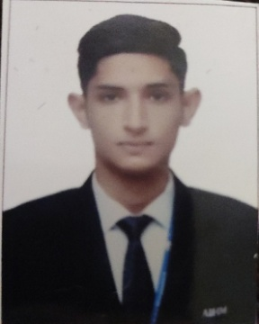 **Curriculum Vitae**

**AVINASH THAKUR**WZ Sant garh,Tilak nagar, New delhi   
110018

**CAREER OBJECTIVE**

Working in an organization where I can work for a long time and improve my talent and skill for my carrier growth.

**EDUCATIONAL QUALFICATION**

* 10thCBSE Board
* 12thCBSE Board
* Student of :

1. BBA 3rd year in Catering Science and Hotel Management &
2. AHLEI 6 Course Hospitality Fundamental Program(USA)

**TECHNICAL KNOWLEDGE**

Basic Knowledge of computer

**INDUSTRY EXPOSURE**

1. Done outdoor catering in different 5 star hotels in Delhi.

**PERSONAL DETAILS**

Father’s Name: Mr. MOHINDER SINGH THAKUR

Date of Birth: 01/08/1998

Marital Status: Single

Nationality: Indian

Sex: Male

Language: English, Hindi, French

Contact no. 9131798662