**CURRICULUM VITAE**

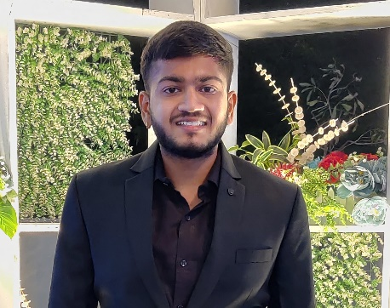

Purvin G. patel

Email Id:-purvinpatel7744@gmail.com

Add:-B-7 Punjibapark society, Dabhoi.

Mob:-9722319222

CAREER OBJECTIVE

To seek a dynamic and challenging career an organization strives for excellence with my knowledge and effort while making positive contribution to promote the individual opportunity and professional growth.

ACADMIC QUALIFICATION

|  |  |  |  |  |
| --- | --- | --- | --- | --- |
| Sr.no. | Class | University | Year | CGPI |
| 1 | BE (CIVIL) | SVIT,vasad | 2020 | 7.13 |

TECHNICAL SKILL

* MS Office: MS word, MS Power point
* Internet ability

FIELD SKILL

* Level surveying
* Material Quantity calculation

LANGUAGES

* English,Hindi,Gujarati

Extra-Curricular Activities

* Taken part in various curricular activities in school and college(as act play, delivering speech, volunteer in events)

STRENGTHS

* Being spiritual nature
* Inherent nature of teaching ,communication skill, house-keeping and taking seminar
* Good managerial and planning skill
* Accepting my weakness and trying to improve
* Curious to learn new things
* Ability to cope with failures and try to learn from them

DECLARATION

I hereby declare that all the information mentioned above is true and complete to the best of my knowledge and belief.