**SHASHI KANTI**

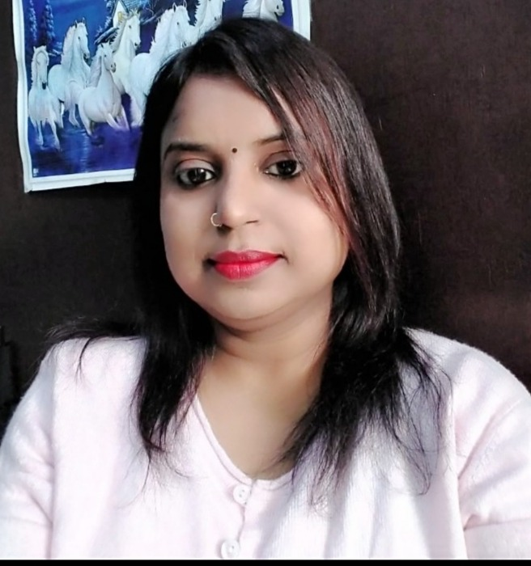

Ex Faculty

RDGV Inter College, Kanpur

|  |  |
| --- | --- |
| **Area Of Expertise**  Resource management  Pupil motivation  Pupil discipline  Curriculum planning  Policy implementation  Planning activities  **PERSONAL SKILLS**  Communication skills  Attention to detail  Keen to Learn  Student focused  Relationship building  **PERSONAL DETAILS**  **Address:**  117/280, B, Q Block Sharda Nagar  Dist.- Kanpur (UP), Pin-208025  Mobile: +91-8180232855  **shrutisingh3100@gmail.com**  **DOB: 28th February 1989**  **Marital Status:** Unmarried | **Personal Summary**  I am is passionate about giving young children the best possible education in life, and enjoys working in a busy environment and relishes the challenge of managing a diverse workload. I am able to establish a supportive relationship with not only students but also their parents and fellow teachers all with the aim of promoting and reinforcing a student’s independence and self-esteem. I am someone who is fundamentally committed to good practice and innovation and who is very much a team player. Always engaged in continuous learning in order to broaden my knowledge and experience, I am confident, passionate and enthusiastic about working with children. I am currently looking for a challenging teaching role that is only limited by the candidates drive and ambition.  **WORK EXPERIENCE**   * 2 years’ experience in Teaching. * 1 year experience in Data operator job. * 6-month experience from Call center job in Delhi.   **QUALIFICATIONS**   * B.Ed Qualified from Kanpur University * T.E.T. Qualified from Allahabad board * M.A. from Kanpur University in2013 * Diploma of Basic computer knowledge   **KEY SKILLS AND COMPETENCIES**  **Teaching attributes**   * Able to create a vibrant and effective learning environment. * Familiar with a variety of approaches to teaching pupils. * Having the ability to motivate and earn the respect of students. * Can work with other professionals, like speech therapists * Occupational therapists. |
| **Language:** Hindi/ English |  |