**BHAVANA CHOUDHARY**

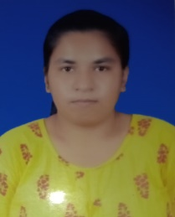 Goregoan (west) MUMBAI: 400104

Phone no: [+91]8591530357

Bhavanachoudhary1868@gmail.com

**Personal Details:**

• D.O.B: 01-06-2002

• Hobbies: Drawing, Cooking

• Language Known: English, Hindi, Marathi, Marwadi.

**Education Qualification:**

|  |  |  |
| --- | --- | --- |
| Course | Board Name | Year of passing |
| SSC | Maharashtra State Board | 2017 |
| HSC | Maharashtra State Board | 2019 |
| BCom | Mumbai University | 2022 |

**Key Skills:**

• Computer skill

• Cooking

• Communication

**Other Achievement:**

Awarded with Hindi handwriting computation.

**Work Experience:**

Blue Bell Finance: Telle calling (personal loan)(1 year experience)

**Declaration:**

I hear by assure you that the above-mentioned information is true to the beat of my knowledge.

Date:

Signature: