**RESUME**

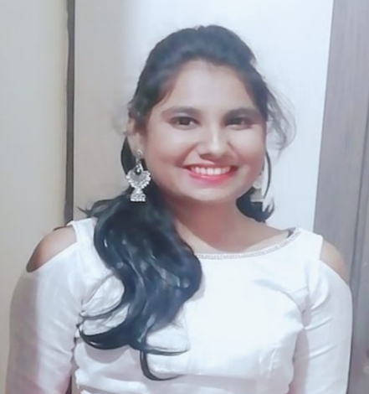

**SOUJANYA SOBARAD**

#202, Sai Shelter’s Apartment

Old IT Road Behind Ganesh Temple,

Vidyanagar Hubli.

Pin : 580021.

Email ID:[**soujusobarad@gmail.com**](mailto:soujusobarad@gmail.com)

Contact No: +91- 8660082114/8217615616

|  |
| --- |
| **Career Objective** |

Seeking for a job to pursue a highly rewarding career and healthy work environment where I can utilize my skills and knowledge efficiently for the organizational growth. A job that gives me opportunities to learn innovative and enhance my skills and strength in conjunction with company goals and objectives.

|  |
| --- |
| **Profile Summary** |

1. An enthusiastic fresher with highly motivated and leadership skills having bachelor of engineering degree in Electrical and Electronics Engineering.
2. Eager to learn new technologies and methodologies.
3. Always willing to innovate the new things which can improve the existing technology.
4. Good communication skills.
5. Hard-worker, disciplined and good etiquette.
6. Positive Thinker.

|  |
| --- |
| **Technical Skills** |

**Programming Languages:** C language, Python, Basics of SQL**,** IOT**.**

**Others:** MS Word, MS – Excel, and MS –PowerPoint.

|  |
| --- |
| **Academic Qualification** |

1. BE from **KLE TECHNOLOGICAL UNIVERSITY HUBLI** with an aggregate of 8.6%
2. 12th from **SAMARTH COLLEGE OF SCIENCE AND COMMERCE HUBLI** with an aggregate of54%
3. SSLC from **CHETAN PUBLIC SCHOOL HUBLI** with an aggregate of 72.64%

|  |
| --- |
| **Academic Project Undertaken** |

1. **Mini Project: - “Control of Hybrid Electrical Vehicles” – (October – January).**
2. **Minor Project: - “Finger print using Pi model” – (February – May).**
3. **Internship: - Have completed my internship in the Month of Feb – July 2023 in the subject IOT(Internet Of Thing’s).**

|  |
| --- |
| **Hobbies** |

1. Dancing
2. Playing Badminton
3. Listening to Music

|  |
| --- |
| **Achievements** |

1. Has been awarded for “All India General Knowledge Competition”.
2. Got Training Certificate Programme on “Challenges and Opportunities in Electric Vehicles technologies Adoption Coimbatore” – Series:- 02.
3. Got certificate from Google in the subject named as “ Google Analytics for Beginners”.
4. Attended 1 day workshop on “Solar Energy-Theory & Hand’s- on Experiment’s” which was conducted in IIT Dharwad.

|  |
| --- |
| **PERSONAL DETAILS** |

1. **Date Of Birth** :- 02 – 05 – 2000.
2. **Languages Known** : English , Kannada , Hindi, Basic German

|  |
| --- |
| **DECLARATION** |

I hereby declare that all the information mentioned above is true and

complete to the best of my knowledge and belief.

**Date :-** 23-06-2023

**Place :-** Hubli.

**SOUJANYA SOBARAD**