RESUME

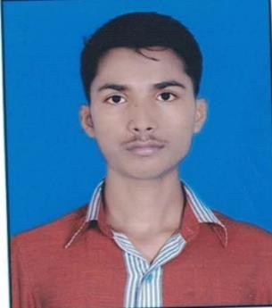

# KANOJIYA RAVIKUMAR RAMCHANDRA

**E-mail**: [0999bhuvan@gmail.com](mailto:0999bhuvan@gmail.com)

**(M**): 6394924406

# ADDRESS:-

132, Bhagvatinagar , Kathwada GIDC, Singarava, Daskroi, Ahmedabad, Gujarat

PIN-382430

# OBJECTIVE:-

To succeed in responsibility centered environment with decision authority and to provide value added services to organization, to constantly strive to enhance knowledge and learning innovative way of doing assigned work.

# PERSONAL DETAILS:-

* Date of Birth : 29/08/1999
* Gender : Male
* Hobbies : Reading and Watching Movies.
* Languages Known : Gujarati, English, and Hindi
* Nationality : Indian
* Category : GANERAL

# ACADEMIC CREDENTIALS:-

|  |  |  |  |  |
| --- | --- | --- | --- | --- |
| **Sr. No** | **Degree** | **Board/University** | **Year** | **%** |
| 1. | 10th | GSEB | 2016 | 58.83% |
| 2. | ITI | NCVT | 2019 | 73.42% |
| 3. | 12th | GSHEB | 2021 | 45.54% |

**SKILLS:-**

* Team Work
* Quick learner
* Commitment to Hard work
* Desire to succeed

# COMPUTER SKILS:-

* Basic knowledge of computer.
* Internet Browsing

# JOB EXPERIENCE:-

* SUZUKI MOTOR GUJRAT Skill Source learning and Technology Pvt. Ltd National technical Institute 29-July-2020 to 27-Feb-2021 7 months.

# DECLARATION: -

I, RAVI declare that all the information given above is true.

Yours faithfully KANOJIYA RAVI