SATYAPAL JAT

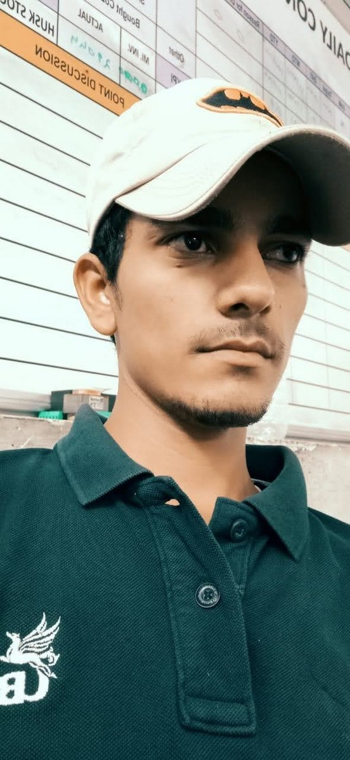

[SATPALJAT78@GMAIL.COM](mailto:SATPALJAT78@GMAIL.COM)

# +91-(8058891832)

**Current Address : - Village birod, post palawa , Dist - Alwar Rajasthan – 301706**

**Objective**

To obtain a job in a company renowned for its excellence and to have consistent growth in the company through my fullest efforts and knowledge.

# Academic Qualifications

|  |  |  |
| --- | --- | --- |
| **Examination** | **Board** | **Percentage** |
| I.T.I. (Fitter) | Ncvt jodhpur | 62.96 |
| 12th | Bser ajmer | 57.20 |

|  |  |  |
| --- | --- | --- |
| 10th | Bser ajmer | 58.50 |

**Technical Skills**

⮚ MS Office: MS WORD, MS Excel, PowerPoint Manufacturing : Basic Manufacturing Processes

⮚

Inspection Methods

# Training & Work Exp.

* **1 year apprenticship** parle biscuit private ltd.neemrana
* 1 year Djdc batry private ltd.bawal
* **I am working in UNITED BREWERIES LTD** since november 2019 Shahjhanpur Alwar. As a **Maintenance Fitter**

# Job Profile

* **Preventive Maintenance as per standard Format.**
* **Shutdown maintenance as per standard Format.**
* **All utility basis maintenance**
* **All type pumps Repairing.**
* **All type Gear Box maintenance.**
* **Machine aliments & Screw Conveyor , Chain Conveyor .**
* **Plumber work upvc cpvc ppr pp pvc pipe fitting**
* **Ark welding and plastic welding**
* **Botling line Conveyor Maintenance**
* **PHE, NUMETIC AIR LINE, PIPE LINE & VALVE**

Name: SATYAPAL JAT

**Personal Dossier**

Father’s Name: CHANDRAM JAT

Date of Birth: 10-08-1995

Languages: English, Hindi

Marital Status: married

Email Address: [SATPALJAT78@gmail.com](mailto:SATPALJAT78@gmail.com) Permanent Address: Village birod, post palawa

Tehsil mundawar, district alwar Pin 301706

**Declaration**

I do hereby declare that the particulars of information and facts stated herein above are true correct and complete to the best of my knowledge and belief.

Place: shahjahanpur

(SATYAPAL JAT )