RESUME

**Sadhana Bhalchandra sonje**

Email: sadhanasonje123@gmail.com

Mob No:9322834237

**Career Objective:-**

To secure a position that offers me an opportunity to utilize my skills & abilities in development field with professional growth & challenging work while being resourceful, innovative & flexible.

**Academic Records:-**

* **M.sc in computer science from B.P.Arts ,S.M.A science and K.K.C college c Commerece college chalisgaon(North Mahararastra university of Jalgoan) Year 2023**
* **B.Sc. in computer science** From **Zulal Bhilajirao Patil College. Dhule(North Maharashtra university of Jalgoan)** passed 77.08% % with **Distinction** in the year of 2021**.**
* **H.S.C** From **F.M.Khandelwal college of shirud (Nashik Board)** passed 62.31 % with **First Class** in the year of 2018**.**
* **S.S.C** From **Nutan madhymic kanya vidhymdir borkund Ratnpura(Nashik Board)** passed 81.60% with **Distinction** in the year of 2016.

**Strengths :-**

* Self motivated, initiative, high level of energy
* Flexible and adapt quickly to new working environments
* My thought implementation in new activities
* Strong determination to succeed
* Accuracy and Attention to details

**Project:-**

* Project Name : Online Real Estate
* Tecnology : PHP
* Description:

This application us develoveloped in PHP

**Languages & Skills in computer:-**

Programming Languages:

Procedural language:c programming

Object Oriented Programming:C++ Programming

Web Technologies:HTML,CSS,Javascript

Database:PL/SQL(oracal),MySQL,MS SQL

**Personal Information :-**

**Name :** Sadhana Bhalchandra Sonje

**Date Of Birth :** 25 Oct 1999

**Language :** Marathi,Hindi and English

**Gender :** Female

**Marital Status :**Unmarried

**Nationality :** Indian

**Permanent Address :** At Ratanpura Post Borkund,

Tal & Dist Dhule,

Pin Code-424308.

**Declaration:-**

I hereby declare that all the information mentioned the above is true and correct to best of my knowledge and belief.

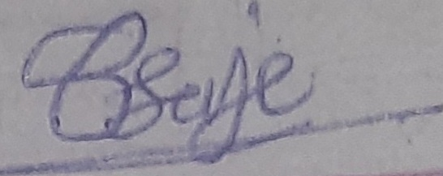

Sadhana Bhalchandra sonje

(Signature and Name)