**KR Saneesh**

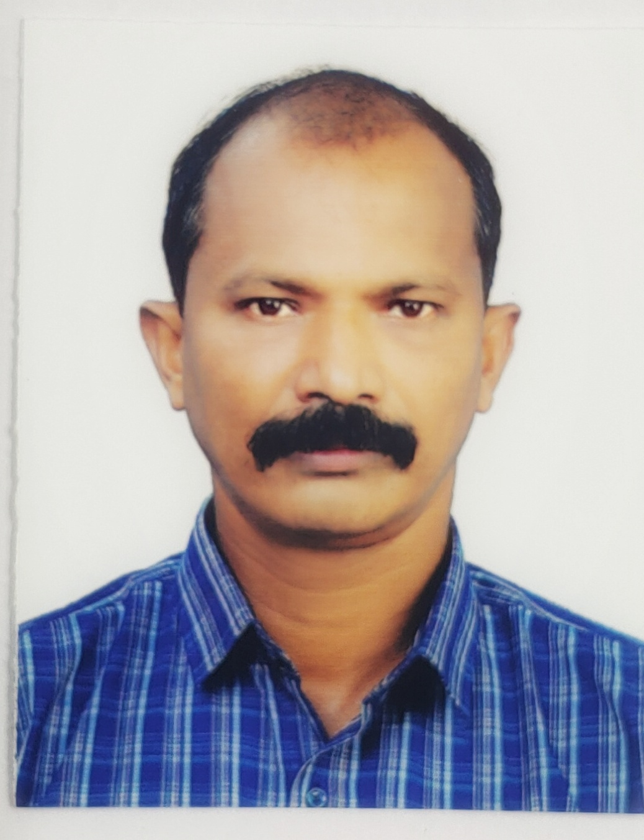

+91-9497304225 | [saneeshkpr@gmail.com](mailto:saneeshkpr@gmail.com)

**Leadership| Human Resource Professional | Organizational Development**

Veteran Human Resource Management leader, with more than 33 years’ experience. Enhancement organisational continuity through foresight, initiation, planning and optimization of human resources. Adept at prioritizing human resource requirements and skill set.

Develop, train and mentor large, culturally diverse, multi-lingual and teams in fast-paced, ambiguous and challenging environments. Deliver strategic advantages through interactions and liaisons with key stakeholders in public and private sectors. Drive strategies with result oriented focus across multi-functional groups to optimize the Organizations’ progress. Recognized as a value creator who leads initiatives and achieves organizational growth through building consensus.

**Additional Competencies**

**Logistics | General Management | Event Management | Supervisory Role | Stakeholder Engagement | Risk Mitigation | Crisis Management** **|**

**Professional Experience | Executive Highlights**

**Human Resource Management / Development**

* **Revitalized HR efficiency** in an environment characterized by varied challenges and ambiguity, by driving a multi-pronged change strategy.
* Spearheaded planning for operations, HR management, administration, financial management, accounting, intelligence management, and people management and training**.**
* Ensure co-worker orientation, Code of Conduct and monitoring its implementation.
* Drive and implement people and cultural change agenda pan-organization.
* Adapt organizational HR concepts to local needs and implement support actions where needed**.**
* Achieved expertise on Human Resources Management during tenures with various Army Units, United Nation Mission in Congo and National Security Guards.
* **Enhanced morale and** motivation of a large team by defining and implementing new training objectives, creating a sense of ownership and empowerment, and enabling a continuous process of feedback and change.

**Organizational Development**

* Drive implementation of good management and accountability standards.
* Communicate changes in the organization’s personnel policies and procedures and ensure that its proper compliance followed.

**HR Data Management**

* Ensure regular HR reporting and maintenance of data.
* Ensure Mid-Term Planning validations of HR expenditures.
* Coordinate or conduct exit interviews**.**

**Workforce and Compensation Management**

* Drive, manage and monitor implementation of HR strategy, policies, and guidelines in the central and regional offices. Drive strategic workforce planning.
* Support the higher Director, Regional entities with expertise, consultancy and controlling in the areas of human resources and organization development.
* Maintain knowledge of trends and employment legislation and ensure organization's compliance.

**other Competencies**

* Long practical experience in man management.
* Ability to manage and lead men.
* Material handling and management to include vehicles and other resources.
* Logistics provision.
* General Administration.
* Events Management.
* Acquired Diploma In Supervisory Management & Human Resources Management.
* Learning and Development.

**International Exposure**

Part of Indian United Nations Peace-Keeping Force in the Democratic Republic of Congo.

**Education**

Matriculation.

Diploma in Supervisory & Human Resources Management.

Various Military courses and cadres.

Subedar Major Course of Indian Army.

**Additional Information**

**Languages Fluent:** English, Hindi and Malayalam

**Willingness to Relocate**: Yes

**Honours and awards**

**C-in-C Andaman & Nicobar Command Commendation Card**

**Sainya Seva Medal (Arunachal NEFA)**

**United Nation Mission in Congo Medal**

**Videsh Seva Medal**

**CISC Commendation Card**