RESUME

NAME : Tapas Kumar Palai 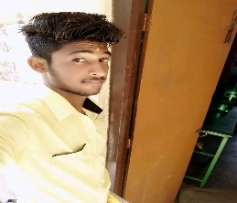

C/O : Muktikanta Palai

AT : SOLAGAN , TENTEI

DIST : BALASORE , ODISHA , 756046

MOB : 9337101074

EMAIL : [tapaspalei224@gmail.com](mailto:tapaspalei224@gmail.com)

OBJECTIVE

My desire is work with a company that provides open work environment.

I am graduate in b.com and continuing my MBA in BPUT. I am enclosing a

Copy of my details resume for ur kind verification and further action .

If any further information required by you , I will be feel glad to

Provide.

STRENGTH

* Positive attitude
* Good listener
* Very fast learner
* Quick verbal calculation of the math

ACADEMICS AND EDUCATION PROFILE

|  |  |  |
| --- | --- | --- |
| COURSE | BOARD OF EDUCATION | YEAR |
| SSLC | B.C HIGH SCHOOL TENTEI | 2013 |
| PUC II (COMMERCE) | U.N COLLEGE SORO | 2016 |
| B.COM | F.M UNIVERSITY | 2019 |
| MBA | BPUT | CONTINUING |
|  |  |  |

COMPUTER KNOWLEDGE

* MS OFFICE
* MS EXCEL
* MS WORD
* TALLY ERP9

OVERALL EXPERIENCE

I am a fresher.

PERSONAL INFORMATION

NAME : Tapas kumar palai

Mother’s name : Banita Palai

Father’s name : Muktikanta palai

Date of birth : 07/01/1998

Nationality : Indian

Religion : Hindu

Marital status : Single

Gender : Male

Language known : Hindi , English , Odia

Hobbies : Playing cricket, watching movies , reading books

Declaration

I hereby that the above information is to true and correct to the best of my

Knowledge and belief

Date :

Place :Odisha