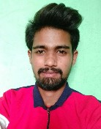**Aniket Damodhr Khorgade** [khorgade245@gmail.com](mailto:khorgade245@gmail.com) 7020268824

**CAREER OBJECTIVE**

A challenging Career which offers an opportunity to apply my skills knowledge with continuous learning and growth.

**EXPERIENCE**

**Sep-2018 - Aug-2021 Machine Opratar, and DJ. Opratar computer**

**Fun Planet Water park PLT**

**EDUCATION**

|  |  |  |  |  |
| --- | --- | --- | --- | --- |
| Degree/Course | Institute/College | University/Board | Percentage/ CGPA | Year of Passing |
| High school | Adarsh vidyaly Patnsaongi | Maharashtra Bord | 63.60 % | 2016 |
| Entermedite | Baba Saheb kedar kanishth mahavidyaly | Maharashtra Bord | 60.00 % | 2018 |

**HOBBIES**

Cricket

**PERSONAL DETAILS**

Address Village ward. No. 3 Wakodi Nagpur, Maharashtra, 441101

Date of Birth 13/07/1998

Gender Male

Nationality India

Marital Status Single

Languages Known Hindi, Marathi

**DECLARATION**

I hereby declare that all the details furnished here are true to the best of my knowledge and belief.

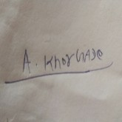

Aniket Damodhr Khorgade