**ABDUL HAMEED**

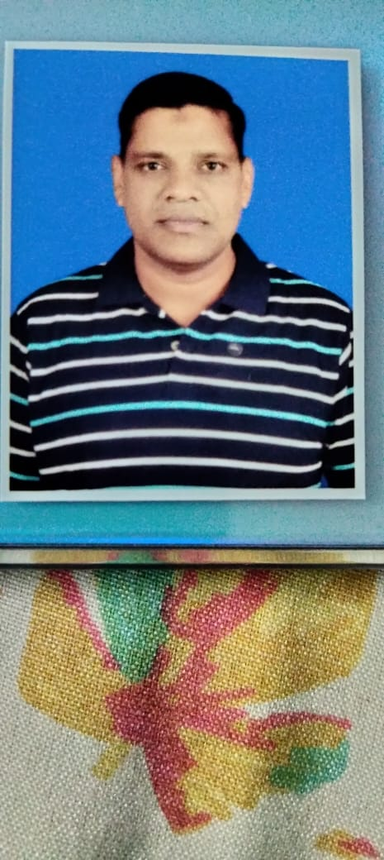

D.NO 2-30, VILL & PO -- ISLAMPETA

DISTRICT -- VISAKHAPATNAM

ANDHRA PRADESH – 530031

**MOBILE**: **+918527470121** **EMAIL**: [abdulhameed724737@gmail.com](mailto:abdulhameed724737@gmail.com)

An accomplished professional with strong management skills and exposure to a wide variety of functions, seeking senior level assignments in General Administration/HR/Safety & Security with a growth oriented institution.

**CARRER SUMMARY**

• An established professional with experience of 26 years in Indian Air force as a Junior Commissioned Officer in the areas of General Administration, HR Management ,Transport management ,Airfield management ,Aircraft refuelling procedure management ,Manpower Management, Campus safety & Security Management, Housekeeping management, Inventory & Logistics Management, Warehouse management and Audit management

• Possess exceptional knowledge of Administration, Manpower management, Campus safety and security, Transport, Airfield, Fire fighting audit, Housekeeping, Logistics, Stores, Inventory and Procurement procedures

• Developing & implementing Key Procurement Strategies and ensuring that plans are aligned with all contractual & statutory requirements; creating contingency plans to ensure smooth functioning of the system

• Driving the entire gamut of administrative matters including in depth campus safety and security, daily matters, Facility management, Vendor management, office management

• An effective communicator with excellent interpersonal skills and capability to relate to people at any level of business and management

• Proficient in Transport management, Airfield and security management and warehouse, aircraft refuelling and aircraft transport management procedures and logistics functions

• Adept in handling all general administrative activities in co-ordination with internal/external departments.

• Target and achievement oriented with an ability to take up challenges, Natural leader, demonstrate good team management skills with diverse groups and level.

_________________________________________________________________________________________

**CORE COMPETENCIES_AND SKILLS**___________________________________________________________

• Transport Management • Material & Inventory Management

• Security Management • Human Resource Management

• Facility and Housekeeping management • Airfield Management

• Logistics management • Team Management

• Mess & Hostel management • Administration & office management

• Manpower management • Liaison management

• Warehouse management • personnel management

• Aircraft refuelling management • Aircraft transport management

• Operating Indian & Russian Vehicles •Training & Development Management

• Disciplinary Matters Event Management •supervisory management skills

**ORGANISATIONAL EXPERIENCE**

Joined Indian Air Force on 17 Dec 1996 and Date of release from Indian Air Force 31 Dec 2022

As on date working as a Junior Commissioned Officer in Indian Air Force

**KEY RESULT AREAS**

• General Administration

• Daily matters & activity, Office management

• Human resource management, Manpower Hiring & Management

• Transport Fleet Management

• Labour hiring through contract and distribution

• Facility Management

• Housekeeping Management

• Campus Safety & Security Management

• Fire Fighting Safety audit

• Stores and Warehouse Management

• Logistics activities

• Coordinating with external agencies

• Spearheading end-to-end administration activities inclusive of finalisation of SOP

• Civil liaisioning

• Aircraft refuelling transport management & many more

• Team management

• Event management

**ACADEMIC DETAILS**

**EDUCATION**  **UNIVERSITY** **YEAR**

• ASSOCIATE DEGREE IN SCIENCE IGNOU 2013

• DIPLOMA IN AUTOMOBILE IGNOU 2012

• CERTIFICATE IN SECURITY MANAGEMENT OF IGNOU 2011

STRATEGIC INSTALLATIONS

•GRADUATE (BA) BERHEMPUR 2000

•MANAGEMENT DEGREE ANDHRA UNIVERSITY 2010

**TRAININGS**

• Transport management cum operation of Indian and Russian vehicles by Indian Air Force

• Logistics management by Indian Air Force

•Aircraft refuelling and airfield management by Indian Air Force

•HRM by Indian Air Force

•Security Management by Indian Air Force

• Integrated Material Management On-Line System (IMMOLS) ERP System by Indian Air Force

•Equipment management and maintenance system (EMMS) BY Indian Air Force

•F ire safety management by Indian Air Force

**TECHNICAL SKILLS**

• Software Package: MS Word, Excel & Power Point

•Management supervisory skills

**PERSONEL DETAILS**

**FULL NAME**  : ABDUL HAMEED

**DATE OF BIRTH** : 18-09-1977

**EMAIL ID**  : [abdulhameed724737@gmail.com](mailto:abdulhameed724737@gmail.com)

**CURRENT COMPANY**  : INDIAN AIR FORCE

**CURRENT DESIGNATION**  : JUNIOR COMMISSIONED OFFICER

**PREFERED DESIGNATION**  : TRANSPORT/SECURITY/LOGISTICS/SAFETY OFFICER

AIRFIELD OFFICER/HRM

**CURRENT LOCATION**  : VISAKHAPATNAM

**PREFERED LOCATION**  : VISAKHAPATNAM

**CURRENT INDUSTRY**  : DEFENCE (INDIAN AIR FORCE)

**PREFERED INDUSTRY**  : E-COMMERCE/COMMERCIAL / NON COMMERCI

AL/ AUTOMOBILE/AERONAUTICAL/ AIRPORT

PHARMACEUTICAL/AIRFIELD/MANUFACTURING

CONSTRUCTION/LOGISTICS

**LANGUAGES KNOWN :** ENGLISH, HINDI, TELUGU, ODIYA AND URDU

**CURRENT SALARY**  : 9.0 LACS

**SALARY EXPECTED**  : 5.8 LACS

**TIME REQUIRED JOINING**  : AFTER JAN 2023  **QUALIFICATION** : ASSOCIATE DEGREE IN SCIENCE/MANAGEMENT

DIPLOMA IN AUTOMOBILE

CERTIFICATE IN SECURITY MANAGEMENTOF

STRATEGIC INSTALLATIONS

**EXPERIENCES :** 26 YEARS OF EXPERIENCE IN INDIAN AIRFORCE AS A

JUNIOR COMMISSIONED OFFICER IN THE FIELD OF

TRANSPORT/AIRFIELD/LOGISTICS/SAFETY/HRM

SECURITY/CRISIS/VENDOR/LIAISON/ PERSONNEL/

MANPOWER /HOUSE KEEPING/INVENTORY/

WAREHOUSE MANAGEMENT/GENERAL ADMINIST

RATION/AIRCRAFT TRANSPORTAND REFUELLING

**CONTACT NO :** 8527470121/7011831730