**Deepthi PS**

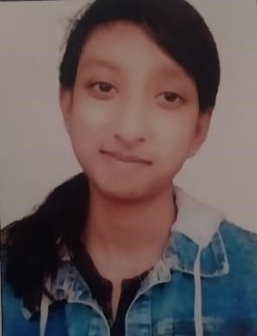

**"Seeking entry-level IT position to apply skills, learn, and contribute to innovative tech solutions and projects."**

[**Email:deepthis287@gmail.com**](mailto:deepthis287@gmail.com?subject=mail)

**Contact:** 8088413427

**Address :** no.96 4th cross bangaragiri

layout modigarden , banglore 560004

EDUCATIONAL INFORMATION

|  |  |  |  |  |
| --- | --- | --- | --- | --- |
| COURSE(SUB) | SCHOOL(COLLAGE) | | PERCE | |
| SSLC(2015-17) | GFGC High school Periyapatna | | 72% | |
| PRE UNIVERCITY COURSE  ,commerce[computer science]  (2018-19) | Basaweshwara Independent P U Collage periyapatna Mysore dist 571107. | | 72% | |
| B.com First grade Collage  (2019-2022) | Govt. First Grade Collage Periyapatna | | 85% | |
|  | BASIC TECHNICAL SKILLS | |  | |
| Programming Lang | : | Python | |
| Web development | : | HTML, CSS, BOOTSTRAP, JAVASCRIPT.  Basic knowledge = Networking and AWS | |
| Operating system : |  | Windows 10/7 | |
| Applications | : | Microsoft word/Excel/PowerPoint /  SSMS 18, visual studio code,  Tally erp 9, | |
|  |  | EXPERIENCE(INTERN) | |

Latpas institute of software developer institution banglore

6TH Month experience of HTML ,CSS , Javascript , python.

PROJECT 1 : Banglore web page With the help of (HTML ,CSS,JS) .

PROJECT 2 :Simple calculator based on python .

CERTIFICATION OF GOVT COMPUTER OFFICE AUTOMATION COURSE.

(ms office,word ,excel, powerpoint,nudi and tally).

AREAS OF STRENGTH

* Understanding the situation and solving the problem.
* Flexible enough to handle situation and making better decision.
* Management time and work
* Good presentation skill

PERSONNEL DETAILS

Name : deepthi ps

Mother name : Shashikala

Father name : Sunil kumar

DOB : 09/02/2001

Languages : kannada and English.

Hobbies : writing,reading,istening music,video editing.

Adress : R T nagar,banglore 560006.

DECLARATION

I here by declare the all the information furnished above is true to best of my knowledge

-DEEPTHI P.S.