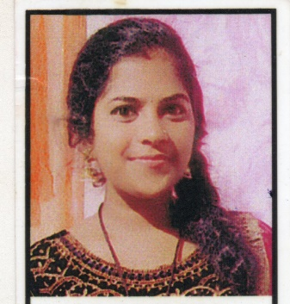**CURRICULUM VITAE**

|  |  |  |  |  |  |  |
| --- | --- | --- | --- | --- | --- | --- |
| **Rajeshwari S** |  |  | |  | | --- | |  | | |  |  |
|  |  |
| D/o Shivaputrappa | |  |  |  |  |
| Sathkodige Byredevaru, | | |  |  |  |
| Koppa Tq, Chikkamagaluru Dist. | | |  |  |  |
| Karnataka -577123 |  |  |  |  |  |
| Mobile No : +91- 8618071023 | |  |  |  |  |
| [Email ID : rajeshwariraju@gmail.com](mailto:Email%20ID :%20rajeshwariraju@gmail.com) | |  |  |  |  |

**OBJECTIVE:**

I would like to work in an organization that nurtures professional growth records, innovation and creativity and values hard work, I view myself as an asset of the organization and could make positive contribution.

**QUALIFICATION:**

|  |  |  |  |  |
| --- | --- | --- | --- | --- |
| **Course** | **Institution** | **Board** | **Year of Passing** | **Percentage Of Marks** |
| B.COM | Govt First Grade College Hebri | Mangalore University | 2022 | 70.34% |
| PUC | Govt PU College Hebri | Department of Pre University Education | 2019 | 78.50% |
| SSLC | ST Joseph High School Koppa | Karnataka Secondary Education Examination Board | 2017 | 73.28% |

**OTHER QUALIFICATION**:

* Basic Computer Knowledge (Ms Word, Ms Excel, Tally, Powerpoint, Nudi)

**PERSONAL DETAILS:**

Name : Rajeshwari S

Father Name : Shivaputrappa

Gender : Female

Date of Birth : 11/02/2001

Nationality : Indian

Marital Status : Unmarried

Languages Known : English, Hindi, Tulu & Kannada

|  |
| --- |
| STRENGTHS & COMPETENCIES |

* Ability to learn new things quickly
* Positive & practical approach with a can do attitude
* Capable of sustained effort to complete given tasks as early as possible.

|  |
| --- |
| HOBBIES |

Reading Books, Listening Music, Singing, Dancing & Gardening.

**DECLARATION:**

I solemnly declare that above information is correct to the best my knowledge.

Date:   
Place : Hebri Yours Faithfully

*(Rajeshwari)*