SHRUTHI MURARI RAO JADHAV

No.28, Third Floor, 3B,

1st Cross, 1st Main,

Cholurpalya, Magadi road,

Bengaluru – 560023

[shruthiarun91@gmail.com](mailto:shruthiarun91@gmail.com)

Ph No: 7259825424/6361459557

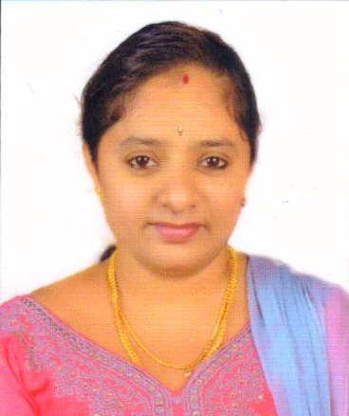

*Looking for a position where I can use my experience and my ambition to grow both as a team member and as an individual inside a company.*

# PERSONAL INFORMATION

* Born May 2nd, 1991
* Citizenship: Indian
* **MARITAL STATUS: MARRIED**

# WORK HISTORY

09. 2010 – 02.2018 **WIPRO INFOTECH**

**ASSOCIATE ENGINEER**

* Network support (**Projects:** HDFC, Shared NOC, Suzlon)
* Application support (**Projects:** RGI, NABARD)

09. 2010 – 11. 2013 **SKILLSET**

* Troubleshooting client specific applications via phone using remote desktop.
* Report preparation using MS Excel.
* Interacting with customer, understanding their application related problems and delivering the right solution within the stipulated SLA.
* Installation and troubleshooting of network printers & and local printers
* Installing applications like browsers, Winzip, Adobe reader, Microsoft office, open office etc.
* Resolving system performance issues by clearing temporary files, cache etc.

11. 2013 – 12. 2015 **SKILLSET**

* Worked in Network Operations Centre (NOC)
* Receiving customer complaints via phone/mail, providing first level troubleshooting and logging tickets to the relevant category using the ticketing tool (E-Helpline) and doing end to end follow-up till the ticket closure.
* Report preparation using MS Excel.
* Doing first level network troubleshooting using ping, tracert, telnet etc.

12. 2015 – 02.2018 **SKILLSET**

* Good Knowledge on Cisco networking concepts
* Good Knowledge on handling Wipro ticketing tools like E-Helpline.
* Good Knowledge on handling network monitoring tools like Event Grid, Spectrum etc.
* Timely follow-up with networking vendors via mail and call. End to end follow-up and providing resolution to the customer/client.
* Good knowledge on Microsoft office (Excel and Word)
* Good knowledge on Routing, Switching, LAN and WAN technologies
* Good knowledge on networking concepts like Subnetting, OSI model, DNS, DHCP, BGP, OSPF etc
* Managing LAN & network related issue, taking daily backup of switches & routers.
* Good knowledge on BGP traffic diversion, static routing.
* Good communication skills, both verbal and written

09. 2021 – Present **Fidelis GROUP**

**desktop engineer**

* Desktop support (**Project:** Heineken)
* IT support (**Project:** UBL)

09. 2021 – Present **SKILLSET**

* Installing, Configuring and Troubleshooting the Windows7 & windows10
* Configuring & troubleshooting of Systems/Laptops for L1 levels & Managing data backup and recovery
* Collecting IMAC after providing newly configured systems.
* Laptop/systems format and reinstallation
* Installation and Troubleshooting of Network printers & and local printers
* Maintain IT Assets & peripherals.
* Provide Share folder access to customers as required and mapping share folders in client systems.
* Active directory user password reset; password lock/unlock.
* Installation and configuration of Crowdstrike antivirus.
* SAP GUI installation and configuration.
* User password reset/lock/unlock in SAP GUI (SU01)
* Provide support in resolving Networks problem & troubleshooting of WiFi connectivity issue.
* Configuring Microsoft Outlook and troubleshooting mail problems.
* Office 365 installation and configuration.
* Providing technical assistance to remote location engineers
* Troubleshoot Network connectivity (LAN) issue & Internet issue
* Enterprise scan installation & configuration
* Setup and Administration, Device Management, Application & Patch Management, Disk and File system Management, System Security Management, Performance Management
* Preparing MIS report, comparison data, day to day pending ticket report using MS Excel

# EDUCATION

**2006–2009 JSS POLYTECHNIC FOR THE PHYSICALLY HANDICAPPED**

**DIPLOMA IN COMPUTER SCIENCE AND ENGINEERING**

* Main Subject was Computer Science and Engineering
* University: BTE Bengaluru
* Percentage: 63.95%
* First Class

**2006 GOVERNMENT HIGH SCHOOL KRISHNARAJASAGARA**

**Matriculation**

* Certified by KSEEB Bengaluru
* Percentage: 61.44%
* First Class

# LANGUAGES KNOWN

|  |  |  |  |
| --- | --- | --- | --- |
| **Language** | **Read** | **Write** | **Speak** |
| English | Yes | Yes | Yes |
| Hindi | Yes | Yes | Yes |
| Kannada | Yes | Yes | Yes |
| Marathi | No | No | Yes |
| Malayalam | No | No | Yes |

# AWARDS & RECOGNITIONS

* Certificate received for being unique example of dedication and great work from Wipro Infotech, Mysore. (Spot Award)

# CERTIFICATION/DECLARATION

I do hereby declare that all the above information furnished by me are true and correct to the best of my knowledge.

Bengaluru

Sign

01/12/2022