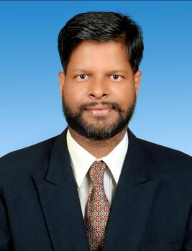

**RESUME**

MANOJ KUMAR THAKUR

**Diamond Crossing Railway colony**

**Naya Bazar Bank More Dhanbad**

**Jharkhand-826001**

**e-mail-manojkumar0202@gmail.com**

**MOBILE .NO.-8667271072**

**Objective**

**To work in a stimulating environments conducive to growth for optimum utilization of my technical skills**

**Experience**

* 1 -LUPIN Pharmaceuticals Ltd.–Respiratory Div.

Duration. 10 April 2009 to 2016 Oct. MEDICAL REPRSENTETIVE

* 2 - KURESYS LAB LTD. TERRITORY MANAGER

Duration: 01 Nov 2018 to Nov 2019

Location: - Bangalore

* 3 -Good Hums Life Science Pvt. Ltd. (ABM Jharkhand)

Duration: 2nd January 2020 to 2022 July

Location: - Ranchi

* 4 -Morksons pharmaceutical Pvt.Ltd. (ABM Jharkhand)

Duration: - 06/08/2022 to till Now

**Professional Qualification**

* Diploma course in computer (TALLY, BASIC DFA) from DHANBAD.
* Basic knowledge Of Computer

**Technical Skill**

Operating System **: -** Windows XP, 2000, 2003

* Networking CCNA
* AWS cloud ( Ec2,S3 Bocket , Lambda, Instance ,VPC,IAM, RSD)
* Devops( Jenkins ,Kubernet, Ansible, Teraform, CICD Pipeline

Docker, Git hub Ubuntu)

* Azure 104

**Hobbies: -**

**Working Innovative Idea Tour Traveling, Bike Riding, Photography, Cooking, New friendship**

**Academic Qualifications**

* **B.com** (A/C Hons.) From **BVU UNIVERSITY** (Graduate G N College Dhanbad) Complete in the year 2008.
* **Intermediate Commerce** from GN Collage Dhanbad Complete in the year 2004
* **Matriculation** from **J.A.C** (RSP. School Jharia Dhanbad Complete in the Year 2002

**Personal profile**

* **Father ‘s Name : Sri. Chandeshwar Thakur**
* **Date of Birth : 2nd Feb. 1987**
* **Religion : Hindu**
* **Gender : Male**
* **Marital Status : Married**
* **Language : English & Hindi**
* **Nationality** : **Indian**
* **Height : 5.10inch**

**Place: Ranchi**

**Date:**  Manoj kumar Thakur

**Signature**