**Machana Sai Bhavani**

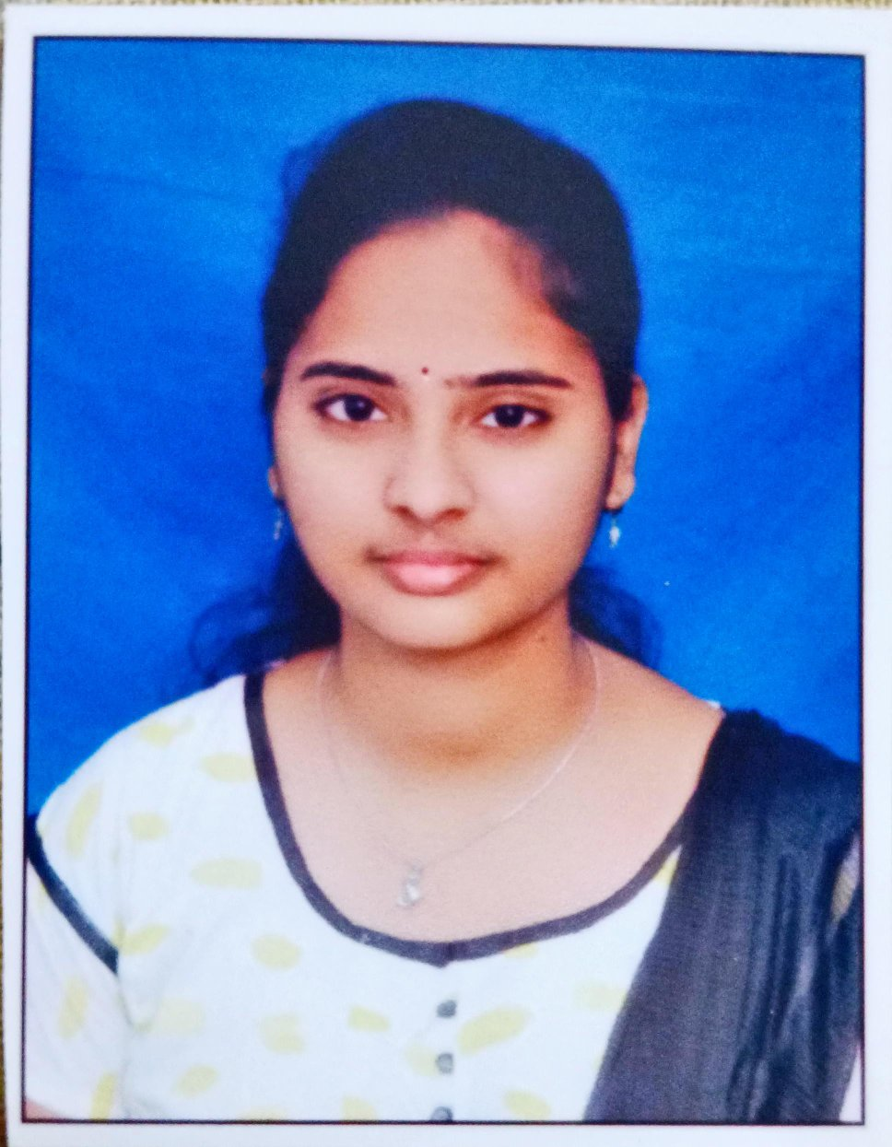

Mobile: +91 9490247723

Email ID: [machanasaibhavani9491@gmail.com](mailto:machanasaibhavani9491@gmail.com)

**Career Objective:**

Being ambitious and hardworking, I am looking forward to challenging my potential and be worthy of Management trust and confidence.

**Education:-**

|  |  |  |  |  |
| --- | --- | --- | --- | --- |
| **Qualification** | **Institution** | **University/Board** | **Year of Passing** | **Percentage** |
| B. Tech (ECE) | Potti Sriramulu Chalavadi Mallikarjuna Rao College of Engineering & Technology | JNTU-K | 2022 | 68 |
| Diploma | Vijaya Institute of Technology for Women | APSBTET | 2018 | 72 |
| SSC | Sree Seven Hills E.M High School | S.S.C | 2015 | 88 |

**Skills**

Software Languages: C, Java.

Operating Systems: Windows, Android

**Work Experience:**

1. Currently working as a Associate Software Engineer in NEWFOUND INFOTECH PRIVATE LIMITED, from May 30th, 2022 till date.

**Project1 :-**

**Project Title : Uk-PostOffice**

**Client** : UK

**Technologies** : Core Java,J2SE

**Database :**  Mysql

**Project Description:**

UK Post Application is offering a fully integrated end-to-end business information system for stamp-selling, stamp-accepting, rod-fishing license, courier-tracking, return-stamps and many more .It focuses on powerful back-office financial management tools, known generally as Enterprise Resource Planning (ERP).

**Roles & Responsibilities:**

* Involved in designing, developing the application using JSP, core Java.
* Involved in developing action, service and Helper classes coding.
* Involve to Write the test cases of unit-testing and e2e testing
* Involved in Database connectivity through cloudant and JSON structure database properties file
* Preparing System Design documentation.
* Add plug-in to project.

**Personal Details**

Date of Birth : 09-11-1999

Gender : Female

Marital status : Single.

Languages Known : English, Telugu.

Nationality : Indian

Hobbies : Listening Music, Gardening.

**Declaration**

I hereby declare that the details above are correct and true to the best of my knowledge.

**Place:** Vijayawada

**Date:** 20-04-2023.

**Signature**

**Machana Sai Bhavani**