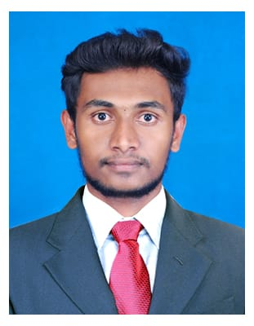

**Suijithkumar R**

**Jay Hanuman Chawl No -2 Nagwdi , P L L Marg  
Near by Hanuman mandir Chembure**

**Mumbai - 400089**

**E-mail Id:Sujithkumar48051@gmail.com**

**Contact No: +9629594847**

**CAREER OBJECTIVE:**

To be involved in work where I can utilize my skills and creatively with the system that effectively contributes to the growth of the organization.

**EDUCATIONAL QUALIFICATION:**

|  |  |  |  |
| --- | --- | --- | --- |
| **DEGREE** | **INSITITUTION** | **YEAR OF PASSING** | **PERCENTAGE** |
| DME | Bharath polytechnic college, Tiruchengode | 2017 - 2019 | 72% |
| HSC | Patwardhan.Hr.sec.school, Ratnagiri, Maharastra | 2015 - 2016 | 68% |
| SSLC | Phatak.Hr.sec.school, Ratnagiri, Maharastra | 2014 | 60% |

**PROFESSIONAL QUALIFICATION:**

**ASNT LEVEL II**

* Magnetic particle test,
* Liquid penetrant test,
* Ultrasonic test,
* Radiography test.

**INPLANT TRAINING:**

Thermal power plant, Mettur.

**PROJECT:**

Fabrication of battery car.

**WORKSHOP:**

Completed one day workshop of **“Two wheeler technical service”.**

**WORKING EXPERIEANCE**

**EBIXCASH – ANDHERI - 2020 Jan to July 2021 (1 .year 7 moth Exp)**

* LODHA - commercial product selling – sales executive.- Tellecolling

**TOOTHSI - EASY SMILE MAKE OVER – September – 2022 to March - 2023 ( 1.year 6 month Exp )**

* ­­Inside sales Specialist. - Tellecolling
* Languages known : - (**Tamil, Hindi & English, Marathi.)**

**PAPER PRESENTATION:**

Attend seminar of advance welding technologies.

**COMPUTER SKILLS:**

* AUTO CADD,
* MS Excel, PowerPoint.
* Data entry , software work , typing work
* Basic java coding

**Personal Details**

* Father Name **: :** Ravishankar .P A.
* Mother Name **:** Annamyil .R
* Date of birth : 05/02/1997

**DECLARATION:**

I hereby declare that all the above information are true to the best of my knowledge and belief.

DATE: Yours faithfully

PLACE : (SUIJITH KUMAR R)