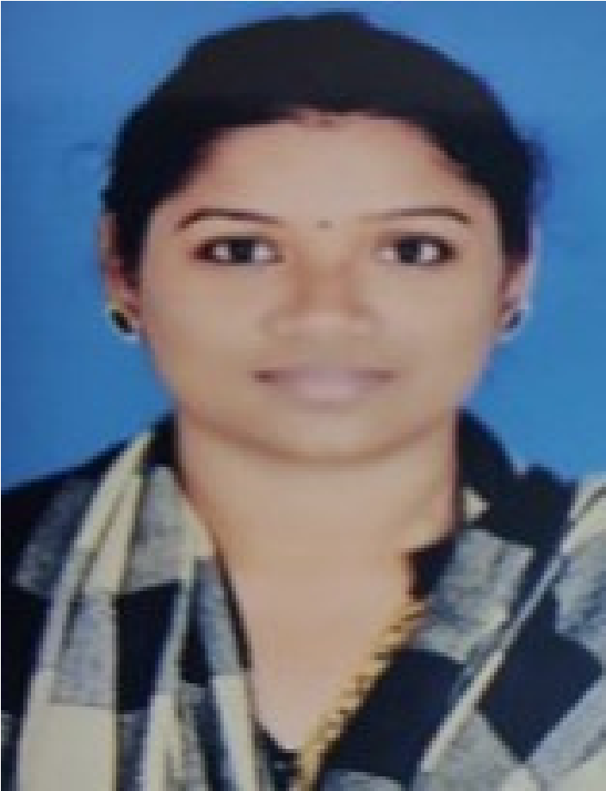

**CONTACT**

**MEENAKSHI SELVARAJ**

MIS / HR EXECUTIVE

Analytical, accomplished, professional Data Analyst

with over 5 years of experience in MIS and HR

operations. Skilled in the areas of report generation,

data analytics and orientating new employees and

training existing employees. Motivated and eager to

advance my career with a growth-oriented,

technically-advanced organization. Strong leadership

ability and good time management skills.

**WORK EXPERIENCES**

**MIS / HR Executive**

**-**

**Reliance Retail,Madurai,TamilNadu**

June 2008 - September 2010

Responsible for the Warehouse Overall

Inventory

Core team Member of Physical Inventory&

Shutdown inventory.

Administrating the health of the

warehouse.

**PERSONAL**

**DETAILS**

**Date of Birth**

29

th August,

1985

**Nationality**

Indian

**Marital Status**

Married

**Address**

G02,B Block,Celebrity Srivarus

Apartment,Near Thogur

cross,Opposite to Munishwara

Temple,

Electronic City Phase I

Bangalore - 560100.

**EDUCATION**

Bachelor of Computer

Science in Thiagarajar

College (Madurai Kamaraj

University -

(2002 - 2005)

+91-9353498647

meenakshi.bangalore123@gmail.com

**LANGUAGES**

English

Tamil

End-to-end recruitment process. And

onboarding formalities.

Screen incoming resumes and application

forms.

Interview candidates (via phone, video and in-

person).

Design and update job descriptions

Craft recruiting emails to attract

passive candidates,



**MIS Executive**

**-**

**e4e Nittany Healthcare**

**BPO,Chennai,TamilNadu.**

**SKILLS**

Responsible in sending the daily MIS Report

to all the senior managers and CEO.

Daily project status report and number of

people worked in each project.

Employee wise productivity details report.

June 2005 - May 2008



Assisting with training and onboarding process.

Maintaining, managing and updating software.

Supervising the development and maintenance of websites

BOOTSTRAP

JAVA

JAVASCRIPT

SQL

MS EXCEL & WORD

HTML & CSS

Shortlisting resumes of our students, escalating to the technical team & onboarding formalities

Completed Java Full stack developer Course at Besant

**HR & MIS Executive - June 2022 to Present – Besant Technologies**