**BIO DATA** 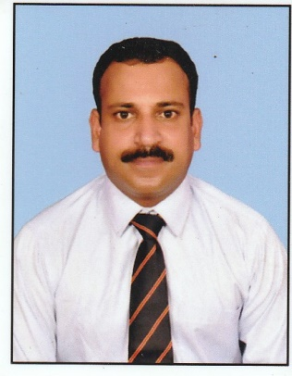

1. Name : Prince K J
2. Designation : 14662833A Ex-Hav (MACP Nb Sub)
3. Gender : Male
4. Religion/ caste : Chirstian, R C
5. Age & date of Birth : 40 yrs, 30-05-1983
6. Address :
7. Present address (b) Permanent address

Kolenchery (house) Kolenchery (house)

North Kuthiyathode P O, Kuzhur P O, Parappuram Pin -683594, Ernakulam (D) Pin -680734, Thrissur (D) Kerala (s) Mob- 9207147276

1. Education : 12th (PDC)
2. Tech qualification : Operator & Driver (Recovery)
3. Work experience : 17 years’ service in Indian army

10. Certificates : (a) Army Graduation certificate

(b) Army tech proficiency certificate

(c) Army security certificate

(d) Diploma in Fire and safety Management

11. Driving license : HMV driving license with Badge, Passport & Harbor

Craft Master License issued from Kerala

12. Tech experience : EOT, Hydraulic & mechanical crane operator

13. Institution : EME, Indian Army

14. Service period : 08-04-2003 to 31-07-2020

15. E mail ID : princekolenchery123@gmail.com