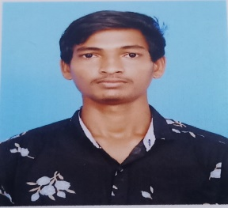SANJIAY R

61 OTHAVAI STREET KAINOOR VILLAGE AND POST ARAKKONAM

RANIPET

9361713150 | sanjiaysanjiay@gmail.com

**Objective**

I am looking for a challenging job with a rapidly growing organization that can provide me with a range of goals and job objectives within a contemporary and economical business setting.

**Experience**

* **FRESHER**

**Education**

* **C S I CENTRAL HR SEC SCHOOL**  2016

SSLC

65 %

* **GOVERNMENT HR SEC SCHOOL**  2018

HSC

82 %

* **GOVERNMENT ARTS AND SCINCE COLLEGE** 2021  
  B.COM (CA)

71 %

* **GOVERNMENT ARTS AND SCINCE COLLEGE** 2023

M.COM

80%

**Skills**

* ADAPTABILITY
* DECISION MAKING
* PROBLEM SOLVING
* TIME MANAGEMENT
* FLEXIBILITY

**Projects**

* PALM TREE CULTURE PROTECTION
* A STUDY ON CUSTOMER SATISFICATION TOWARDS ATM SERVICE

**Interest**

* TO LEARN NRW THINGS
* SPORTS

**Language**

* TAMIL
* ENGLISH

**Technical skills**

* MICROSOFT OFFICE
* TALLY ERP9

**Declaration**

* I solemnly declare the information mentioned herein is true and correct to the best of my beliefs. All the details provided above are genuine to the best of my belief and knowledge. I hereby declare that the above particulars of facts and information stated are correct to the best of my belief and knowledge.