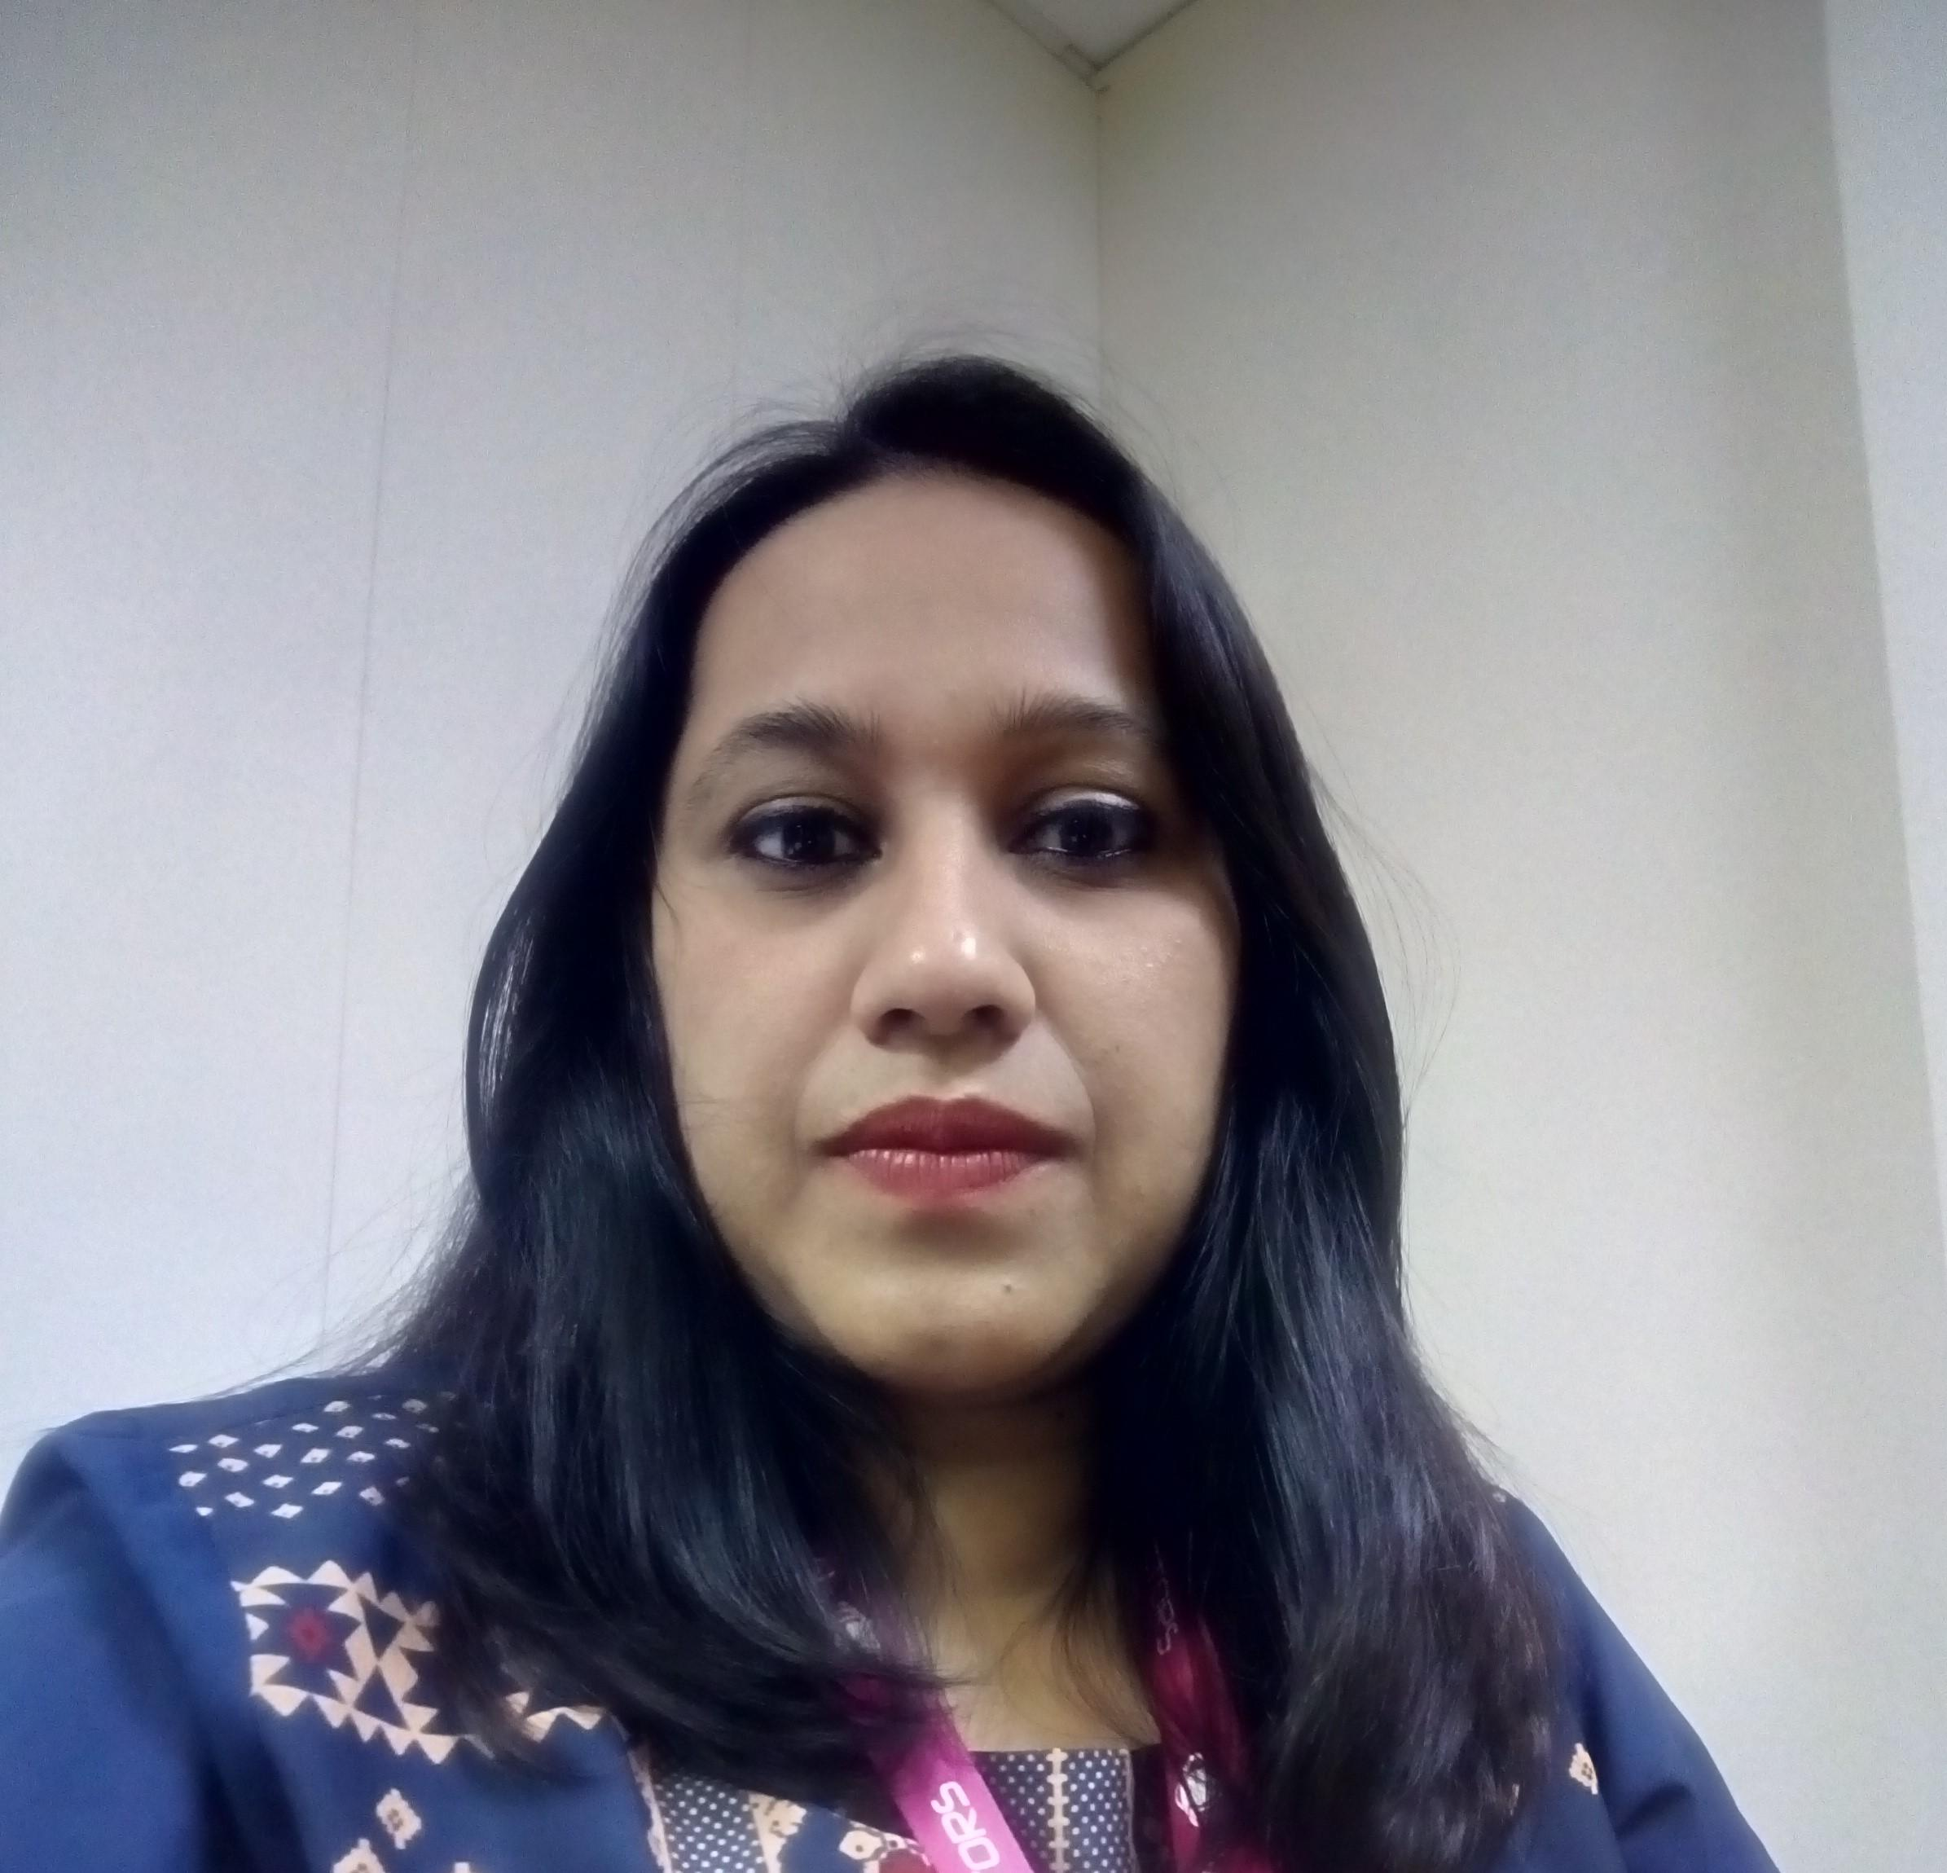

**Trupti Soman**

Phone: +9158979732

Email: [truptii.soman@gmail.com](mailto:truptii.soman@gmail.com) / [trupti_nene@rediffmail.com](mailto:trupti_nene@rediffmail.com)

***Seeking assignments in Functional Consultancy/ Testing with a growth-oriented organization.***

**Summary**

Having 15 years of experience in Administration and Secretarial profile.

## Organizational Experience

**Since Dec.’21 Calsoft Inc. Executive Assistant to COO and VP (Pune)**

### Growth Path

#### *Dec.’21 –Till Date - Executive Assistant to COO and VP*

**Since Oct.’19 Millennium Semiconductors Executive Assistant to MD (Pune)**

### Growth Path

#### *Oct.’19 –Dec.21 - Executive Assistant to MD*

**Since Dec.’13 Greaves Cotton Ltd. Executive Secretary to CEO’s (Pune)**

### Growth Path

#### *Dec.’13 –Oct 19 - Executive Secretary to President*

**Since Jan.’12- Aug 13 mSauda e-commerce Pvt. Ltd. Sr. Admin Executive (Pune)**

### Growth Path

#### *Jan.’12 – Dec..’13 - Sr. Admin Executive*

**Aug.’08 – Nov.’10 DHL Lemuir Logistics Private Limited**

**Executive Assistant (Mumbai)**

***Growth Path***

#### *Aug.08 – Nov.'10 – As Executive Assistant*

**May.’04 – July.’08 Reliance Communications Ltd.**

**Admin Executive (Mumbai)**

***Growth Path***

#### *May.’04 – Feb.’06 - As Web Guide (Thane Reliance World)*

# *Feb.’06 – July.’08 - As Admin Executive (Worli Mumbai)*

**Roles and Responsibilities**

***Calsoft Inc.***

* Complete a broad variety of administrative tasks for the COO including.
* Managing an extremely active calendar of appointments; composing and preparing correspondence that is sometimes confidential.
* Arranging complex and detailed travel plans, itineraries, and agendas; and compiling documents for travel-related meetings
* Management of incoming and outgoing mail, emails, telephone calls and correspondence.
* Keep eye especially skip meetings, appraisals, telephonic interviews for key positions, etc; any other administrative tasks delegated by COO
* Communicate directly, and on behalf of the COO, with Board members, client, vendor, staff, and others as and when required.
* Getting daily /Weekly /monthly MIS reports etc. and take corrective action / follow ups wherever required.
* Provide a bridge for smooth communication between the COO and team; demonstrating leadership to maintain credibility, trust and support with senior management staff.
* Work closely and effectively with the COO to keep him well informed of upcoming commitments and responsibilities, following up appropriately. Acts as a "barometer," having a sense for the issues taking place in the environment and keeping the COO updated.
* Plan events or activities regularly and take initiatives to engage employees and maintain friendly work culture
* Carry out any other duties and responsibilities as maybe assigned

***Millennium Semiconductors***

* Maintains master calendar of events and daily log of activities for the Director
* Management of incoming and outgoing mail, emails, telephone calls and correspondence,
* including where appropriate re-routing to executives.
* Manage MD schedule and update diary accordingly
* Co-ordinate internal and external meetings involving MD executive and others as required
* (including refreshments etc) and provide necessarily follow up.
* Maintained of accurate board minutes, including taking notes at meetings, preparing draft
* minutes for MD’s review and ensuring approved minutes are circulated on mail.
* Maintain a complete set of important papers &amp; Plans papers for reference in MD’s filing system.
* To monitor tasks delegated by the MD’s to customers on new business opportunities to ensure
* that completed work is achieved to agreed deadlines.
* To prepare, proofread and edit all outgoing correspondence e.g. letters, funding proposals,
* press releases, marketing materials and newsletters &amp; Advertisements.
* Coordinated travel and meeting arrangements for M.D.
* To taking care of Personal bills, receipts, insurance &amp; make their payment.
* Analysed reports/emails/memos to determine their significant of distribution.
* Co-ordination between internal Departments.

***Greaves Cotton Ltd.***

* *Receive, direct and relay telephone messages and fax messages*
* *Maintain the general filing system and file all correspondence*
* *Assist in the planning and preparation of meetings, conferences and conference telephone calls*
* *Make preparations for Band Council and committee meetings*
* *Arrangement of ticketing visa, hotel bookings for Domestic as well as International*
* *Online approvals on behalf of senior management.*
* *Supporting digital marketing team for service and product display on catalogues or website*
* *Getting daily /Weekly /monthly MIS reports etc. and take corrective action wherever required.*
* *Provide confidential secretarial and administrative support to the senior management team.*
* *Maintain an adequate inventory of office supplies*
* *Single point of contact between Executive and team.*
* *Taking care of domestic as well as International travel support for team.*
* *Provide word-processing and secretarial support*
* *Keeping eye on service order and co-ordinate with relevant department.*
* *Type confidential documents on a word processing system*
* *Provide administrative services for the CEO’s office*

***mSauda e-commerce Pvt. Ltd.***

* *General Overall Administration activity of site.*
* *Ensure team performance on regular basis*
* *Assisting HR for recruitment.*
* *Taking care for Hotel / flight bookings for the employees*
* *Coordinate between respective client and various departments.*
* *Documentation of the receipt i.e. Preparation of GRIR in SAP & forwarding to user.*
* *Take complete responsibility for all non-technical aspects of company's office*
* *Forwarding the GRIR to accounts for bill passing.*
* *New Innovation and review the existing admin system*
* *Travel Management.*
* *Arrange for Transport, Security, Canteen, House Keeping, Liaison with govt. authority*
* *Responsible for Telephone, Electricity, Office Stationery, Help Desk.*
* *Generating PO’s, Tracking the order.*
* *Co-ordination with various departments like purchase, finance, marketing & maintenance*
* *Monitoring goods sent for re-work to vendors and following-up for receiving back within time.*
* *Arrange for the vehicle for the transportation of the goods*
* *Checking the documents e.g. Road permits, proper invoices, weight and values etc.*

***DHL Lemuir Logistics Private Limited***

* Co*-ordination with department In- charges and Operations Manager.*
* *Getting daily /Weekly /monthly MIS reports etc and take corrective action wherever required.*
* *Interface with customers, projects personnel in absence.*
* *Arrangement of ticketing visa, hotel bookings*
* *Analysis of KPI's and Service levels.*
* *Attending Calls for Director*
* *Managing internal and external communication behalf of Director*
* *Provide confidential secretarial and administrative support to the senior management team.*
* *Preparation of presentation, project assessment work in case of urgency.*
* *Screens telephone calls and visitors, and resolves routine and some complex inquiries*
* *Looking after office Administration*

***Reliance Communication Ltd.***

* *Provide admin & secretarial support.*
* *making travel arrangements*
* *organizing meetings & events*
* *coordinate with Vendors & maintain outsourced reports*
* *Managing data from internal departments.*
* *Generating PO’s, Tracking the order.*
* *Looking after office Administration*
* *executive email management*
* *Coordination with client / onsite and offshore delivery team*
* *Customer Complaint Management.*
* *Looking after Canteen and transport service*

**Qualifications**

* *2008 Graduate in Arts (Sociology) from Mumbai University*
* *2002 H.S.C from V.G. Vaze (Kelkar College) (Mumbai University).*
* *2000 S.S.C from Manisha Vidyalaya (Maharashtra Board)*

**Computer Skills**

* *Excellent in Ms. Office (Word, Excel, Power Point)*
* *Friendly operating Lotus notes and Outlook*
* *Familiar to operating JD Edwards and SAP*
* *Completed Secretarial and EA short term programme.*
* *Gone through various Admin/EA and PA related online examinations.*
* *Well command on paint and oracle for creativity e.g. I-Cards samples, Greeting cards, bookmarks, coasters, T-shirt printing, Mug printing etc.*

**Personal Details**

* *Name : Trupti Soman*
* *Residential Address : A1-801, Royal Castle, Thergaon link road, Chinchwad, Pune 411033.*
* *Date of Birth : 5th August 1984*
* *Marital Status : Married*
* *Notice Period : Immediate*

*Thank you, for perusing my personal information.*

*Place: Pune*

*Date:*

**Trupti Soman**